User Manual for Operators
and Competent Authorities

Notification documents
and
Movement documents

Version proposed by the Commission
Version 2.0
Table of contents
Introduction 4
Chapter 1 Submitting the notification 5
General note 5
Specific instructions 5
Chapter 2 Reviewing the notification 32
General note 32
Table 1. Statuses of notification document in DIWASS 33
Specific instructions 35
Chapter 3 How a waste producer should authenticate the notification 41
General note 41
Specific instructions 41
Chapter 4 Replying to requests for additional information 43
General note 43
Specific instructions 43
Chapter 5 Cancelling the notification 46
General note 46
Specific instructions 46
Chapter 6 Submitting the request for change of notification after consent (Art. 17 WSR) 48
General note 48
Specific instructions 48
Chapter 7 How to submit a movement document 52
General note 52
Table 2. Statuses of movement document in DIWASS 53
Specific instructions 55
Chapter 8 How to update a movement document 64
General note 64
Specific instructions 64
Chapter 9 Contribution of carrier to a movement document 66
General note 66
Specific instructions 66
Confirming the transfer of waste 66
Updating of transfer confirmation 70
Chapter 10 Contribution of consignee to a movement document 74
General note 74
Specific instructions 74
Confirming the receipt of waste 74
Updating the confirmation of receipt of waste 79
Chapter 11 Contribution of waste receiving facility to a movement document 83
General note 83
Specific instructions 83
Confirming the receipt of waste 83
Updating the confirmation of receipt of waste 92
Confirming the treatment of waste 95
Updating the certificate confirming treatment of waste 101

Introduction
This document contains specific instructions on the use of Digital Waste Shipment System. In order to properly explain how certain operations work, this document often refers to the EU legislation concerning shipments of waste, to illustrate how certain requirements are reflected in DIWASS. This document does not contain any interpretation of these laws.
Abbreviations used in the document:
Abbreviation | Meaning
CA | Competent Authority
DIWASS | Digital Waste Shipment System
WSR | Waste Shipment Regulation: Regulation (EU) 2024/1157 of the European Parliament and of the Council of 11 April 2024 on shipments of waste, amending Regulations (EU) No 1257/2013 and (EU) 2020/1056 and repealing Regulation (EC) No 1013/2006, OJ L, 2024/1157, 30.4.2024, ELI: http://data.europa.eu/eli/reg/2024/1157/oj
DIWASS Implementing Act | Commission Implementing Regulation (EU) 2025/1290 of 2 July 2025 laying down rules for the application of Regulation (EU) 2024/1157 of the European Parliament and of the Council as regards the requirements necessary for the interoperability between the central system for the electronic submission and exchange of information and documents related to shipments of waste and other systems or software, as well as other technical and organisational requirements necessary for the practical implementation of such electronic submission and exchange of information and documents, OJ L, 2025/1290, 14.7.2025, ELI: http://data.europa.eu/eli/reg_impl/2025/1290/oj

Chapter 1 Submitting the notification

General note
This chapter provides instructions on submitting a notification in DIWASS. To be able to submit a notification, it is necessary that:
- The operator that will act as a notifier is registered in DIWASS,
- The user is authorised to represent the operator that will act as a notifier in DIWASS,
- All operators that are involved in notification are registered in DIWASS.
Please note that the user acting in DIWASS is always representing a given operator, and that this operator acts in a certain role in the context of shipments of waste. The role in a given notification is established through the selection of the operator in one of the fields of the notification (e.g. notifier, carrier, treatment facility, etc).
Example: user Anna Smith represents the company Waste Management S.A. that is registered as an operator, and that in the context of a given notification acts as a notifier.
To improve the readability of the instructions below, instead of using the formula “user representing the operator that in the context of given shipment acts as […]”, references are to the simpler form “the user”.
Please also note that, for cases where waste is imported into the EU and the third country operator acting as the notifier does not actively use DIWASS, the notification will be introduced to DIWASS by an EU CA, which in context of that notification, is to act as CA of dispatch.

Specific instructions
- After logging in into TRACES NT, the user needs to select in the tab “Documents” the “DIWASS Notification procedure”.
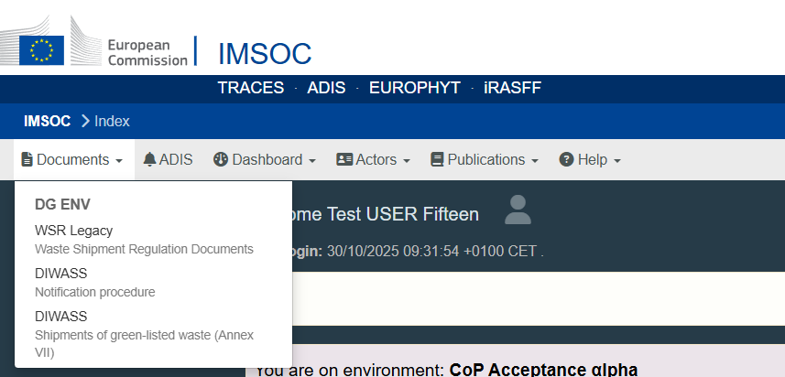
- The screen with a list of notifications, where the operator that user represents is involved, will be displayed. To create a new notification, the user should select the button “Create”.
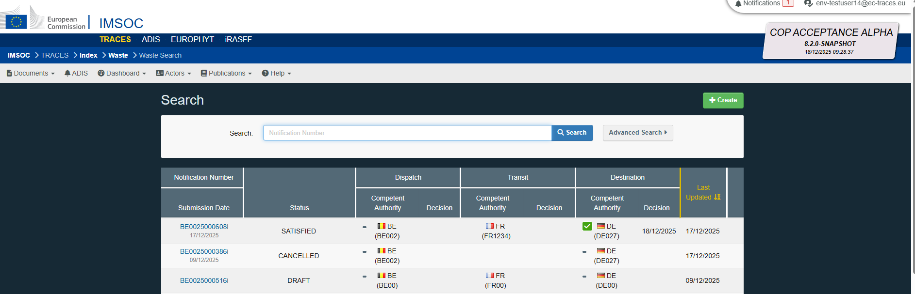
- A notification wizard will be opened, and the user will be asked to select the notifier. To do this, please select the operator from the operators that you are authorised to represent in DIWASS, that you will prepare the notification for. This selection needs to be made also in cases where the user is authorised to represent only one operator in DIWASS. The selection should be done by selecting a name of respective operator from the drop-down list.

Confirm the selection by clicking “Next”.

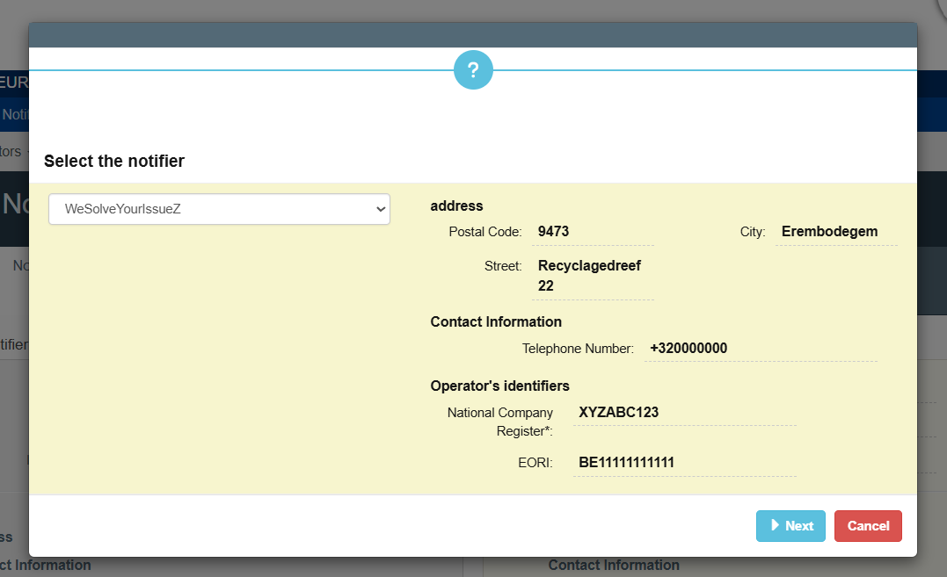
- The user needs to indicate the countries and CAs for the notification from the drop-down lists provided. To add transit countries, the user needs to first click on “+ Add Transit”. In case a notification involves more than one transit country, please list them in the correct order by using arrows next to the names of CAs of transit.

Confirm the selection by clicking “Next”.
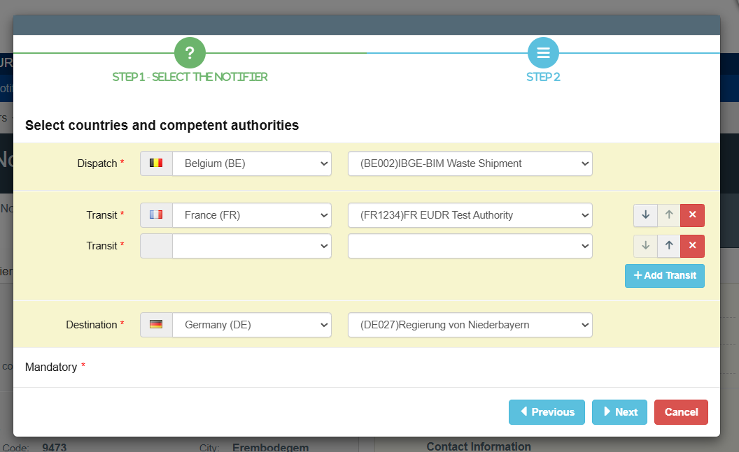
Please note that that DIWASS will not block the possibility to submit a notification starting from country A if the notifier does not have a registered office in country B.
However, many Member States require that the notifier has to have a registered office in their country in order to submit a notification starting from that country, and therefore may object to such a shipment of waste initiated by a notifier not having a registered office in the territory of their country. Therefore in such cases the notifiers are advised to check if the Member State selected as country of dispatch requires the notifier to have a registered office in their territory before submitting notification.

The screen will now display a summary of the data provided so far, and the user will be asked to confirm the selections made by clicking “Confirm”. Based on this data, the template of the notification will be created, and the remaining elements of notification documents can then be filled in in the next steps.

Please note that, in that draft notification, it will not be possible to change the elements concerning notifier, countries and CAs involved. When changes are needed on those elements, a new draft notification needs to be created. It is possible – before confirming – to return to previous screens through the button “Previous”.

When the button “Cancel” is clicked here, the process of drafting the notification will be terminated.
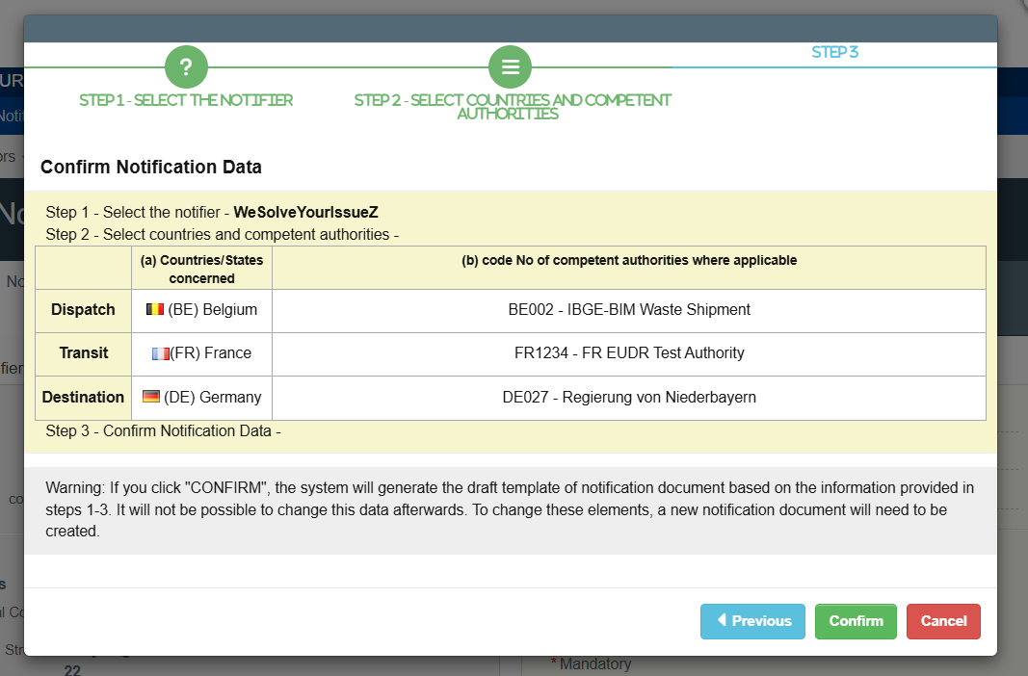
- After confirming in the notification wizard, the main screen of the notification will open. Users will be able to save a draft notification at this stage, and it is recommended to do so at this stage. To do so, please click on “Save” at the bottom right corner of the page.

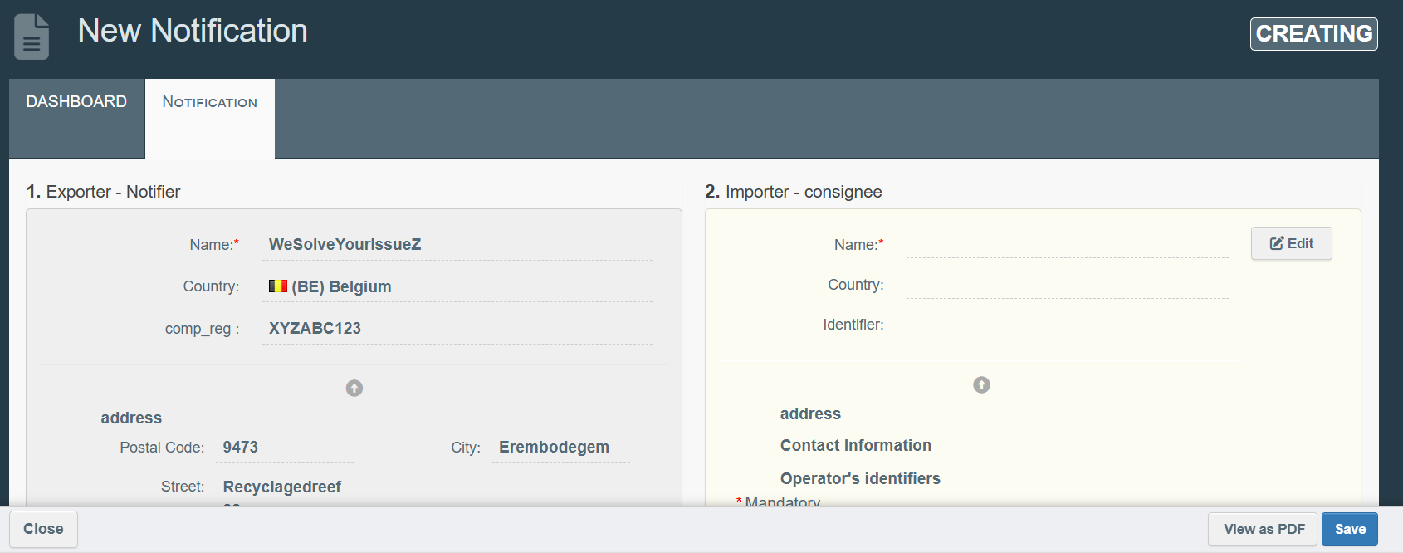
The draft notification will be visible only for the notifier, as well as for the waste producers as indicated after completing box 9 of the draft notification document. The information provided earlier will automatically fill Box 1. “Exporter – Notifier”.
In the further instructions below, the steps are explained in the order of boxes of the notification document as laid down in Annex IA of the WSR, but the user will be able to fill in these boxes in any order.

- Box 2. “Importer – consignee”. In order to select the consignee, the user needs to click on the field “Edit”.
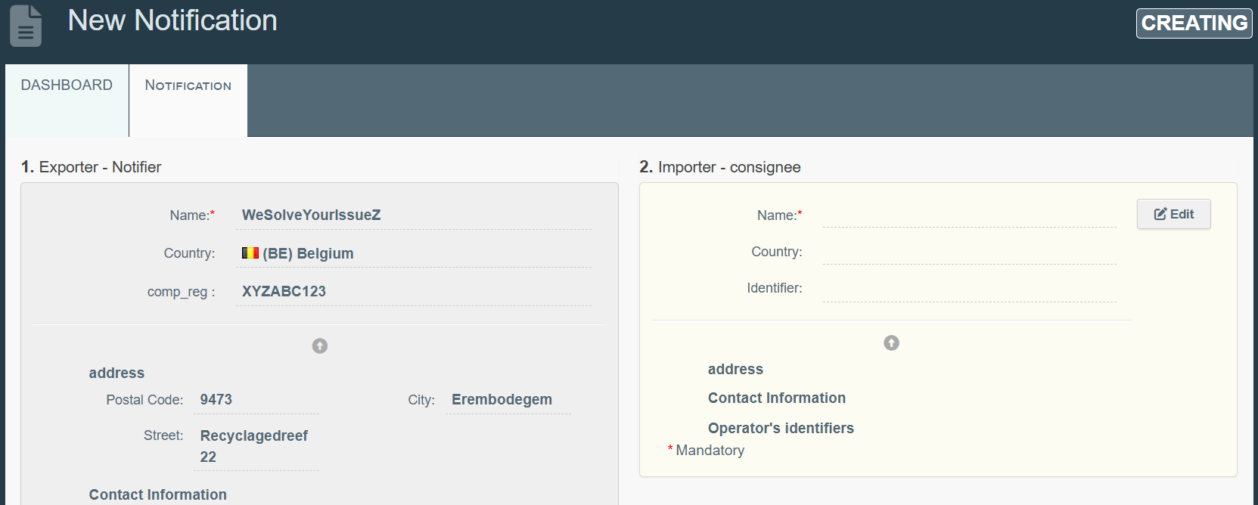
Then, the user will be asked to provide a country of the consignee from the drop-down list.

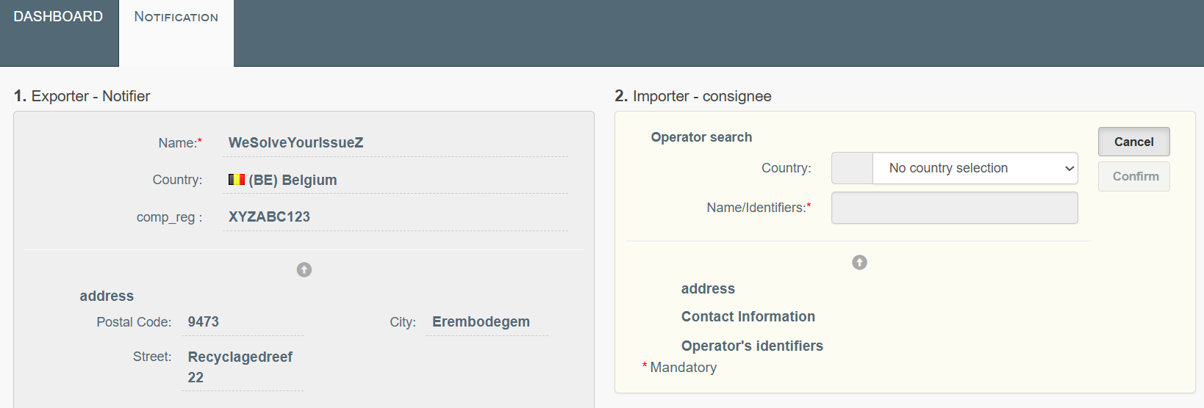
Next, the user will be able to search for the consignee, by typing in the name or identification number of the operator. The system will display search results after providing at least three characters.
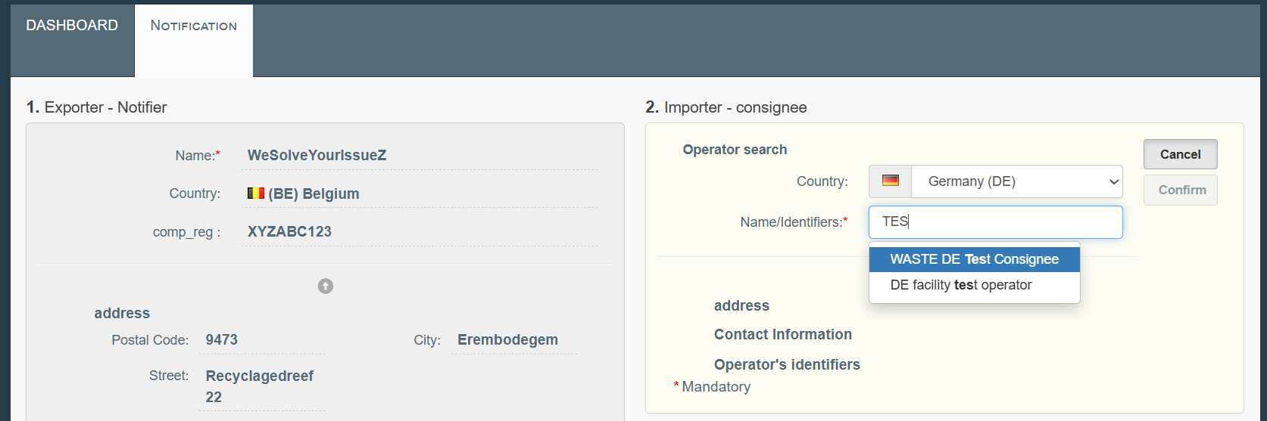
The user should choose the correct operator – basic data of the selected operator will be displayed as soon as the selection is done. The user should verify, if this is the operator it intended to choose and approve the choice by clicking “Confirm”.

Please note that, when selecting operators for a given notification, the user should always carefully verify the details of the operator, to make sure the correct operators is selected. The user should pay particular attention to the possibility that the operator is registered with specific sites in DIWASS. Only users representing a specific site in DIWASS can select it; after having selected the correct site, the users authorised to represent such site in DIWASS will be able to see the submitted notification in DIWASS and contribute to the movement documents. For more information on sites, please refer to Chapter 6 of the instruction manual on Operators [for operators and CAs].

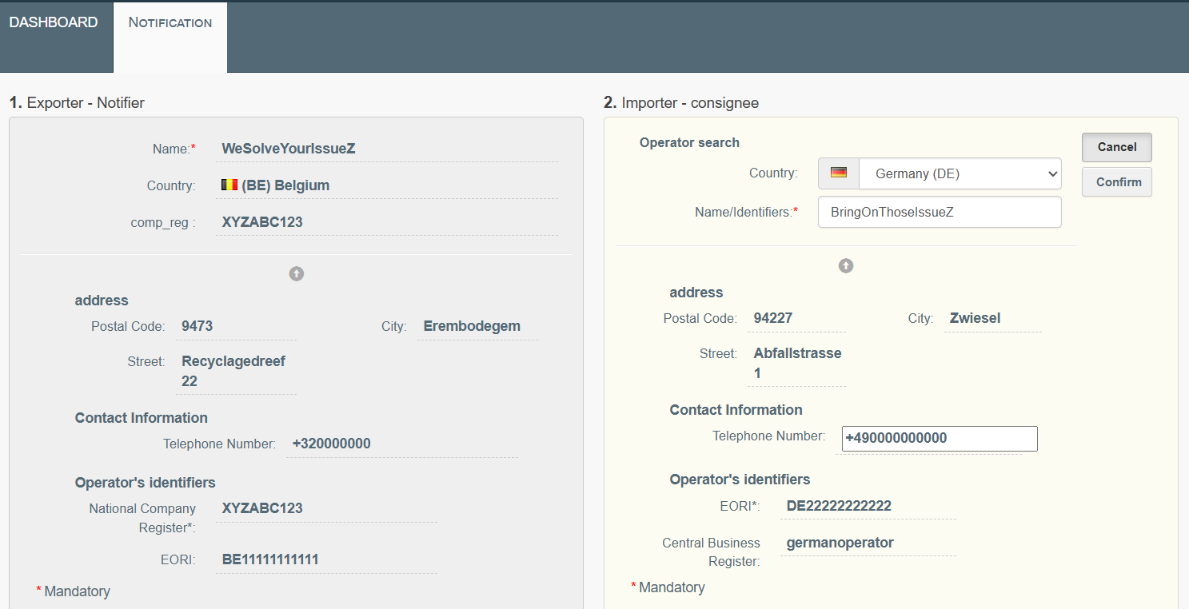
- Box 3. “Notification No.”: The system will generate a unique notification number after a draft is saved for the first time. There is thus no need for the user to introduce such number manually.
[Please note that the Commission works on providing a functionality to allow the EU CA that submits all relevant information to the system pursuant to Article 51(2) point (b), Article 53(2) point (d), Article 57 or Article 58(1) and (2) of the WSR to introduce in the system that the user uses the notification number attributed by the CA of dispatch].

In box 3, the user should specify if the notification that the user creates is linked with another notification document or Annex VII document. The user can indicate this by providing the number of such related document.

The user may indicate the link with another notification or Annex VII document where:
- The new notification seeks to continue shipments of waste that were consented to before (i.e. the same type of waste, the same notifier/waste producer(s), the same destination facility, etc.).
- The notification is created due to a take-back of waste covered by another notification or Annex VII document.

The user should also specify the following:
  - Whether the new notification is created due to take back, and
  - Whether it is created in the context of the detection of illegal activities.
Choosing these options will have impact on the possibility to complete box 3a of the notification document.
The user should also indicate whether the notification concerns:
  - Individual or multiple shipment of waste: the user should indicate “Yes” if the notification concerns one shipment of waste only, and “No” if the user intends to submit a general notification,
  - Shipment of waste destined for disposal or recovery, and
  - Shipment of waste destined for pre-consented facilities (see Article 14 WSR).
Choices made on the first two elements above will have impact on the possibility to complete boxes 4 and 10 of the notification document.
Indicating that the shipment of waste is destined for a pre-consented facility will impact the expected time for the CAs to ask for additional information, consider notification properly carried out and properly completed, as well as the timeline for providing the decision.
Please note that DIWASS will allow to select that a shipment is destined to pre-consented facility only if the facility is listed as such facility in DIWASS.

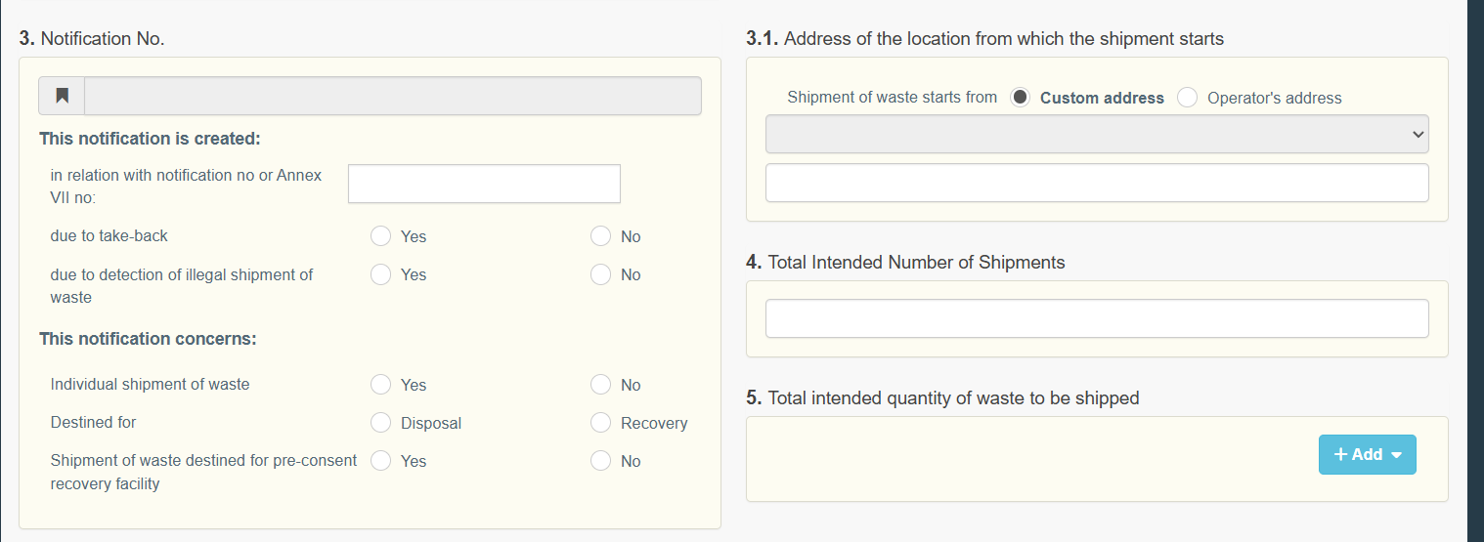
- Box 3.1. “Address of the location from which the shipment starts”: The user needs to indicate the address of the location from which the shipment starts.

The user will be able to select the address of the location from which the shipment starts as one of the address of operators (notifier or waste producers) involved in this notification from the drop-down list.
The user will be able to select “Custom address” and provide the address of the location from which the shipment starts in the free text box in case it is different from the address of the operators involved in a given notification.

If the shipment starts from the address of one of the waste producers, the user needs to first add waste producers in box 9 of the notification document, and only then will they be able to indicate the address of the relevant waste producer.

If the address of the location from which the shipment starts is not the same as the address of any of the operators that is displayed in DIWASS, please note that the shipment may concern not the selected operator, but its site. Please refer to Chapters 6 of the instruction manual on Operators [for operators and CAs].

Please note that in case the notification concerns multiple shipments of waste, the address indicated in this box will be fixed for all movement documents created under this notification.
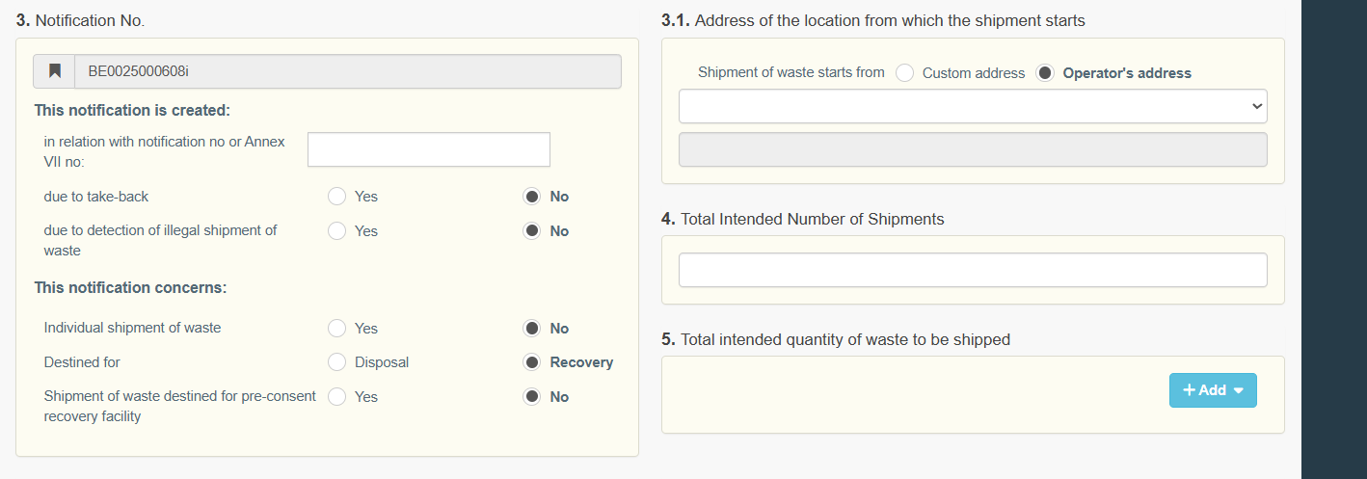
- Box 4. “Total Intended Number of Shipments”: In case the notification concerns multiple shipments of waste, the user needs to indicate the total intended number of shipments of waste by completing the box.
This number will define the maximum number of movement documents that could be submitted under this notification in DIWASS. Please note that this number may be decreased as a result of the CA’s decision and/or specific condition for consenting to the shipment of waste.
Please also note that if a movement document is cancelled by the notifier, it will not affect the number of movement documents that could be generated under a consented notification.
Example: Consented notification allows for 15 shipments of waste, so DIWASS will allow to submit 15 movement documents. If the notifier cancels movement document bearing serial number 013, DIWASS will allow to generate and submit movement document with serial number 016.

- Box 5. “Total intended quantity of waste to be shipped”: The user needs to provide the total intended quantity of waste to be shipped under the notification either by indicating the mass of waste, in tonnes, or the volume of waste, in m³. Please click on “Add” and select volume or mass.
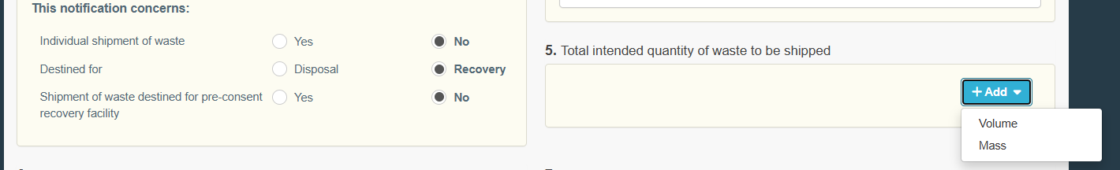
Then, please indicate the correct value of mass or volume by filling in a free text box:
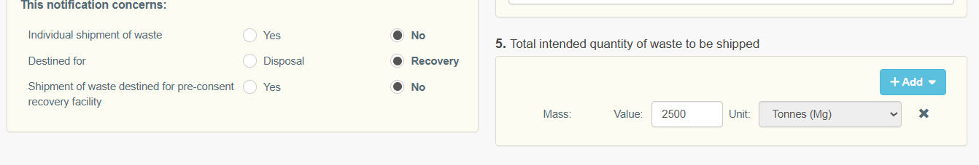
This quantity will define the maximum total quantity of waste to be shipped under all the movement documents generated by the notifier in DIWASS under this notification.
Please note that this quantity may be decreased as a result of the CA’s decision and/or specific condition for consenting to the shipment of waste.
Please note that the choice made in this box will affect the possibility of providing data in the movement documents generated based on notification.
Example: if the notifier provided the total intended quantity of waste in Mg in notification document, in movement documents the notifier will be able to provide quantity only in Mg (and not in m³).
Please also note that DIWASS will check the total intended quantity of waste to be shipped against the data that the notifier provides in box 5 of the movement documents generated based on the notification.
Please also note, that DIWASS will not restrict the waste receiving facility to provide different values, including higher ones, in box 17 of the movement document.

- Box 6. “Intended period of time for shipment(s)”: The user needs to indicate the intended period for shipments by providing the dates of intended first departure and last departure. To select these dates, the user should click on the calendar icon and select the respective dates.
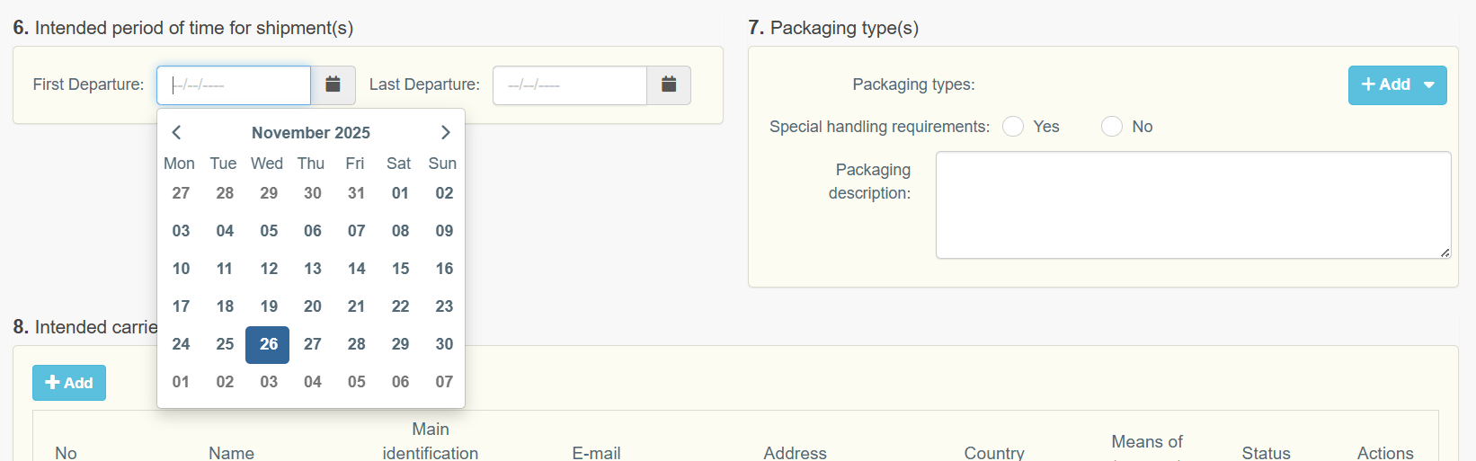

- Box 7. “Packaging type(s)”: The user needs to select packaging types by clicking “+ Add” and selecting relevant type or types of packaging. The user should also indicate if there are any special handling requirements for the shipped waste. The user may also provide a packaging description in the free text box.
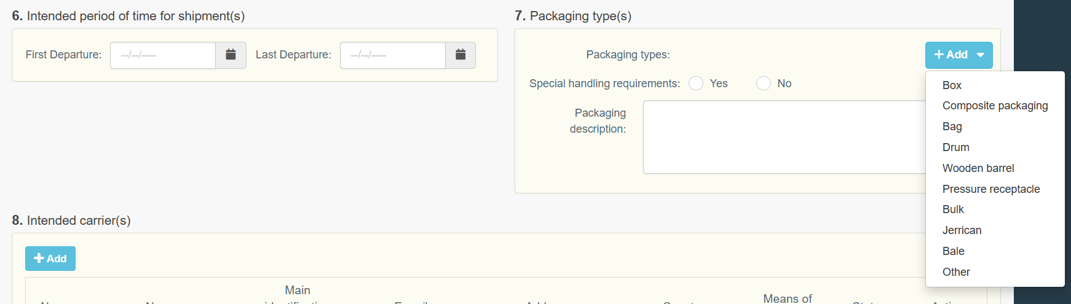
- Box 8. “Intended carrier(s)”: In order to add carriers, the user needs to click “+ Add”.
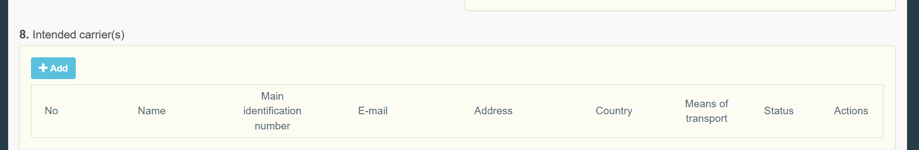
Next, in the pop-up window, user needs to click on “Edit”.
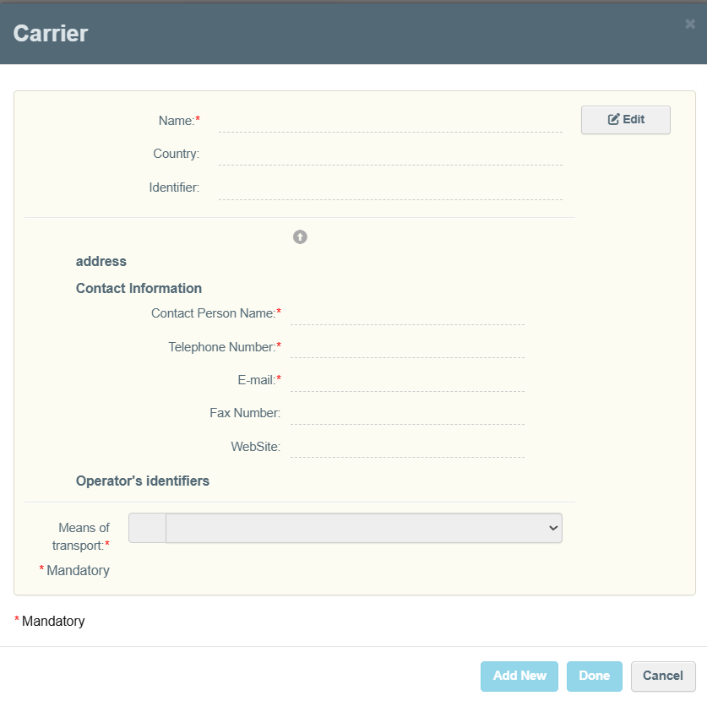
Then, the user needs to select the country from the drop-down list, by typing in the name or identification number of the operator. The system will display search results after providing at least three characters.
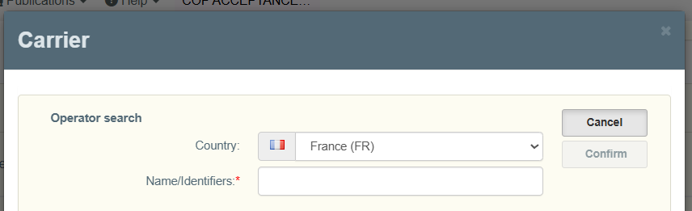
The user should choose the correct operator – basic data of the selected operator will be displayed as soon as the selection is done. The user should verify if this is the operator it intended to choose and approve the choice by clicking “Confirm”.

Please note that, when selecting operators for a given notification, the user should always carefully verify the details of the operator to make sure the correct operators is selected. The user should pay particular attention to the possibility that the operator is registered with specific sites in DIWASS. Only users representing a specific site in DIWASS can select it; after having selected the correct site, the users authorised to represent such site in DIWASS will be able to see the submitted notification in DIWASS and contribute to the movement documents. For more information on sites, please refer to Chapter 6 of the instruction manual on Operators [for operators and CAs].

Then, the user should select the means of transport from the drop-down list.
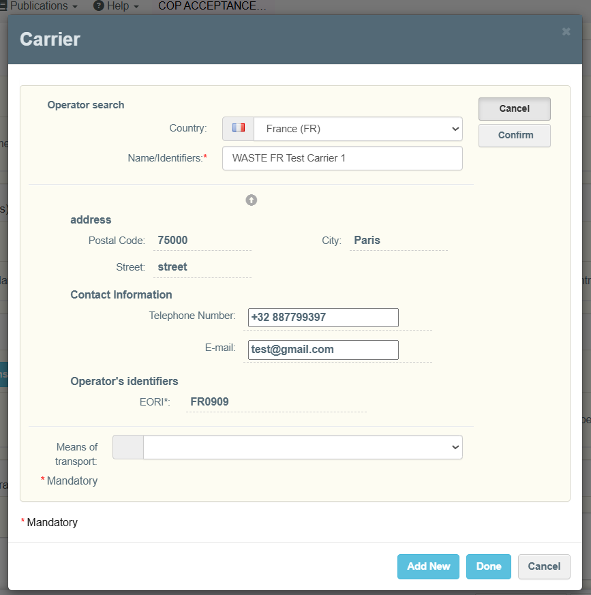
Following that, the user may either add another carrier by clicking “Add New”, following the steps described above, or click on “Done” to close the pop-up window for carrier selection.
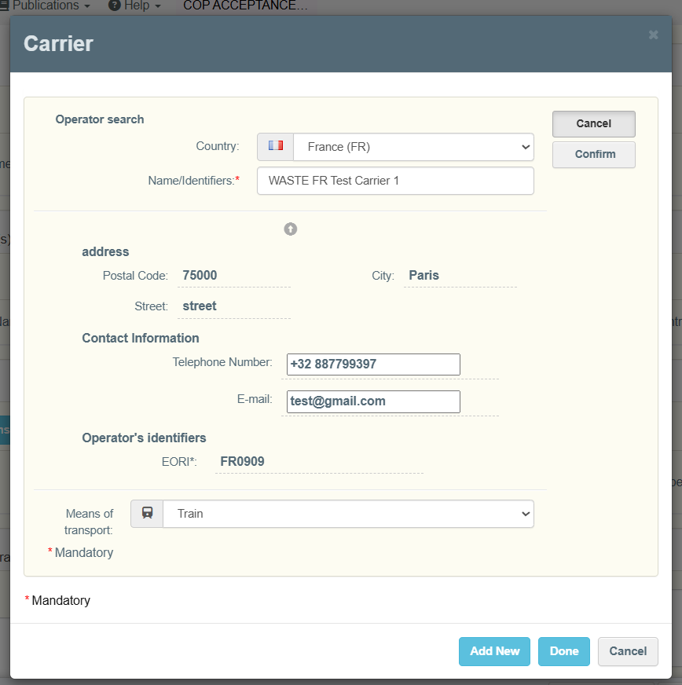
- Box 9. “Waste generator(s) - producer(s)”: In order to add waste producers, the user needs to click “+ Add”.
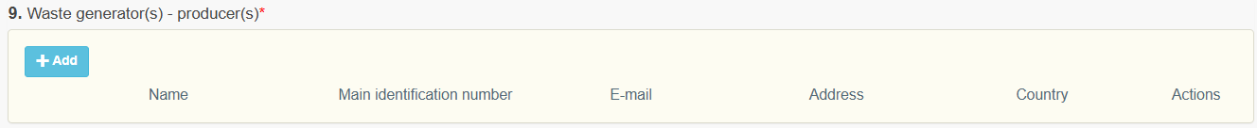
Next, in the pop-up window, user needs to click on “Edit”.
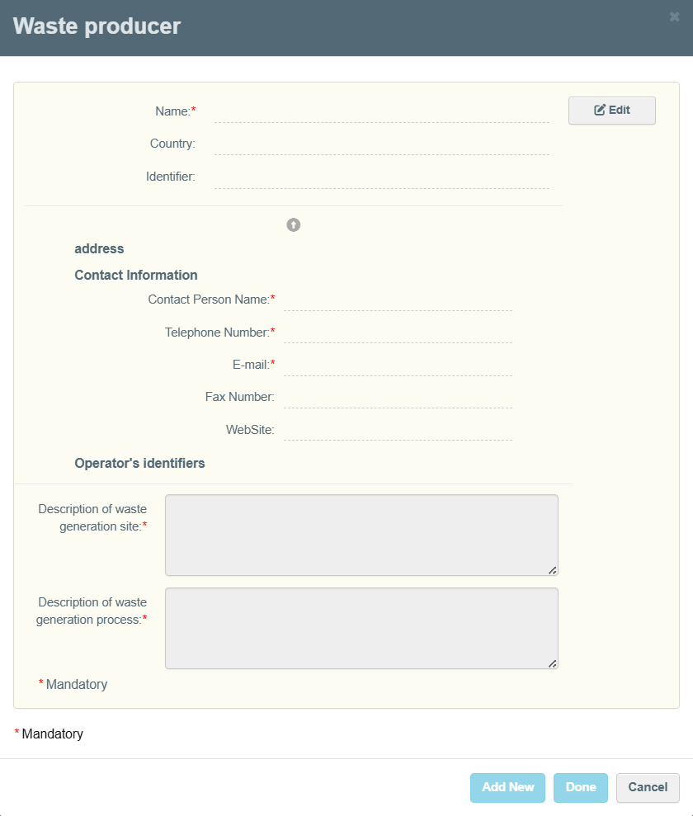
Then, the user needs to first select the country from the drop-down list of countries. Next, the user will be able to search for the operator, by filling in the name or identification number of the operator. The system will display the results after providing at least three characters.
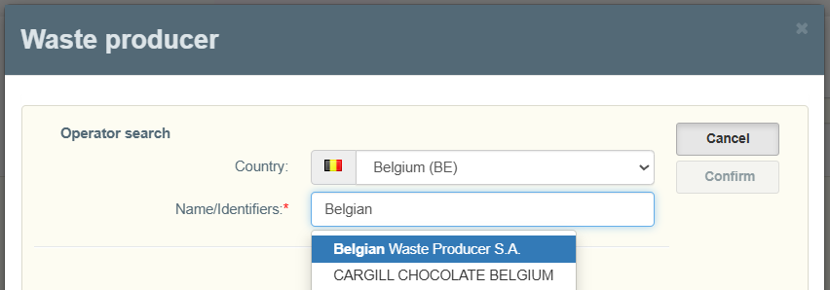
The user should choose the correct operator – basic data of the selected operator will be displayed as soon as the selection is done. The user should verify if this is the operator it intended to choose and approve the choice by clicking “Confirm”.

Please note that, when selecting operators for a given notification, the user should always carefully verify the details of the operator, to make sure the correct operators is selected. The user should pay particular attention to the possibility that the operator is registered with specific sites in DIWASS. Only users representing a specific site in DIWASS can select it; after having selected the correct site, the users authorized to represent such site in DIWASS will be able to see the submitted notification in DIWASS and contribute to the movement documents. For more information on sites, please refer to Chapter 6 of the instruction manual on Operators [for operators and CAs].

Then, the user will be able to provide a description of site of generation of waste and process of generation of waste filling in the two free text boxes. Please note, that these descriptions are linked with a given waste producer.
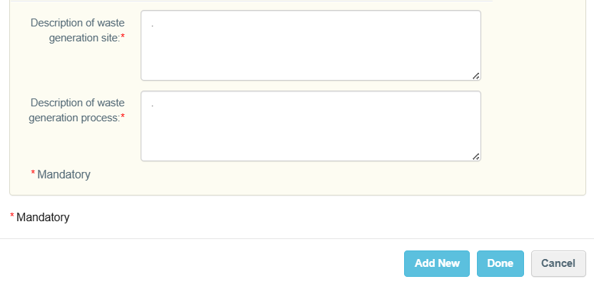
To confirm the selection of the waste producer, user needs to click on “Done”.
Following that, the user may either add another waste producer by clicking “Add New” and following the steps described above.

- Box 10. “Disposal/Recovery operations”: In order to indicate the waste treatment facilities concerned by this notification, the user needs to click “+ Add”.
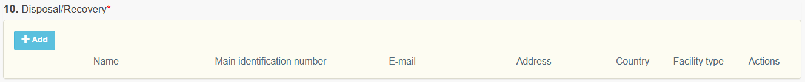
In case the user chose “+ Add”, in the pop-up window, the user needs to click on “Edit”.
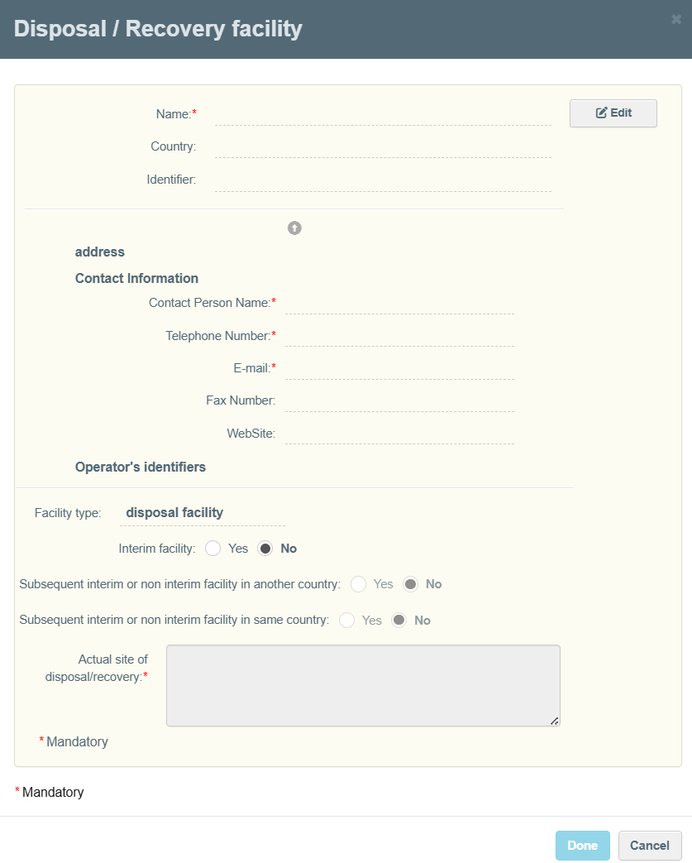
Then, the user needs to first select the country from the drop-down list of countries. Next, the user will be able to search for the operator, by filling in the name or identification number of the operator. The system will display the results after providing at least three characters.
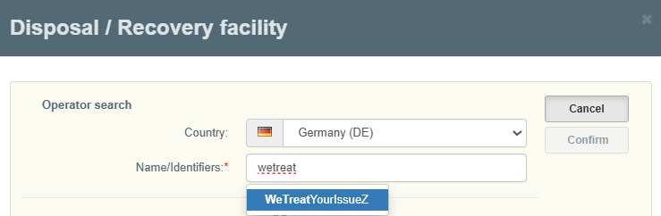
The user should choose the correct operator – basic data of the selected operator will be displayed as soon as the selection is done. The user should verify, if this is the operator it intended to choose and approve the choice by clicking “Confirm”.

Please note that, when selecting operators for a given notification, the user should always carefully verify the details of the operator, to make sure the correct operators is selected. The user should pay particular attention to the possibility that the operator is registered with specific sites in DIWASS. Only users representing a specific site in DIWASS can select it; after having selected the correct site, the users authorized to represent such site in DIWASS will be able to see the submitted notification in DIWASS and contribute to the movement documents. For more information on sites, please refer to Chapter 6 of the instruction manual on Operators [for operators and CAs].

Then, the user needs to indicate:
  - The type of waste treatment facility by selecting from the drop-down list,
  - If this facility performs interim or non-interim treatment process with respect to waste shipped under this notification, and
  - A description of the actual site of disposal / recovery of waste covered by the notification by filling in a free text field.
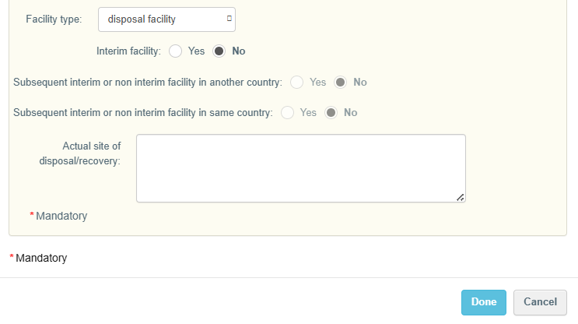
To confirm the selection, the user needs to click on “Done”.
Important note: In case the user selected in box 10 that the facility receiving waste under this notification is an interim waste treatment facility, the user will see two additional boxes – 10.1 and 10.2.

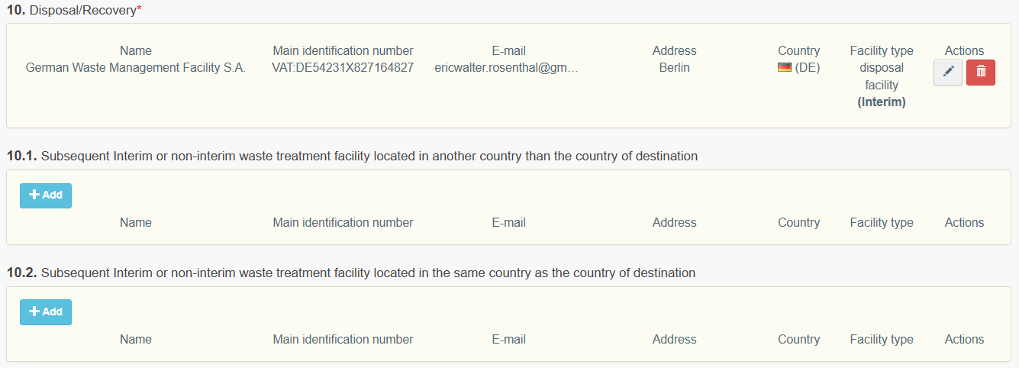
- Box 10.1. “Subsequent Interim or non-interim waste treatment facility located in another country than the country of destination”: To add facilities in this box, please follow the steps as described for adding the facility in box 10 of notification.

The notifier needs to add all such facilities into this box. The facilities will not be able to contribute to any elements of the notification document or movement documents generated on its basis, but it will be able to see it. The details related to connection between the facility indicated in box 10, and facilities indicated in box 10.1 should be explained in attachments (i.e. including types of waste and treatment processes, that facilities listed in box 10.1 should perform).

- Box 10.2. “Subsequent Interim or non-interim waste treatment facility located in the same country as the country of destination”: To add facilities in this box, please follow the steps as described for adding the facility in box 10 of notification.

The notifier needs to add all such facilities into this box. The facilities will not be able to contribute to any elements of the notification document or movement documents generated on its basis, but it will be able to see it. Also, the facilities will be able to submit certificates confirming completion of a subsequent interim or non-interim recovery operation or a subsequent interim or non-interim disposal operation in accordance with Article 15(5) of the WSR.

- Box 11. “Disposal / Recovery operations”: The user needs to choose the code of waste treatment operation(s), by clicking “+ Add” and selecting the relevant operations. Then, the user should describe the technology employed and reasons for export by filling in the free text boxes.
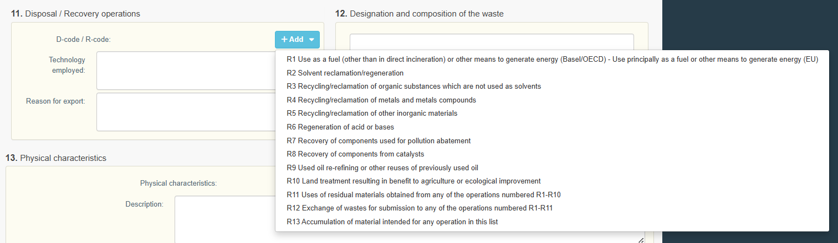
Please note that the selection of codes of waste treatment operations and description of technologies should concern only the waste treatment facility indicated in box 10 of the notification, not the subsequent facilities indicated in boxes 10.1 or 10.2.

- Box 12. “Designation and composition of the waste”: The user should describe the designation and composition of waste by filling out the free text box.
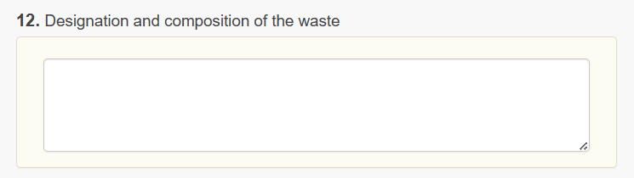
- Box 13. “Physical characteristics”: The user needs to choose the physical characteristics of waste concerned by this notification by clicking “+ Add” and selecting the relevant description from the drop-down list. The user may describe these characteristics by filling in the free text box.
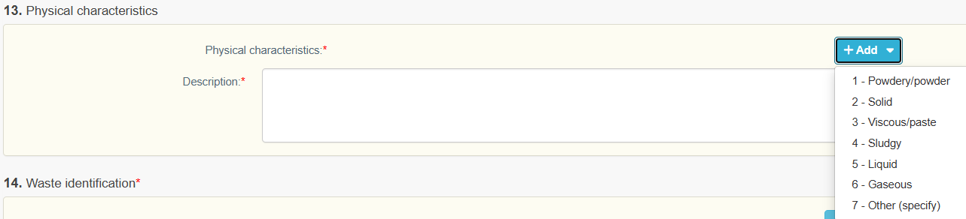
- Box 14. “Waste identification”: in this box, the user should identify the waste to be shipped under the notification.
To facilitate the selection of relevant waste codes, DIWASS incorporates the list of codes, so that the user can select them from the drop-down menu. DIWASS provides also a separate selection for “Main Waste Identification” and “Other Waste Identification”.

The “Main Waste Identification” incorporates the lists of waste codes as provided for in box 14 of the notification document, notably:
- Basel Annex VIII (or IX if applicable),
- OECD,
- EU list of waste,
- National code in country of export,
- National code in country of import,
- Other,
- Y-code,
- H-code,
- UN class,
- UN Number,
- UN Shipping name.

The user needs to click on “+ Add Main Identification” to select the type of waste identification list. The user should select the respective list by clicking on it. The user may choose one or more waste identification lists. If more than one waste code is present, click “+ Add Main Identification” the needed number of times.
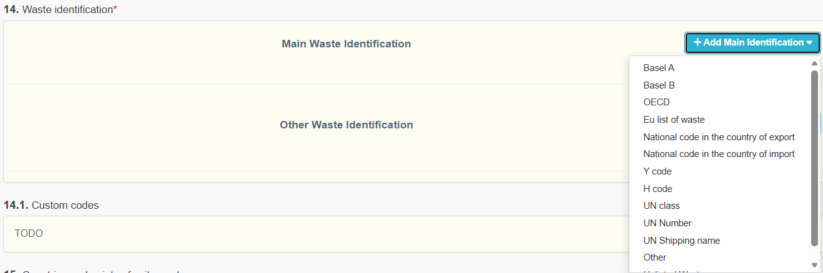
Once the type(s) of waste identification code are selected, the user can select the specific type of waste by clicking “+ Waste code”.
The drop-down list is available for the following waste codes: Basel, OECD, EU list of waste, Y code, H code, and UN class.
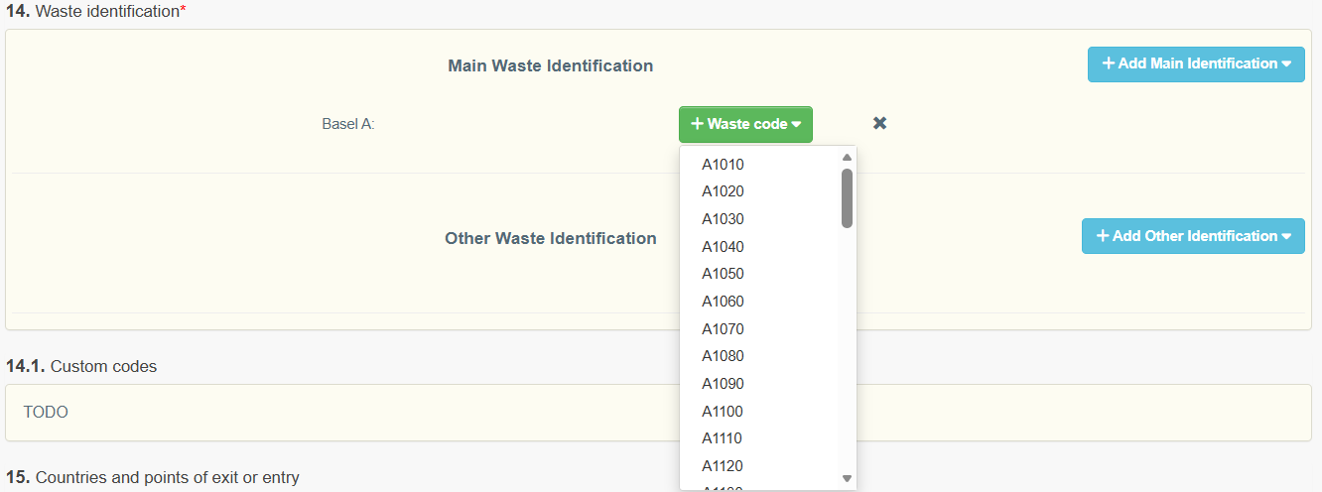
Please note that, for other of the available lists (National code in the country of import, National code in the country of export, UN Number, and UN shipping name, Other and Unlisted waste), the user will be able to insert a code in the free text box.

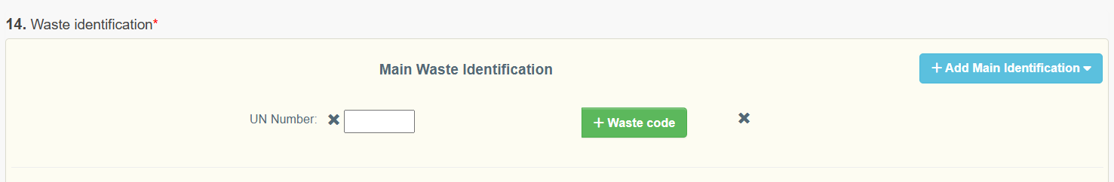

The “Other Waste Identification” allows the user to provide codes from the drop-down menu from other lists than indicated explicitly in box 14 of notification document.
If the user selects “+ Add Other Identification”, a drop-down menu will appear, showing:
- WSR Annex III,
- WSR Annex IIIA,
- WSR Annex IIIB,
- WSR Annex IV and
- HP codes.
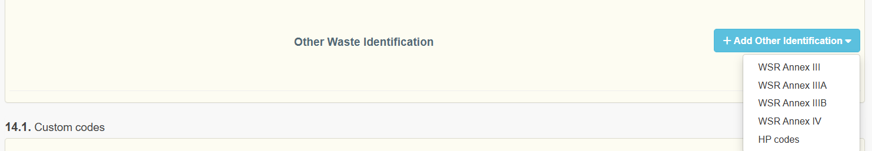

Once the type(s) of waste identification code are selected, the user can select the specific type of waste by clicking “+ Waste code”.
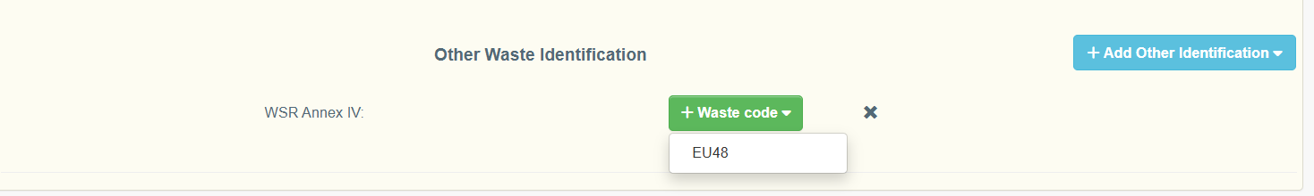

- Box 14.1 “Customs codes”: The user should click on the green button “+ Add custom code”. Then, a pop-out window will be displayed where customs codes are grouped. The user needs to select the relevant code from these lists.

- Box 15. “Countries and points of exit and entry”: The user should indicate the name of the border crossing or port as the point of entry to or exit from a particular country of dispatch and destination. For transit countries, the user should provide points of entry and exit.
This information should be provided by filling in the free text boxes in column “specific points of exit or entry (border crossing or port)”.
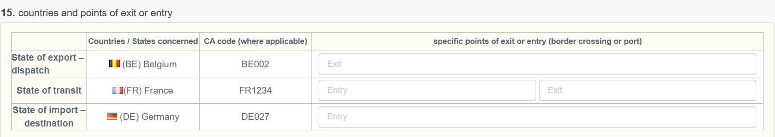

- Box 16. “Customs offices of entry and/or exit and/or export (European Union)”: For notifications involving a “third country element”, i.e. covering:
- Export of waste from the EU/EEA Member States,
- Import of waste from the EU/EEA Member States,
- Transit of waste through the EU/EEA from and to third countries,
- Shipment of waste between EU/EEA Member States with transit via third countries,
The user should also indicate names of customs offices of entry and/or exit and/or export by filling in the free text boxes.
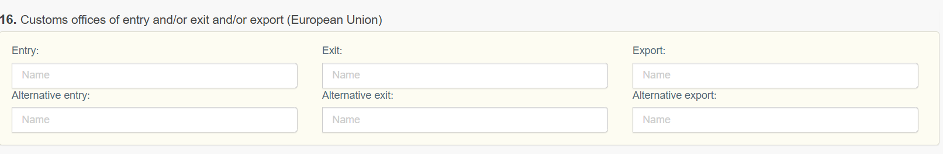
- Adding attachments: To add attachments, the user needs to click “+ Add attachment”.
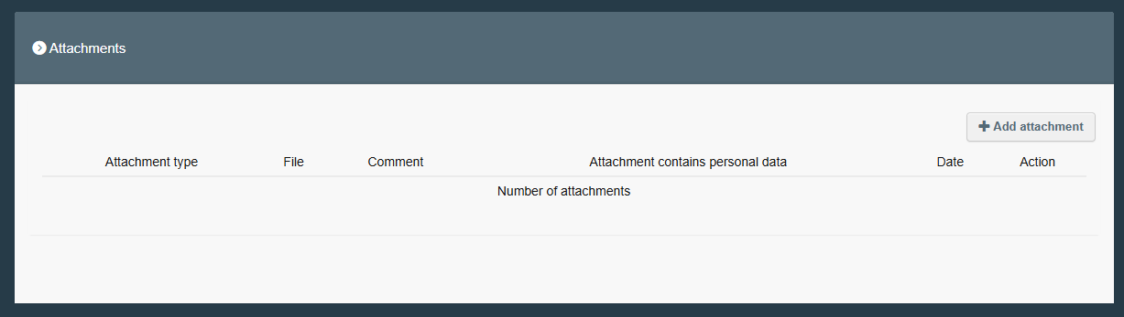
In the pop-up window, the user should choose the attachment type by selecting one of the attachment labels from the drop-down list.
The user will be able to add a file upon clicking on the grey field “Select file”.
The user will be asked to indicate, if the attachment contains personal data. To confirm adding of attachment to the draft notification, the user needs to click on “Add”.
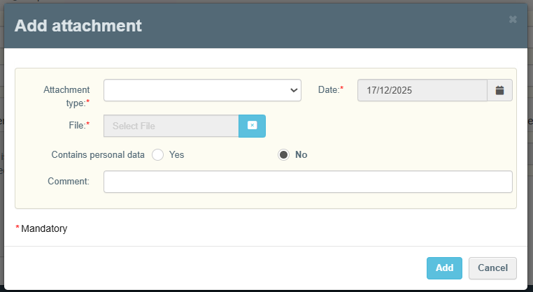

Please note that in the attachments will be visible for: all competent authorities and all operators selected for a given notification, except for carriers.
Carriers will be granted access only to the attachments with the following labels:
- Decision,
- Handling Requirements,
- Intended Route and Alternative Route,
- Composition of waste,
It is therefore important for the notifier to correctly indicate the label describing the content of the attached document,
Carriers will get such access as soon as the notification is consented to by all CAs.

- When the user has provided all the required information, it may authenticate the notification document before submission. This authentication process in DIWASS is an equivalent of signing the documents.
The authentication needs to be performed by the notifier, as well as all the waste producers listed in box 9 of the notification document.

Please note that the waste producers will not be able to edit the notification document. They will be able only to read and authenticate the document. Please also note that the waste producers should authenticate the last version of the notification document. Therefore, in case the notifier decides to change the draft notification document after the waste producer authenticated it, the waste producer would need to re-authenticate the draft notification document in order to allow for its submission.

In order to authenticate the notification document, the notifier needs to click on the button “Authenticate” at the bottom of the screen.
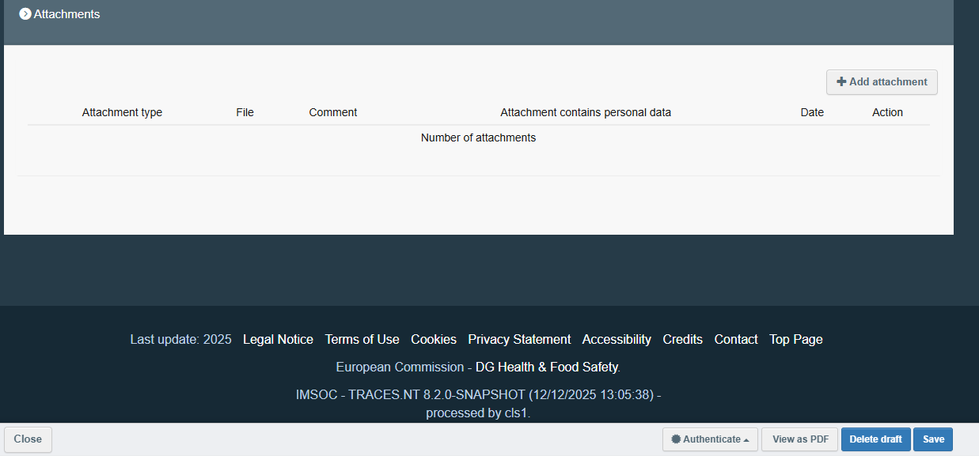
In the pop-up window, the user should indicate what is the role they perform in the organisation of the operator (e.g. proxy, member of the board, president etc.). Then, the user should click on “Confirm”.
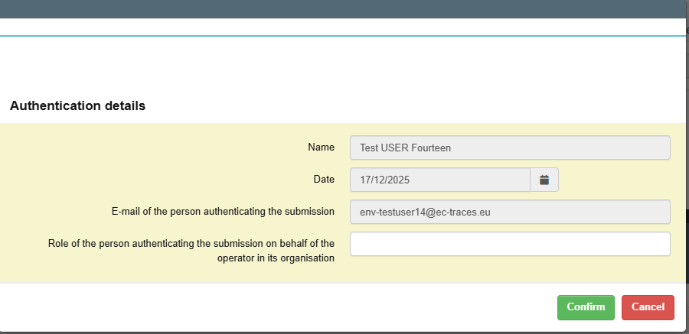
The information on which operators authenticated the notification and when will be displayed in box 17 of the notification document.
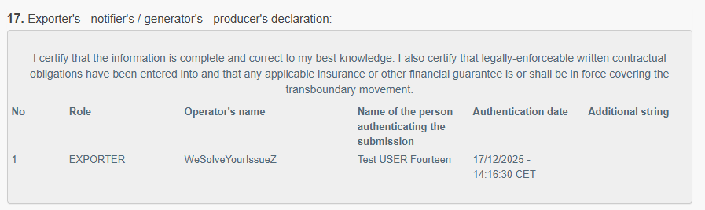
- When all the required authentications are performed, the user will be able to submit the notification by clicking on button “Submit” on the right bottom corner of the page.
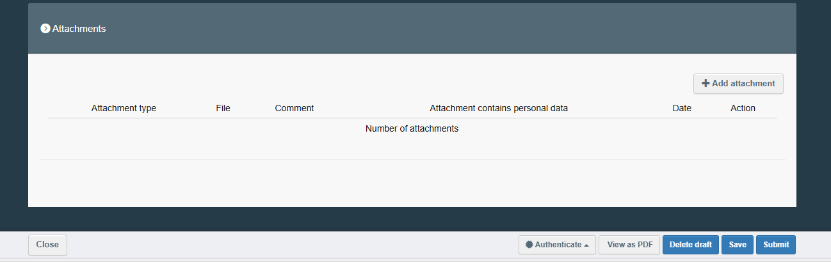

Please note that, as soon as the notification document is submitted:
- The user can no longer edit the notification.
- The notification is automatically sent to CAs indicated by the notifier, that will be able to start resolving the notification.
The user will be able to edit the notification in case one of the CAs provides a request for additional information. Please see further information on that possibility in Chapter 4 Replying to requests for additional information.

- After the notification document is submitted, the notification screen contains three tabs:
  - Dashboard: summing up the developments for this notification.
  - Notification: containing all the details of the notification document.
  - Request for information: indicating all the requests for additional information provided by the CAs and whether they were replied to.

By clicking “Print” in the bottom right corner, the user can see and download a pdf version of the newly created notification.
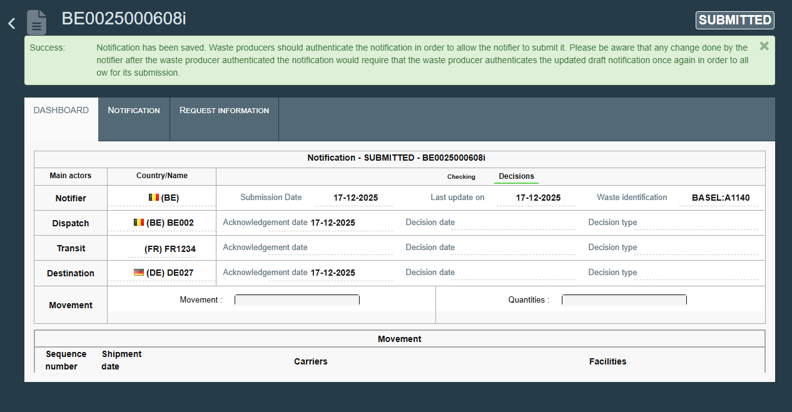

Chapter 2 Reviewing the notification

General note
This chapter provides general instructions on reviewing the notification by operators. Please note that:
- The notifier and waste producers listed in the notification can see the notification as soon as draft notification is saved in DIWASS.
- Consignees and facilities listed in the notification, as well as CAs, will see the notification as soon as it is submitted.
- Carriers will see the notification document only when all CAs provide their consents.
The operators involved in the notification (except for carriers) will be able to monitor the progress related to the review of the notification by the CAs – after following the steps described in specific instructions. Please also note that notification document will be assigned with a specific status – see the table below describing such statuses.

Please also note that if, after reviewing a notification, the CA determines that it is not the appropriate competent authority to issue a decision – because the notifier has incorrectly selected it and another authority is in fact responsible – DIWASS does not allow the CA to transfer the notification to the correct authority. In such case, the CA can:
- Either contact the notifier outside DIWASS and inform them that the CA is not competent to assess the notification, indicate the appropriate CA where possible, and request that they cancel the current notification and submit a new one with the correct information, or
- Consider the notification invalid , and indicate to the notifier, outside DIWASS, the relevant CA for a given notification. The notifier will need to resubmit the notification, including the details of relevant CAs.
Please also note that DIWASS will display timelines for certain actions, as provided for in the WSR, but it will not block the possibility to perform the action in case the deadline is not complied with.
Please also see the general information on the statutes of notification document in the table below.

Table 1. Statuses of notification document in DIWASS
Status | When does the status start? | When does the status end? | Basic consequences of the status
DRAFT | Notifier saves a draft | Notifier submits the notification | Only notifier and waste producers listed in the notification can see the notification  Notifier can update the notification until it is submitted
DELETED | Notifier deletes the draft notification | Not applicable | Notification is deleted and cannot be further changed or submitted
SUBMITTED | Notifier submits the notification  (when data required in the notification document is inserted into the draft and draft is authenticated by notifier and all waste producers) | - Any of the indicated CAs invalidates the notification, or  - Notifier cancels the notification, or  - CA of dispatch considers notification properly carried out and all CAs of transit and CA of destination considered it properly completed | - All CAs indicated in the notification can see the document and start the review process (they can ask for additional information, consider it properly carried out, properly completed or invalid, as applicable)  - Notifier cannot change the document (except for when there is an unanswered request for additional information)  - Operators indicated in the notification can see the notification (except for carriers)  - Notifier can cancel the notification
INVALID | Any CA listed in the notification clicks on “invalidate” | CA that invalidated the notification revalidates it | - Notifier cannot change anything in the notification  - All the CAs can see the notification, but the only action allowed at this stage will be the revalidation of the notification by the CA that invalidated it
SATISFIED | - CA dispatch considered it properly carried out and  - all CAs of transit and CA of destination considered it properly completed | - All CAs provide a decision, or  - Notifier cancels the notification | - Notifier cannot change anything in the notification, but can cancel it  - CAs cannot request additional information or invalidate the notification  - CAs can provide a decision on this notification
CANCELLED | Notifier clicks on “cancel notification”. This action will be possible when notification has statuses: submitted, consented, objected | Not applicable | - No one can change anything in the notification  - Notification cannot be “uncancelled”  - In case notification was consented:  - it will not be possible to submit new movement documents under given notification.  - it will be possible to complete movement documents that were already submitted
CONSENTED | all CAs consented to the notification (irrespective of validity period of each consent) | - any of the CAs updates its decision to “objection” or “withdraws the consent”, or  - notifier cancels the notification  - notifier marks the notification as completed | - notifier can submit movement documents (but only when all required consents are valid)  - notifier cannot change the notification, but can request changes in line with Article 17 WSR  - notifier can cancel notification  - any of the CAs can update their decisions and reply to notifier’s request for changes in the notification in line with Article 17 WSR
OBJECTED | at least one of the CAs objected to the notification (also through updating initial consent) | - any of the CAs issues or updates its decision to “objection” | - notifier cannot submit new movement documents  - respective boxes in movement documents that have been already submitted by the notifier can be updated by operators listed in the movement documents (carriers, consignee, facility)  - notifier can cancel notification
WITHDRAWN | at least one of the CAs withdrew the consent | The CA that withdrew the consent updates the decision to “Consent” | - notifier cannot submit new movement documents  - respective boxes in movement documents that have been already submitted by the notifier can be updated by operators listed in the movement documents (carriers, consignee, facility)  - notifier can cancel notification
COMPLETED | Notifier may mark notification as completed when:  - All the movement documents generated based on a notification have been completed by all relevant operators,  - There will be no more new movement documents submitted under the notification | Not applicable | No actions concerning notification (and movement documents based on it) can be performed.

Specific instructions
- Following the login, the user needs to select the fields “Documents” and the “DIWASS Notification procedure”.
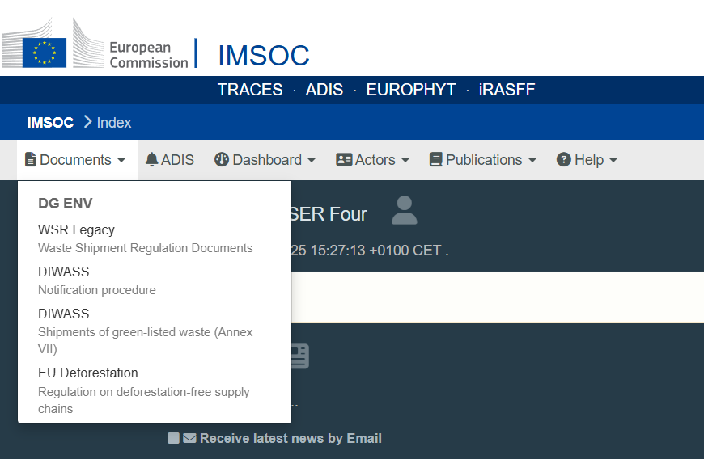
- Then, the user will see a list of all notification documents that were submitted in DIWASS, in which the operator it represents is involved. The user needs to select a notification document, in relation to which the user intends to submit a request for additional information.
[Please note that the Commission works on improving the readability of this screen, i.e. providing information on notifier, destination facility and type of waste concerned by notification.]
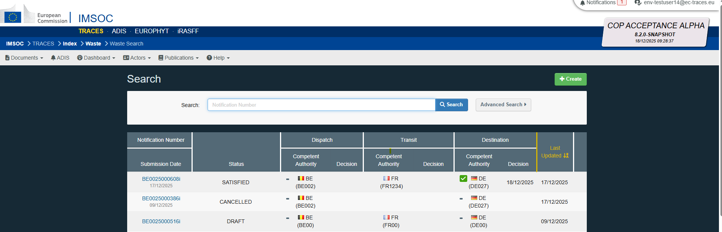
- Following the selection of a given notification document, the user will see a notification screen containing three tabs:
  - Dashboard: summing up the developments for this notification.
  - Notification: containing all the details of the notification document.
  - Request information: indicating all the requests for additional information provided by the CAs and replies of the notifier.

As soon as the notification is consented to by all relevant CAs, 4 additional tabs will appear:
  - Request change: the notifier will be able to request changes of such notification document (Article 17 of the WSR) in this tab and CAs will be able to react to such requests (for details please refer to Chapter 6 Submitting the request for change of notification after consent (Art. 17 WSR))
  - Movement: allowing to generate and complete movement documents under this notification (for details please refer to Chapters 7 – 11 of this document)
  - Certificate under Article 15(5)WSR: in case the shipment is destined to an interim waste treatment facility, and shipped waste will be subsequently treated by interim or non-interim facility located in the same country, as country of destination, DIWASS will allow for providing certificates confirming treatment of waste conducted by such facilities.
  - Facility name - confidential - Art 21 WSR: Article 21 of the WSR obligates the Commission to publish information on shipments of waste, on a monthly basis, in line with template set out in Annex XII to that Regulation. That Annex contains two tables – Table 1 concerns data on notified waste. Footnote 6 to that table specifies the following: "The name of the facility shall be published, unless one of the competent authorities involved in the procedure of prior written notification and consent considers that this name is confidential and therefore shall not be disclosed, in accordance with Union or national law. The competent authority shall provide this information in the systems or software as referred to in Article 27." This tab allows any of the CAs involved in the notification to indicate that name of the waste receiving facility is confidential and shall not be published by the Commission in the overview on shipments of waste. The operators have only a reader access to this tab.

Please note that DIWASS does not provide a specific functionality for the notifier or waste receiving facility to ask the CAs involved in the notification to consider the name of the waste receiving facility as confidential. Such request should be included in the attachments to the notification document.

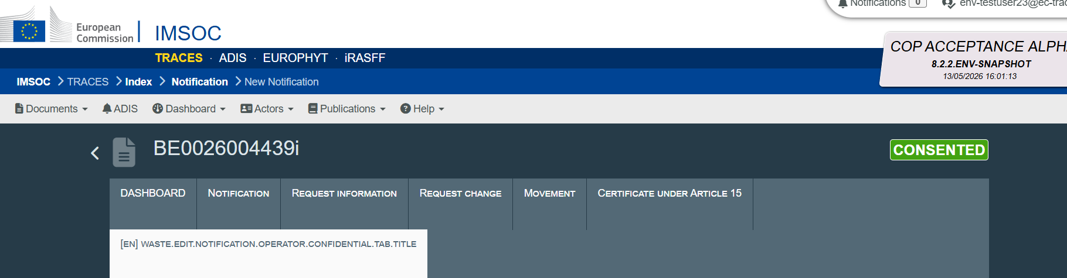
- If the user would like to check, whether the CAs considered the notification properly carried out / properly completed, the user should click on “Checking” in the tab called “Dashboard”.
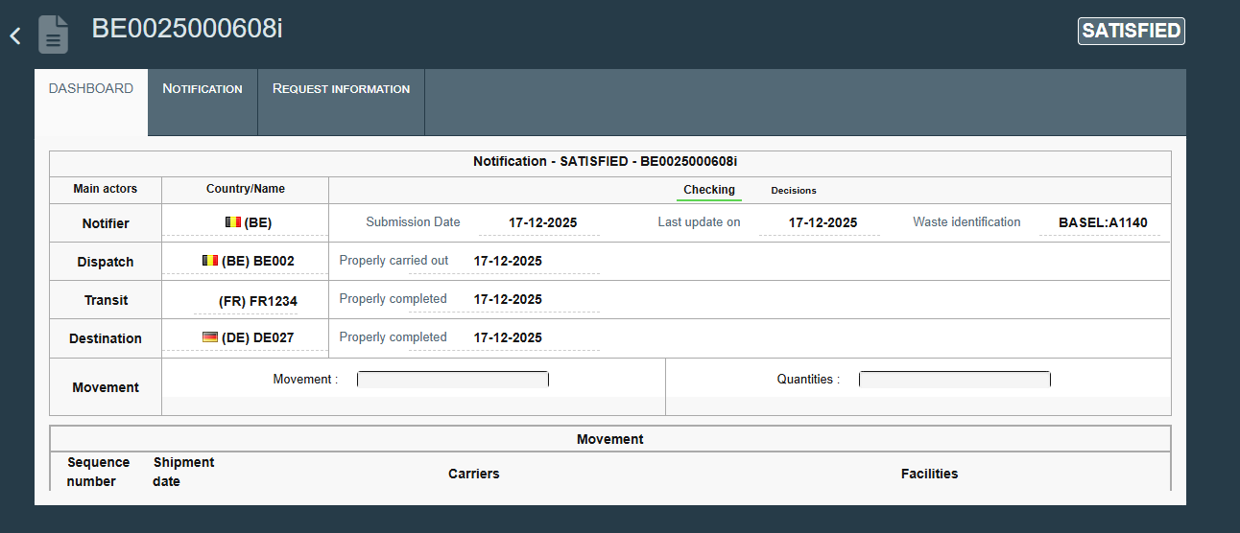
- If the user would like to see whether the decision was issued by any of the involved CAs, the user should click on “Decisions” in the tab called “Dashboard”.
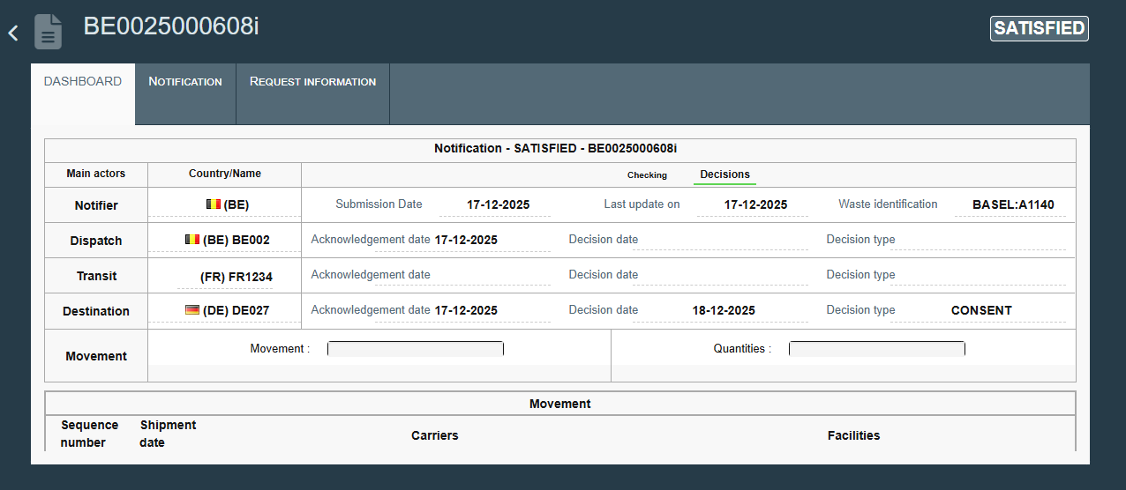
To see the details of the decision, the user needs to click on tab called “Notification” and scroll down to box 20.
To review the content of the decision, the user needs to click on the icon in the column “Actions”.
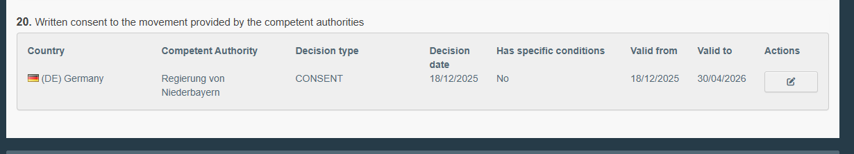
The user will see a pop-up window indicating first the type of the decision. Following the review, the user should click on “Next” to see details of decision.
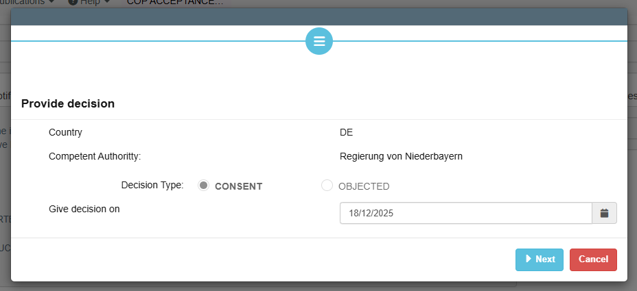
Following this review, the user may either click on “Next”, to see the details on the user who authenticated the decision, or click on “Cancel” to close this view.
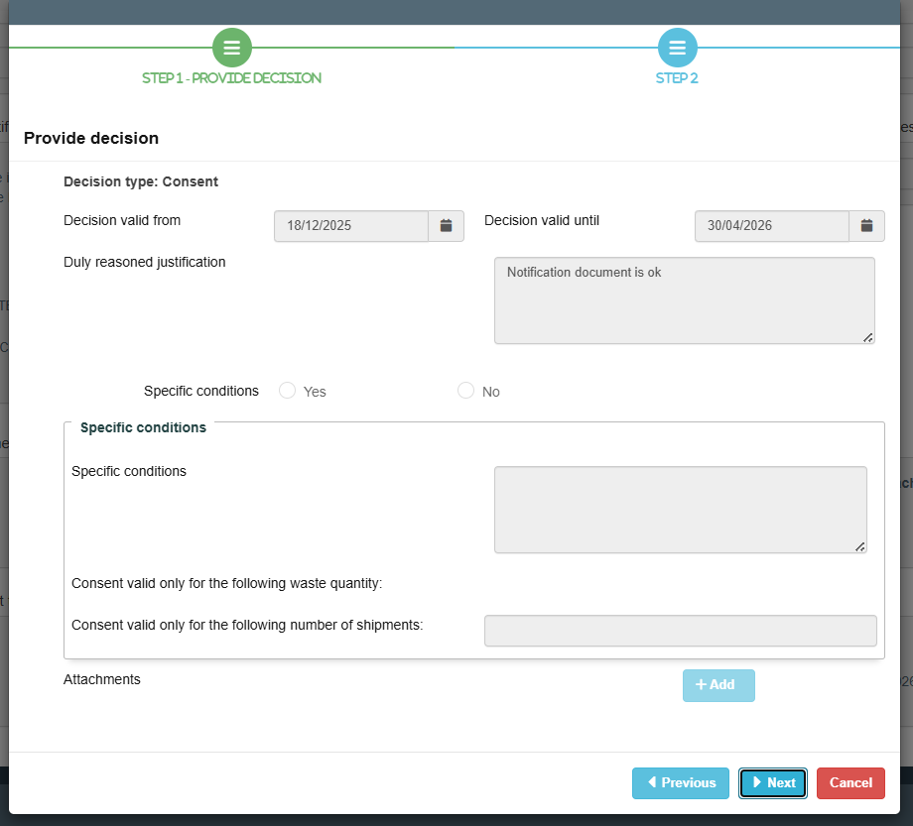
By clicking “Print” in the bottom right corner, the user can see and download a pdf version of the notification.

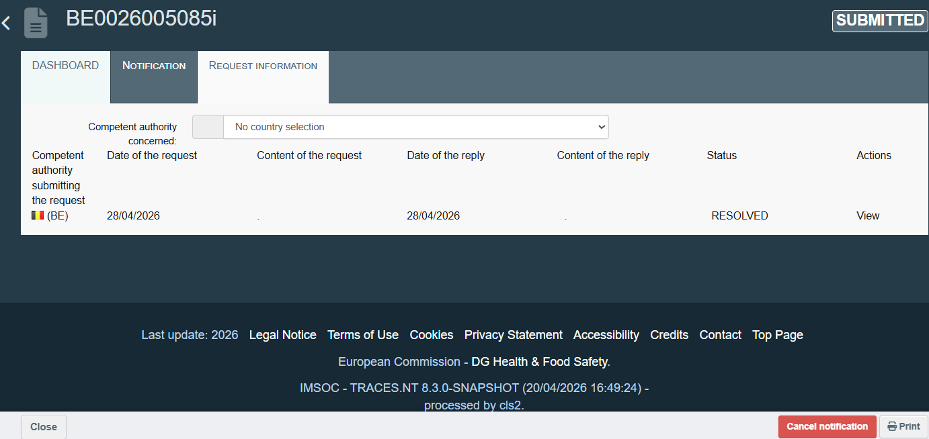

Chapter 3 How a waste producer should authenticate the notification

General note
This chapter provides general instructions on how a waste producer should authenticate the notification. Please note that:
- Authentication process in DIWASS is an equivalent of signing the documents.
- In order to submit a notification document, it needs to be authenticated by all the waste producers listed in box 9 of the notification document.
- In case the notifier changes anything in the notification document after it was authenticated by the waste producer, the waste producer needs to re-authenticate any changes made in the notification document, as DIWASS removes the former authentication of the waste producer.
DIWASS requires this re-authentication, to ensure that the waste producer is aware and agrees to the shipment of waste and its treatment as described in the final draft of the notification.

Specific instructions
- Following the login and selecting the relevant notification document from the list of all notification documents involving the operator, the user should review the notification. Following that, the user should click “Authenticate” at the bottom of the screen.
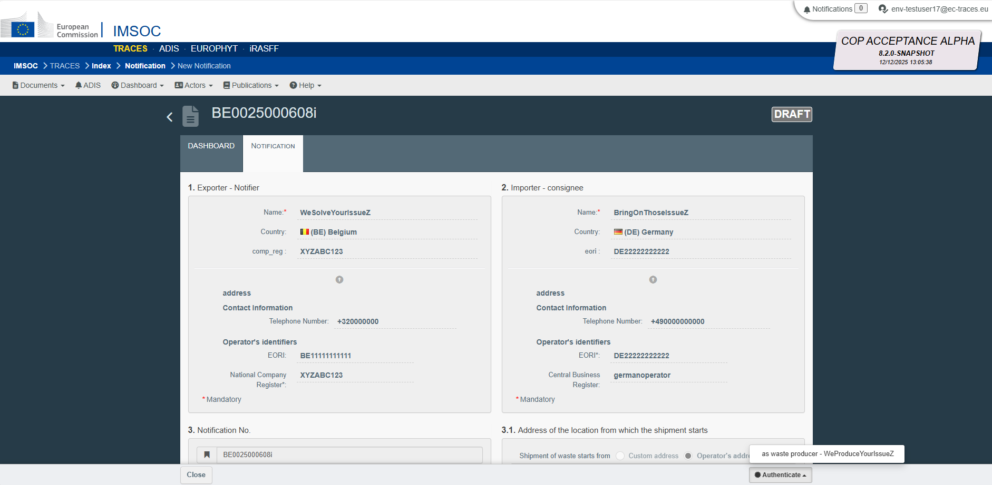
- In the pop-up window, the user should indicate what is the role they perform in the organisation of the operator (e.g. proxy, member of the board, president etc.). Then the user should click on “Confirm”.
The information on which operators authenticated the notification and when will be displayed in box 17 of the notification document.
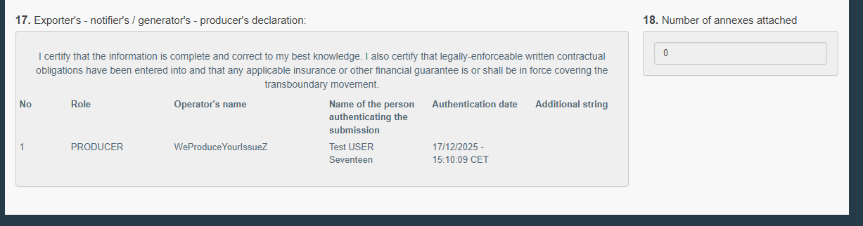
By clicking “Print” in the bottom right corner, the user can see and download a pdf version of the notification.
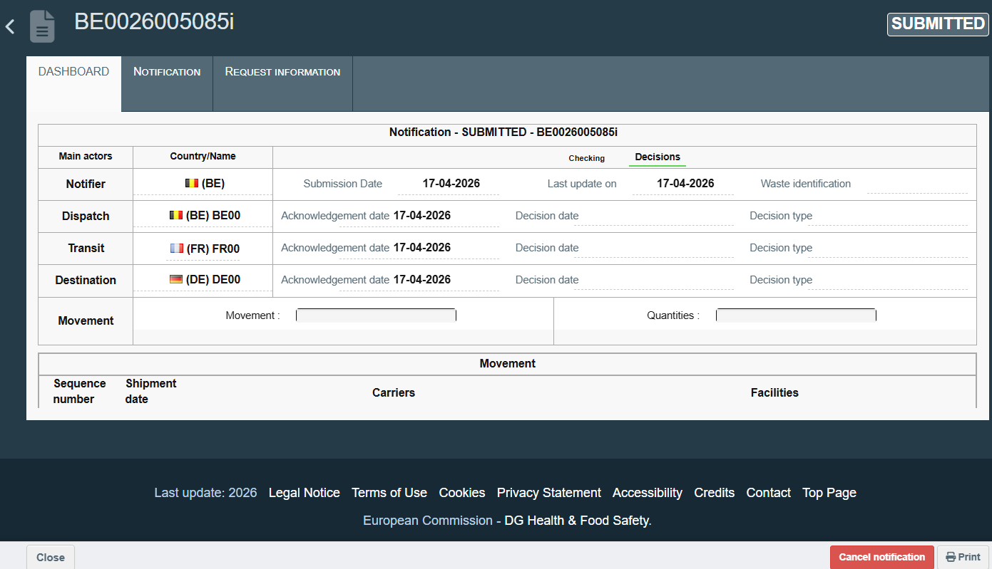

Chapter 4 Replying to requests for additional information

General note
This chapter provides instructions on replying to a request for additional information submitted by the CA. To be able to submit a such a reply, it is necessary that:
- The notification document is submitted in DIWASS.
- The CA submitted a request for additional information in DIWASS.
Please also note that, in accordance with Article 8 of the WSR:
- As soon as notification document is submitted, only the CA of dispatch can submit a request for additional information.
- Only after the CA of dispatch considers that the notification is properly carried out, the CAs of transit (if any) and destination may submit a request for additional information.
- The expiry of the deadline to submit such a request does not deprive the CA of the right to submit a request for additional information.
- The expiry of the deadline to submit a reply to a request for additional information does not deprive the notifier of the right to submit a reply for such a request.
- The CA may submit three requests for additional information per notification document. DIWASS will not allow to submit more such requests.
Please also note that:
- The notifier will be able to edit the notification as soon as the request for additional information was submitted by any CA.
- The possibility to edit a notification will be closed as soon as the notifier provides a reply for request for additional information.
- The notifier will be able to edit all elements of the notification, except for countries and CAs concerned, and the data of notifier.
- Requests for additional information and notifier’s replies will be visible for all the CAs and all operators involved in notification, with the only exception of carriers.
Please note, as well, that the CA may update the request for additional information by changing the “content of the request” or adding an attachment. Such update does not impact the time in which the notifier should reply for such request. Therefore, the CAs should not use this functionality to add additional elements on the substance of the request (but only to extend the time of the reply, or correct typos).

Specific instructions
- Following the login and selecting the relevant notification document, the user needs to choose the “Request information” tab. In the top right corner of the website, the user will see the status of the document and a deadline to perform a specific action.

- Then, the user will see pending request for information. The user needs to click on “Reply”, next to the request for information it intends to review and provide answer to.
Please also note that if any of the CAs submitted a request for additional information, the notifier will be able to edit the notification document until it provides a reply to all pending requests.

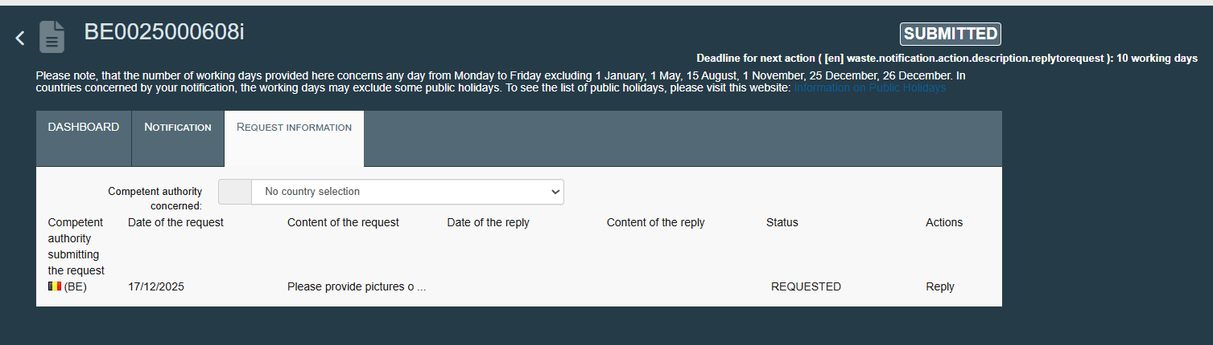
- Then, in the pop-up window, the user will see the content of the request. The user can provide a reply by filling in the respective “Content of the reply” free text field. The user can also add an attachment by clicking on “+ Add”. The user should also indicate the date of reply. Then, the user should click on “Next”.
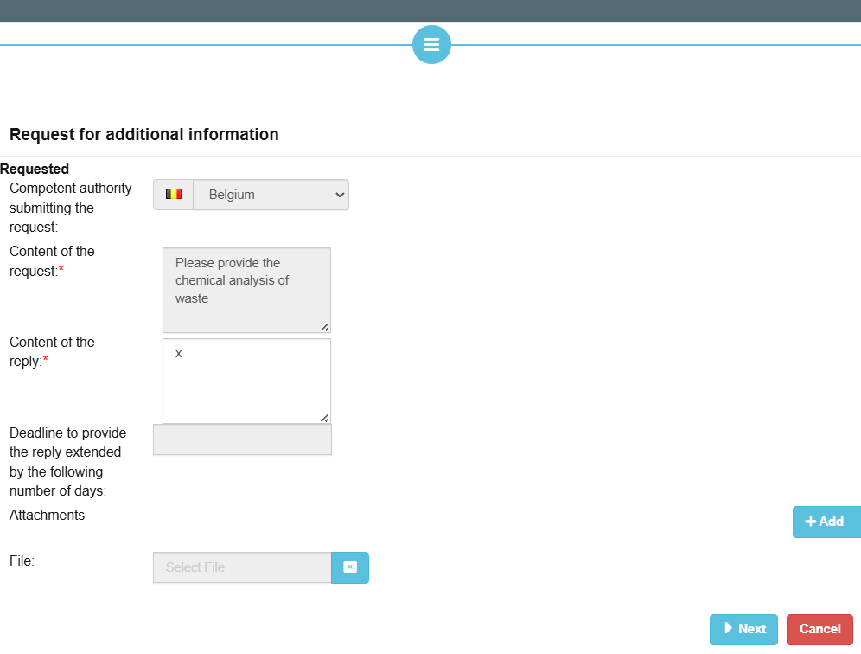
- Then, the user should indicate what is the role they perform in the organisation of the operator (e.g. proxy, member of the board, president etc.). Then the user should click on “Confirm”.
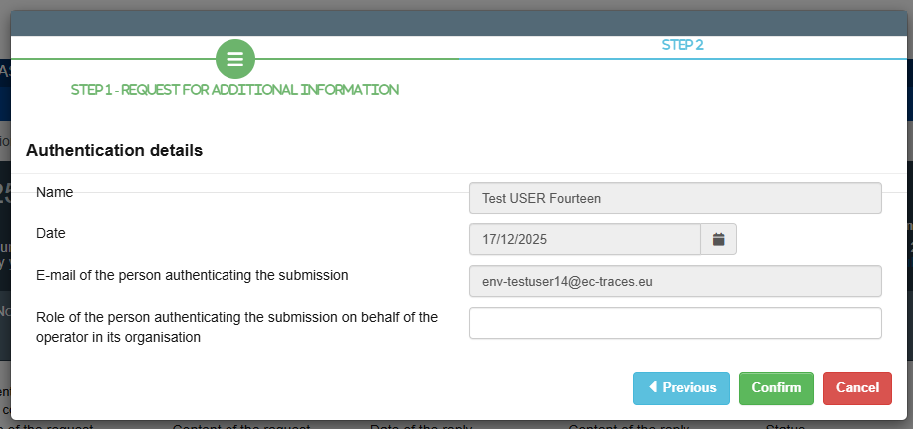
- Following that, the status of the request will be updated to “Resolved”.
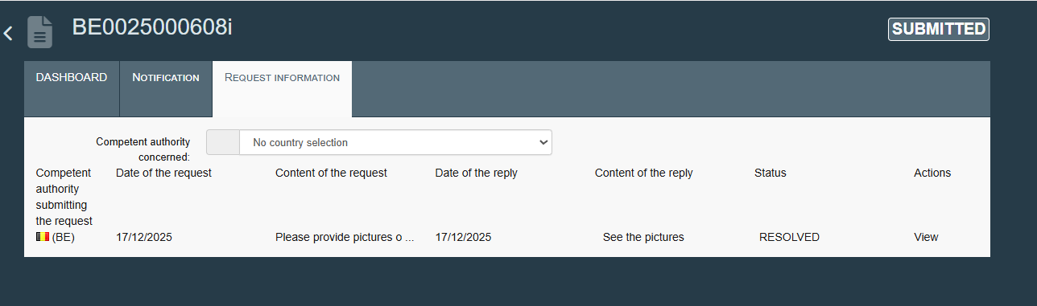

Chapter 5 Cancelling the notification

General note
This chapter provides instructions on cancelling the notification. Notifier may cancel the notification from the moment it was submitted, until the notifier considers the notification completed (see instructions on that in Chapter XXX of this document) [Chapter will be added].
Please note that cancelling the notification cannot be reversed.
When the notification is cancelled:
- No new movement documents can be generated,
- It will be possible for respective carriers, consignee and facility to complete movement documents that were already submitted.

Specific instructions
- Following the login and selecting the relevant notification document, the user needs to click on the red button “Cancel notification” at the bottom of the page.
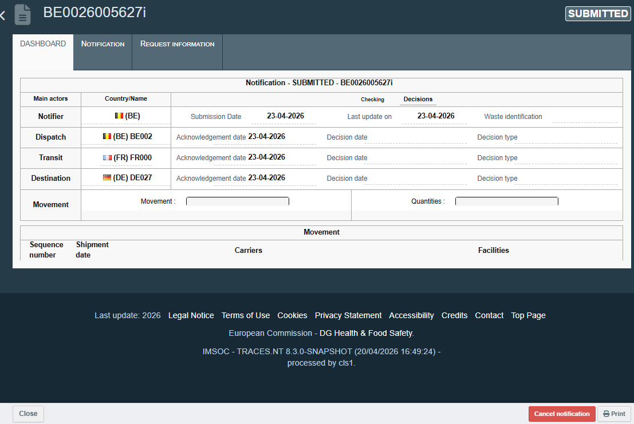

- Then, in the pop-up window the user may provide reasons for cancellation or add attachment by clicking on “+ Add”. The confirm cancellation of notification, the user needs to click on “Confirm”.
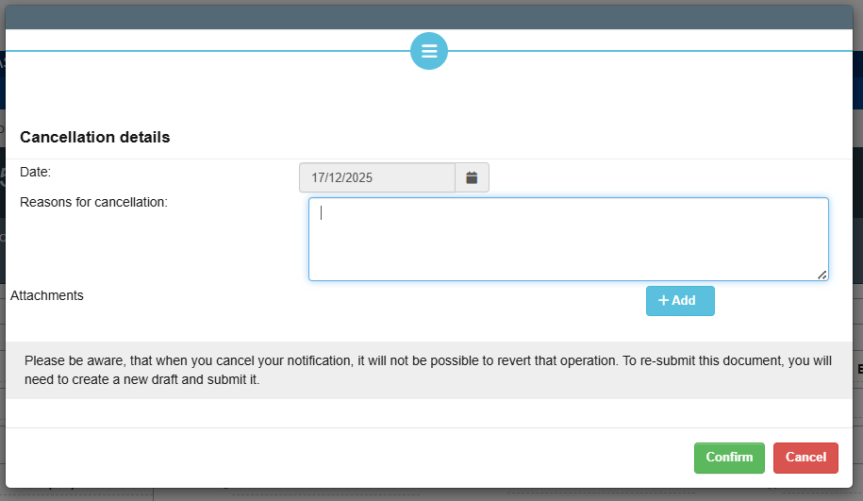
- Following that, notification will have status “Cancelled”. By clicking “Print” in the bottom right corner, the user can see and download a pdf version of the cancelled notification.
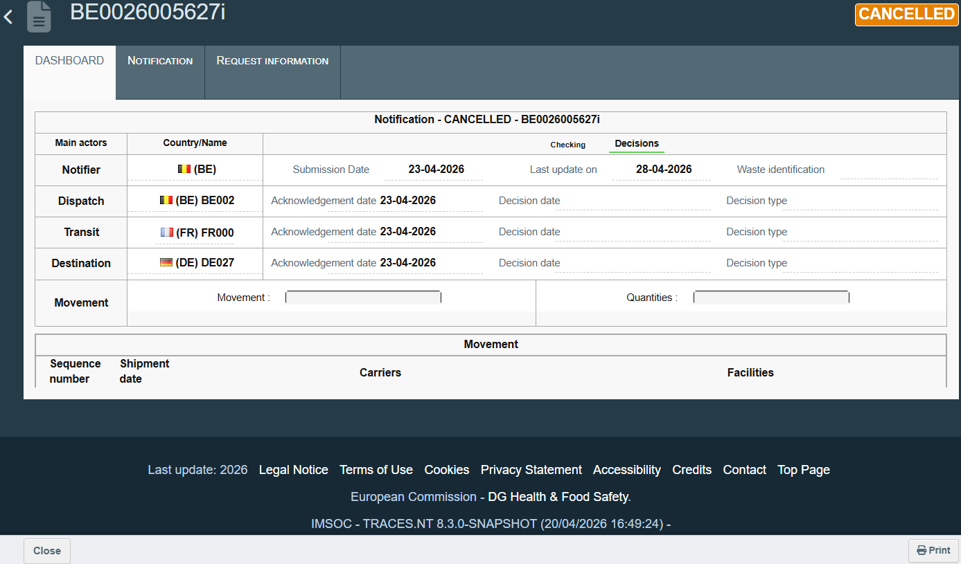

Chapter 6 Submitting the request for change of notification after consent (Art. 17 WSR)

General note
This chapter provides instructions on how the notifier can request changes in the notification document after it has been consented to, according to Article 17 of the WSR.
As certain data from the consented notification is copied into a movement document, as explained in Chapter 7 How to submit a movement document, the notifier will not be able to change it at the level of that document. To do such a change, e.g. to add an additional carrier, the notifier needs to request for introducing a change to the notification,
Please note, that:
- Such request can be submitted only by the notifier;
- Such request can be submitted only when the status of the notification is “Consented”;
- Only when all the competent authorities involved in a notification approve such request in DIWASS, these competent authorities will be able to insert the actual change into the consented notification;
- Only when such change is introduced, the updated data can be used by the notifier when filling in the movement documents.
Please also note that changes introduced in result of such request cannot cover:
- Countries concerned by notification;
- Competent authorities concerned by notification;
- Notifier.

Specific instructions
- Following the login and selecting the relevant notification document, the user needs to click on tab “Request change”.
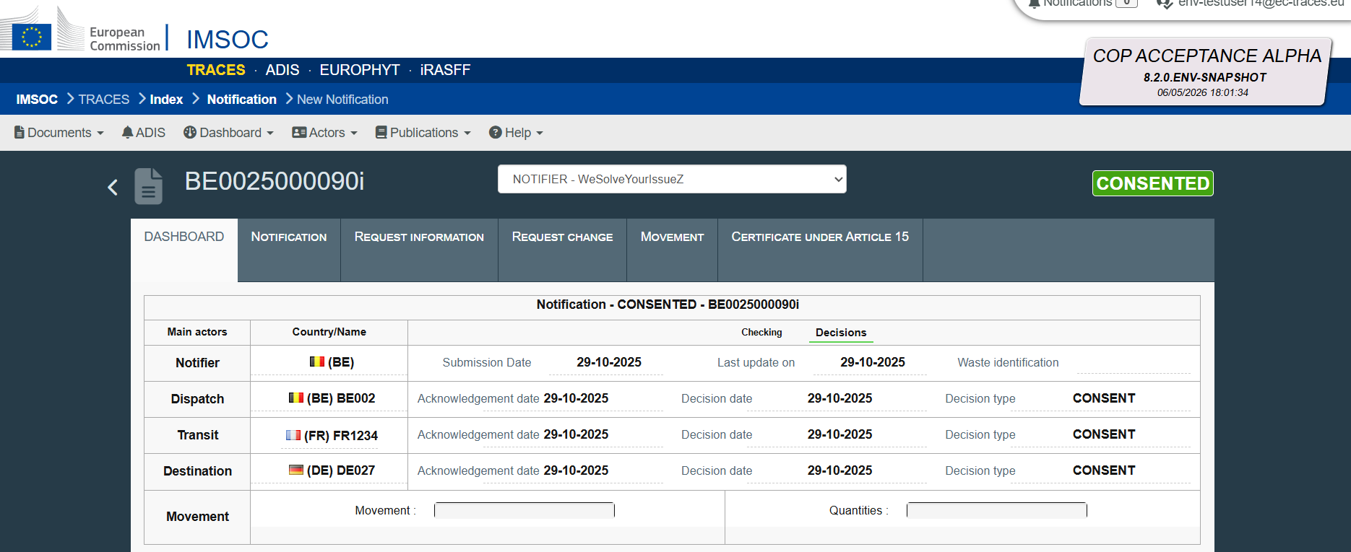
- Then, the user needs to click on the button “+ Add request change”.
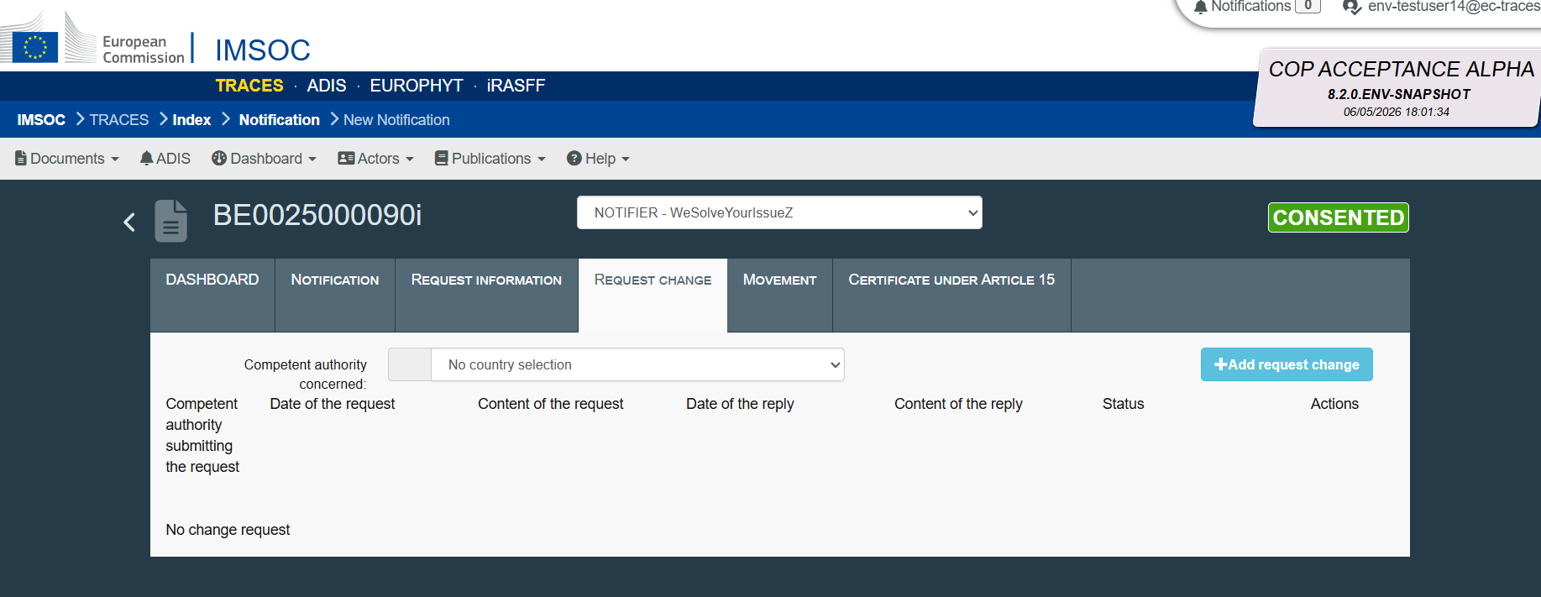
- A pop-out window will appear. The user needs to
- indicate whether the change concerns the route of the shipment, by selecting Yes or No,
- indicate the content of the request by providing text in the “Request content” field.
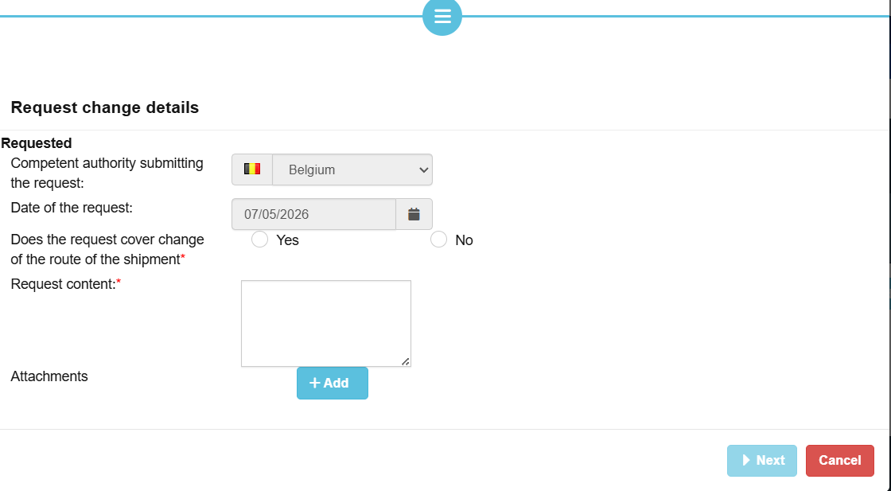
The user may also add an attachment by clicking “+ Add”. Then the user needs to click on the grey field “File” to select the relevant file.
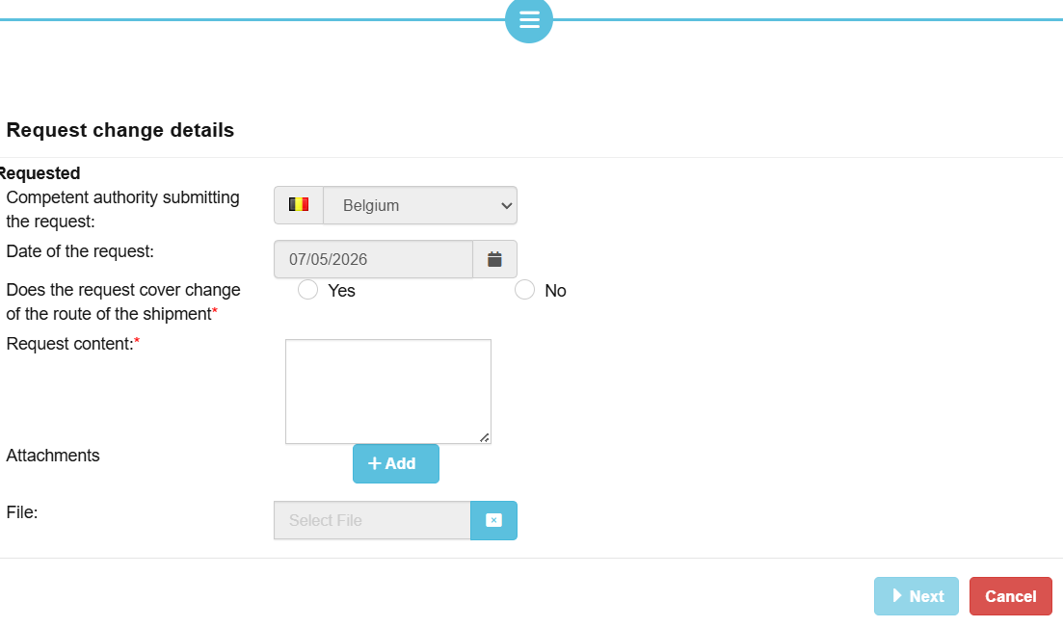
To approve the choice, the user needs to click “Next”.
- Then, the user should indicate what is the role they perform in the organisation of the operator (e.g. proxy, member of the board, president etc.). Then the user should click on “Confirm”.
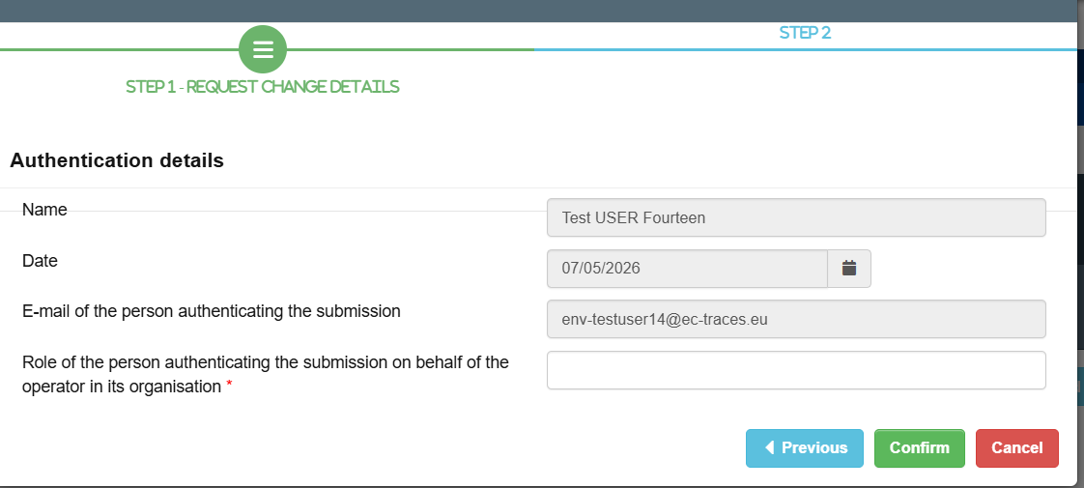
- Following that, the submitted request is visible in the “Request change” tab. There, the notifier can check if any of the CAs approved the request.
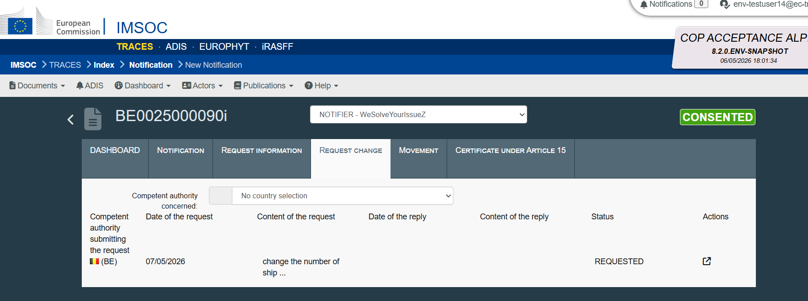

Chapter 7 How to submit a movement document

General note
This chapter provides general instructions on how a notifier should submit the movement document.
Please note that:
- In order to submit a movement document, the notification needs to be in status “Consented”.
- Only the notifier can submit a movement document.
- Movement document can be submitted 2 working days in advance of the planned shipment of waste (DIWASS will not allow to create a movement document indicating the actual date of shipment on the same date as submission date, or the next day).
- DIWASS will not require the waste producers to authenticate the movement document for its submission. Waste producers will have a read-access to the submitted movement documents.
- Movement documents cannot be generated after the consent for the shipment is revoked or expired. The movement documents submitted in the system can be however updated and relevant information can be provided there by carriers, consignee and facility.
Please note that DIWASS will copy specific information from the consented notification directly to the template of the movement document. Such information cannot be changed at the level of movement document. To change it, the notifier needs to first request the change of consented notification – for instructions on this process, please refer to Chapter 6 Submitting the request for change of notification after consent (Art. 17 WSR).
Please also note that DIWASS will restrict the following actions of notifier:
- Submitting more documents than the total intended number of shipments specified in the consented notification (including in the specific conditions provided in the decisions of CAs, if applicable);
  - Please note that the movement documents that have been cancelled by the notifier will not count towards this number.
Example: Consented notification allows for 15 shipments of waste, so DIWASS will allow to submit 15 movement documents. If the notifier cancels movement document bearing serial number 013, DIWASS will allow to generate and submit movement document with serial number 016.
- Submitting movement documents covering shipments of bigger quantity of waste than specified in the consented notification (including in the specific conditions provided in the decisions of CAs, if applicable);
  - DIWASS will compare the total quantity of waste to be shipped under a notification with the data provided by the notifier in box 5 of the movement document;
  - In case a notification concerns multiple shipments of waste (i.e. general notification), DIWASS will sum all the quantities of waste indicated by notifier in box 5 of submitted movement documents and will compare such a sum with the amount of waste indicated in the consented notification;
  - Please also note, that consignee and facilities will be allowed to provide, in their respective boxes, higher values concerning quantities of waste received than the notifier indicated in box 5. Data provided by consignee and facility in that respect will not be automatically compared by DIWASS with the quantities consented to under a notification.
Please also note that movement document will be assigned with a specific status – see the table below describing such statuses.

Table 2. Statuses of movement document in DIWASS
Status | When does the status start? | When does the status end? | Basic consequences of the status
DRAFT | Notifier saves a draft | Notifier submits the movement document | Only the notifier can see and edit the draft.
ANNOUNCED | Notifier submits the movement document | - Notifier cancels the movement document, or  - Carrier confirms the transport of waste, or  - Confirmation of receipt of waste is submitted, or  - Facility submits certificate confirming the receipt of waste, or  - CA submits the request to take the waste back. | All the CAs and waste producers indicated in the consented notification can see the movement document.  The selected operators (selected carrier, consignee and facility) can contribute to the movement document by filing in their respective boxes.  Notifier can update the movement document.
MOVING | Carrier submits the transport confirmation | - Confirmation of receipt of waste is submitted, or  - Facility submits certificate confirming the receipt of waste, or  - CA submits the request to take the waste back. | CA can submit take back request.  The selected operators (selected carrier, consignee and facility) can contribute to the movement document by filing in their respective boxes.  Notifier can no longer update the movement document.
CANCELLED | Notifier cancels the movement document | Not applicable | This movement document cannot be updated any more.  The notifier can perform this operation only when the status of movement document is “Draft” or “Announced”.
RECEIVED | Consignee / Facility provides a confirmation of receipt | - Facility submits certificate confirming the receipt of waste, or  - CA submits the request to take the waste back. | Notifier can no longer update the movement document.  CA can submit take back request.  The selected operators (selected carrier, consignee and facility) can contribute to the movement document by filing in their respective boxes.
COMPLETED | Certificate confirming completion of treatment of waste is submitted | CA submits the request to take the waste back | Notifier can no longer update the movement document.  CA can submit take back request.  No other operator can contribute to this movement document.
TAKE-BACK | CA submits a take back request | Not applicable | This request can be submitted when movement document is in statuses “Announced”, “Moving”, “Received” and “Completed”.

Specific instructions
- Following the login and selecting the relevant notification document from the list of all notification documents involving the operator, the user should click on “Movement”.
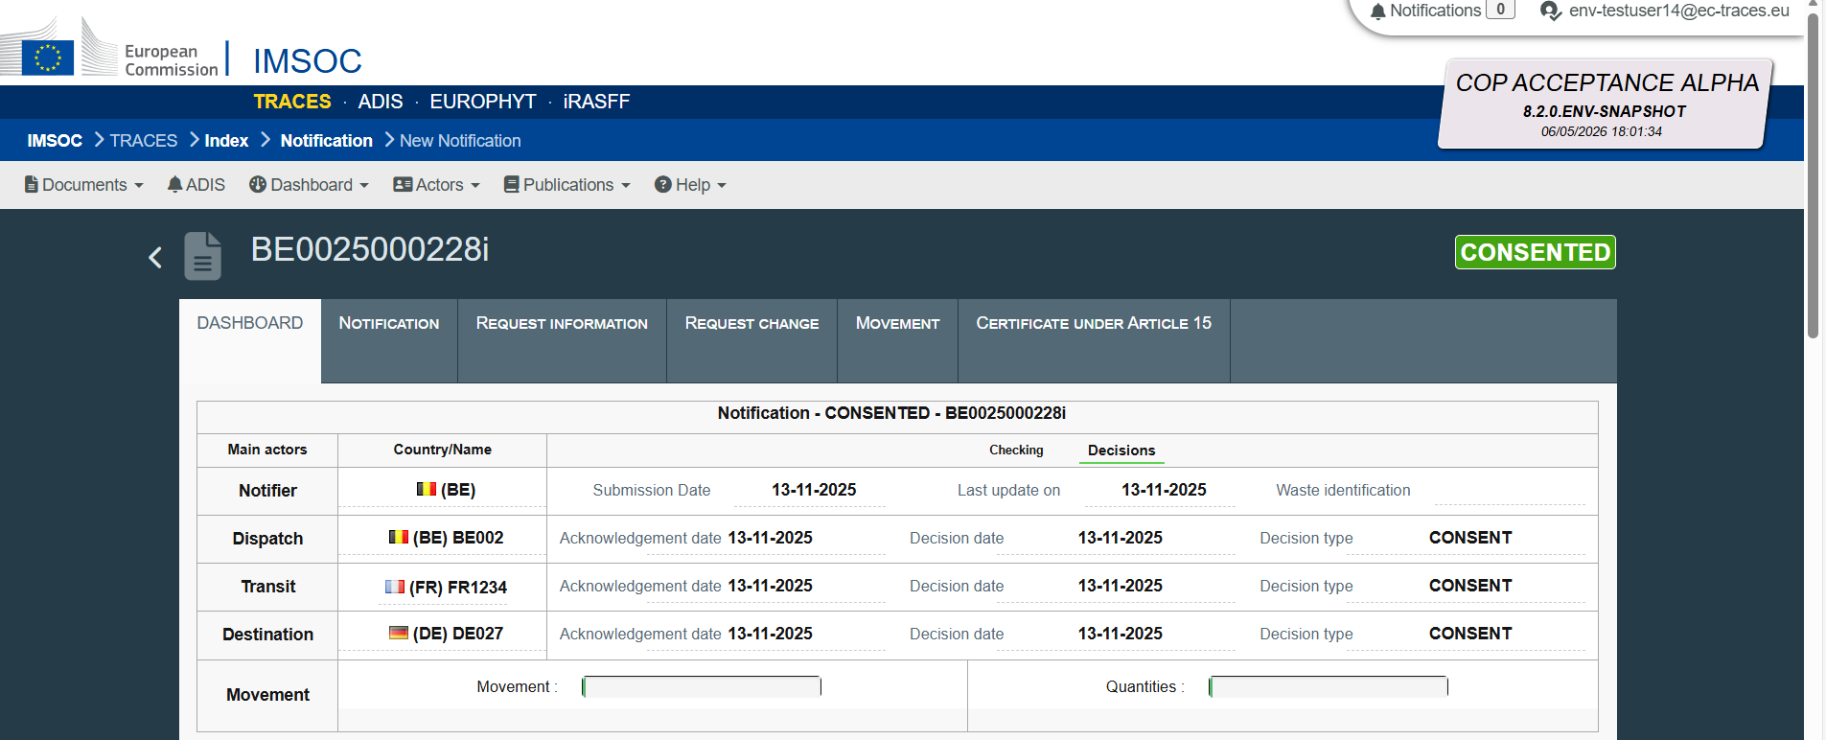

- Then, the user should click on “Create movement document”.
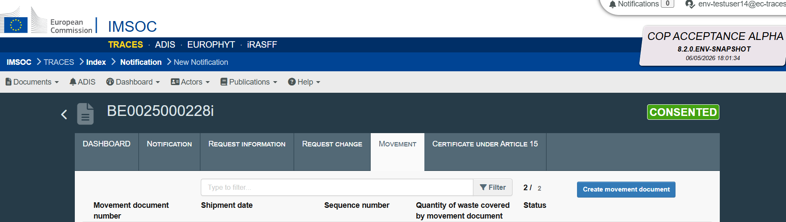
- Following that, the user will see a new template of the movement document displayed in the list of movement documents, in status “New”. To fill it in, the user needs to click in the icon next to the relevant movement document, on the right side of the screen.
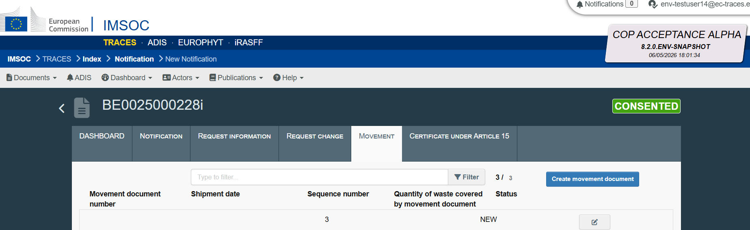

- The movement document template will open. Some fields will be already filled in, with data copied from the consented notification document. At this moment, the notifier is advised to click on “Save New”, to change the status of movement document to “Draft”.
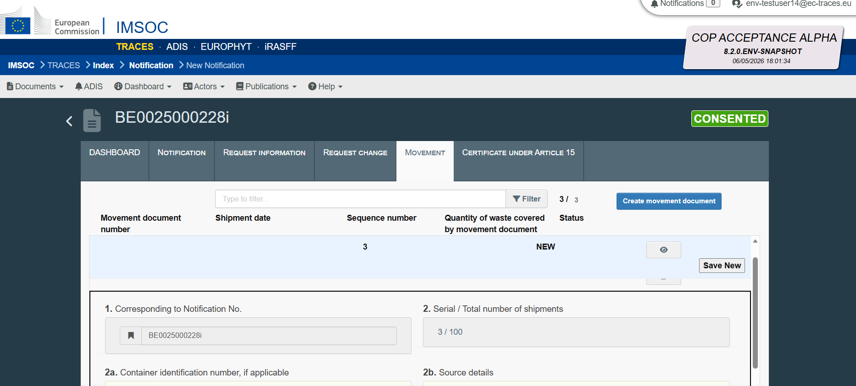
- Following this click, DIWASS will display the dashboard summarising details of the notification document. To continue working on the movement document, the user needs to click once again on tab “Movement”.

Next, the user needs to select, from the list of movement documents, the relevant draft movement document. To edit this draft, the notifier needs to click on the icon on the right side of the screen, next to the selected movement document.

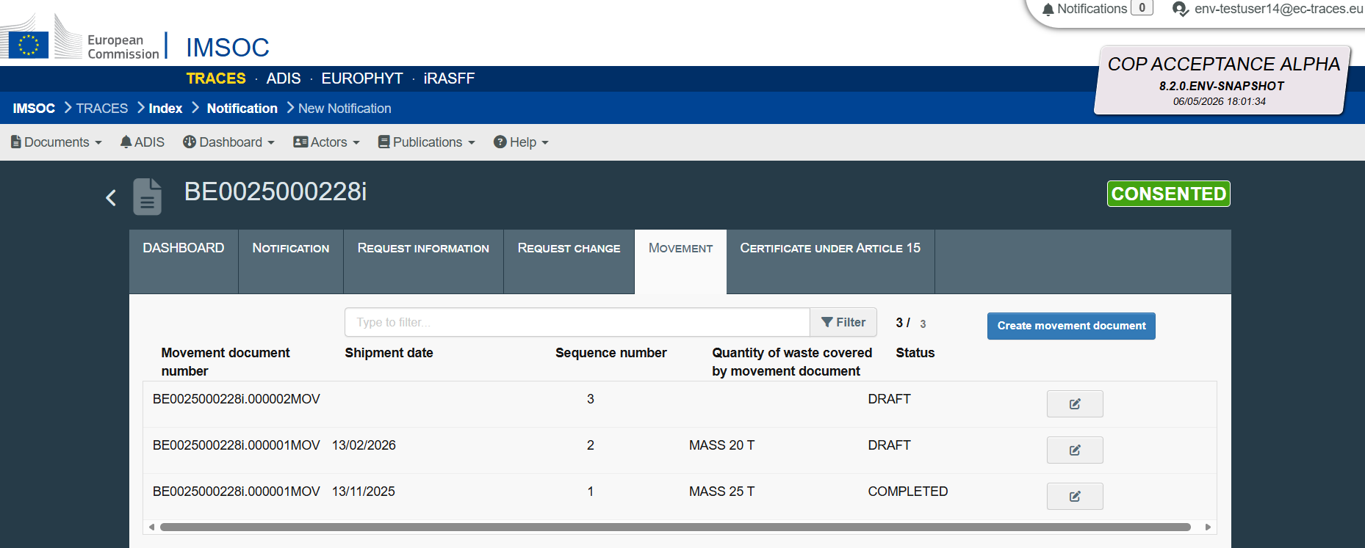

Following that, the movement document template will be opened. On top of the screen, the user will see a movement document menu, providing a possibility for the user to:
  - cancel a movement document – by clicking “Cancel”,
  - save changes – by clicking “Save”
  - authenticate it – by clicking “Authenticate” (this step is explained further in this document)
  - print it – using this possibility the user will be able to extract the movement document into a pdf format.

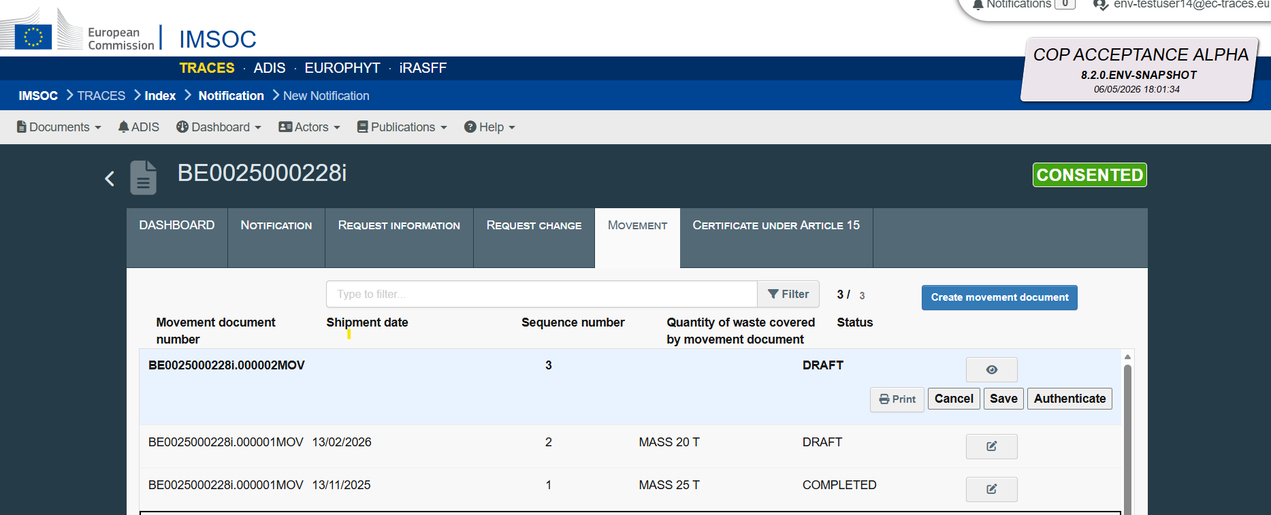
, if a

In order to fill in the movement document, the user needs to scroll down a bit, to see the boxes of movement document.

- DIWASS displays the template of movement document with some fields already filled in. Data displayed in these fields is copied from the consented notification, and these fields cannot be changed at the level of the movement document.

The notifier will be asked to provide only information specific to the movement document, as explained below.

- Box 2a: Container identification number: user should provide, in free text field, container identification number, if such number exists.
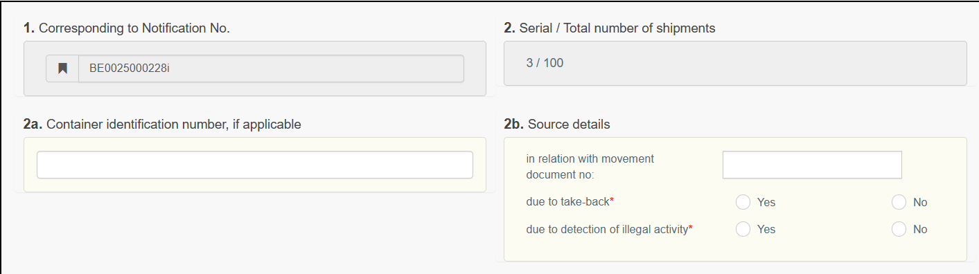
, if a
- Box 2b Movement is created: In case a movement document is linked with another movement document (also submitted under a different notification), is created due to take-back or due to detection of illegal activity, the notifier should provide such information by filing in the correct boxes.
, if a
- Box 5 Actual quantity: the user should provide the actual quantity of waste that is to be shipped based on the movement document. Please note that this information needs to be provided using the same unit of measure (Mg / m³), as provided for in the consented notification. The user needs to click on “+ Add”.
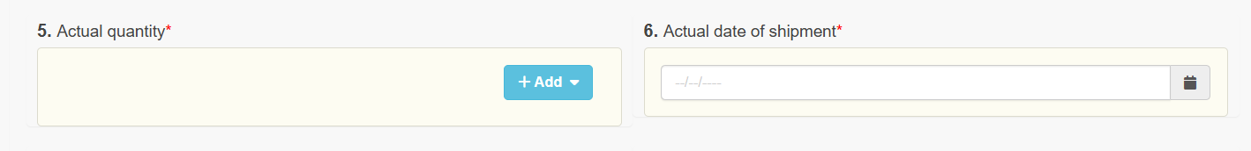
Then, in free text box, the user should provide an actual quantity of waste to be shipped under the movement document.
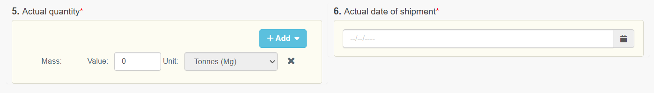
DIWASS takes into account the fact that the notifier provides in this box the estimated actual quantity of waste to be shipped under a movement document. The consignee and facility can provide in their respective boxes different quantities – higher and lower – based on the actual measurements.

- Box 6: Actual date of shipment: the user needs to click on the calendar icon and select the actual date of shipment.
Please note that DIWASS will not allow to submit a document indicating as date of the actual shipment the date on which the movement document is submitted, or the next day, as it will require to respect the obligation arising from Article 16(2) of the WSR to submit a movement document two working days in advance of the planned shipment.

- Box 7: Packaging: The user needs to select packaging types by clicking “+ Add” and selecting relevant type or types of packaging. The user should also indicate the number of packages and if there are any special handling requirements for the shipped waste. The user may also provide a packaging description in the free text box.
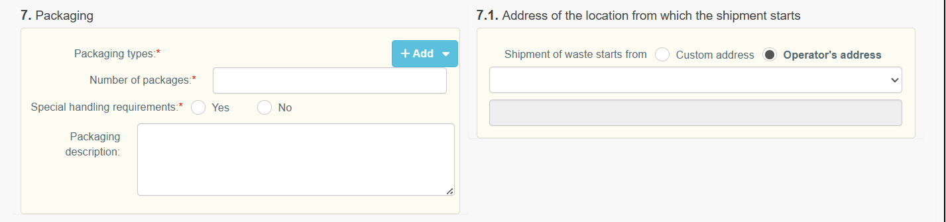

Please note that in principle, information provided in this field should be the same as provided for in the consented notification. However, to provide the notifier with more flexibility, DIWASS does not copy this field from the notification document. Therefore, in exceptional cases, when the notifier used different packaging than indicated in the consented notification, this could be reflected in this box of the movement document. Similarly, if the notifier considers that additional description or special handling requirements should be added, this information should be provided at the level of the movement document.

- Box 8: Carriers: the user should select the carriers for the shipment of waste. Choice of carriers is limited only to the carriers that have been added at the notification level.

Please note that in case that in the consented notification only 1 carrier has been selected, this carrier will be added automatically to the movement document. The user will not be required to fill in this box.

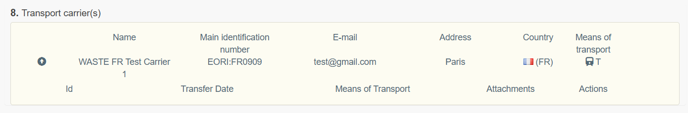

In case in the consented notification there is more than one carrier, the user will be required to select carrier(s) for the given movement document. To do so, the user needs to review the list of carriers displayed in box 8a and select the carrier(s) for movement document by clicking the “+” icon.

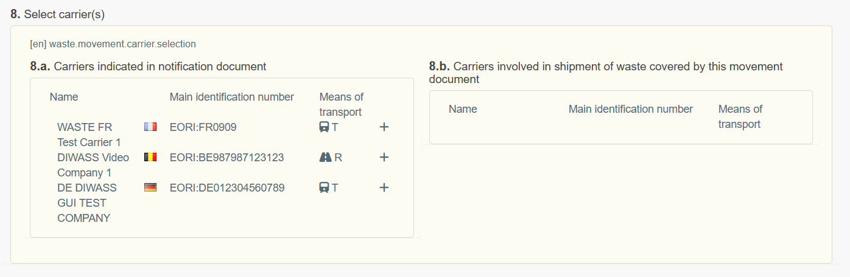

The user can add one or more carriers in this step. If a carrier was chosen by mistake, the user could remove it by clicking the icon “-” in box 8b.

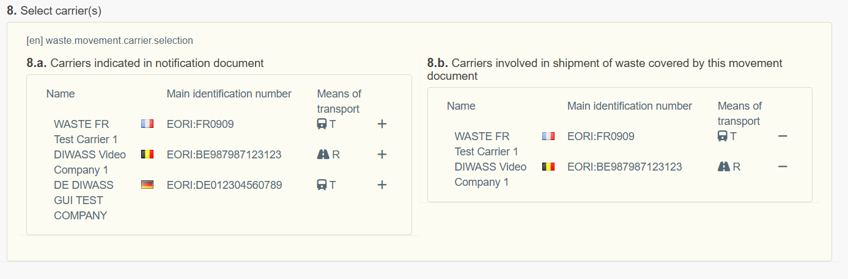

- Box 16: Additional information: the user can provide additional information relevant for the shipment by completing box 16 of movement document.
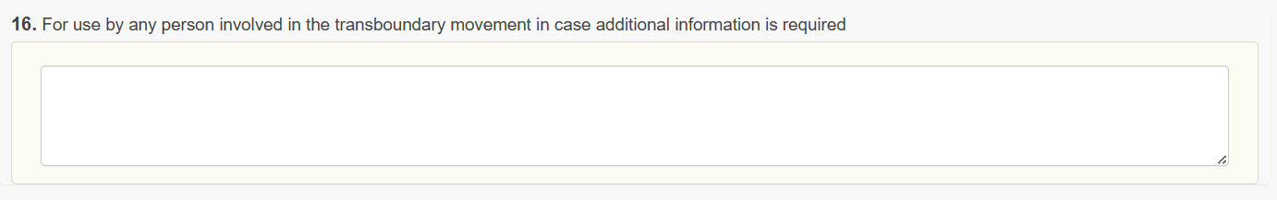
- After filling in the relevant boxes, the user should save the changes in the draft and authenticate the movement document to enable its submission in DIWASS. This authentication process in DIWASS is an equivalent of signing the documents.

To do so, the user needs to scroll up to the top of the page, and click on “Save” first, and then on “Authenticate”.
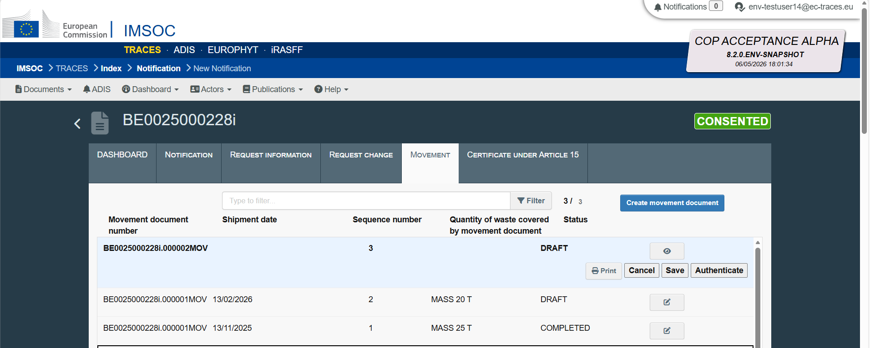
In the pop-up window, the user should indicate what is the role they perform in the organisation of the operator (e.g. proxy, member of the board, president etc.). Then, the user should click on “Confirm”.

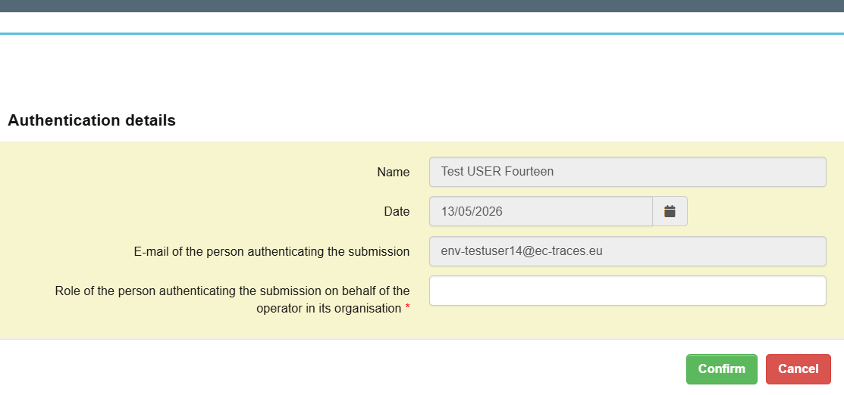
- Following that step, DIWASS will again display the dashboard summarising details of the notification document. To continue working on the movement document, the user needs to click once again on tab “Movement”, and then select the relevant draft from the list. The user will also see an icon of green tick sign, confirming that the movement document authenticated the movement document. To proceed with submission of that document, the user needs to click on the edit icon on the right part of the screen.

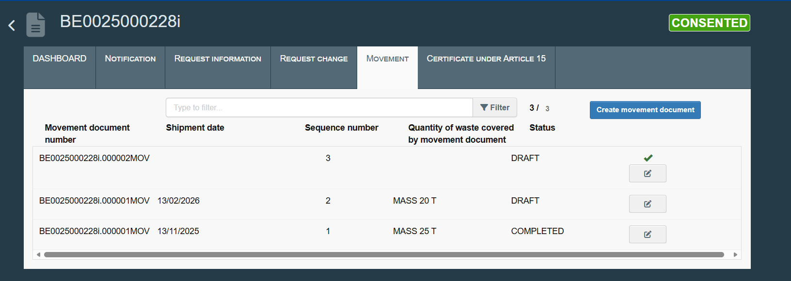

- The user will see now the button “Announce”. User needs to click on it, to submit the movement document in DIWASS.

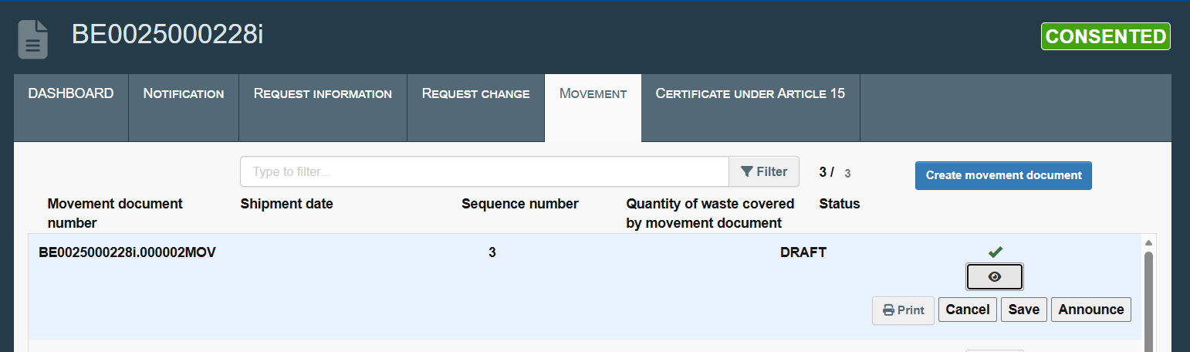

- Then, DIWASS will again display the dashboard summarising details of the notification document. The user will be able to verify the status of movement document after selecting the tab “Movement”. DIWASS will display then the list of movement documents and their statuses.
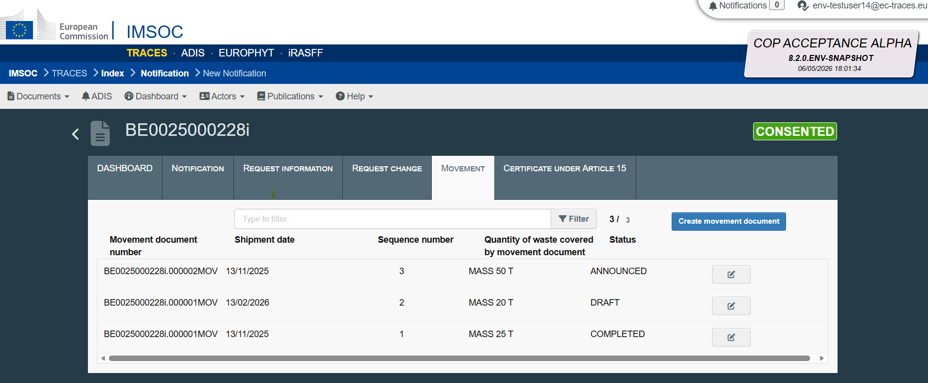

Chapter 8 How to update a movement document

General note
This chapter provides general instructions on how a notifier can update t the movement document.
Please note that:
- In order to update a movement document, the document needs to be in status “Announced”
  - If the carrier, consignee or facility completes their respective boxes in notification document, the document status would be changed (to “Moving”, “Received” or “Completed”) and notifier will not be able to update it anymore;
  - If the CA submits take-back request, the notifier will not be able to update the movement document anymore;
- DIWASS will allow to update only these boxes of a movement document, that the notifier could fill in when submitting a movement document (i.e. boxes 2a, 2b, 5, 8 and 16);
  - The notifier will not be able to update box 6 of the movement document, concerning the actual date of shipment;
  - The update covers both: adding additional text in the movement document and changing the text that has been provided in those boxes of movement documents;
- Only the notifier can update a movement document – this action cannot be done by CAs.
Please also note, that DIWASS will always display the most up-to-date version of the movement document.

Specific instructions
- Following the login and selecting the relevant notification document from the list of all notification documents involving the operator, the user should select “Movement” tab.
- From the list of movement documents, the user should select the document that it intends to update. DIWASS allows for updates only when movement document has status “Announced”. To update the document, the user needs to click on the edit icon next to the relevant movement document.
- Next, DIWASS will display the submitted movement document. The user should edit the relevant fields, following instructions in points 7-13 of Specific instructions of the previous Chapter.

Then, the user should save changes by clicking on “Save” button.
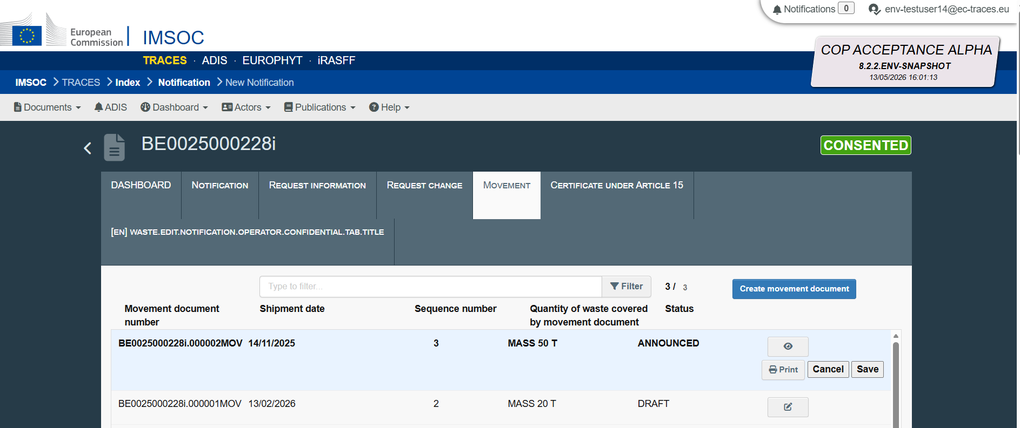

Chapter 9 Contribution of carrier to a movement document

General note
This chapter provides general instructions on how a carrier can contribute to the movement document.
Please note that:
- Only the carrier that has been selected by the notifier as carrier Involved in a shipment of waste based on a given movement document will be able to see such movement document and contribute to it;
- Such carrier will be able to see the movement document only after the notifier submits (announces) it in DIWASS;
- The carrier will be able to contribute to the movement documents when the document will be in statuses: “Announced”, “Moving” and “Received”;
- In case where in a given shipment of waste there is more than 1 carrier involved, DIWASS will allow all the carriers to contribute to the movement document in any order.
  - Example: Movement document lists three carriers: A, B and C. Carrier C can fill in the movement document in DIWASS even if carriers A and B have not yet contributed to that movement document.
- Movement documents cannot be generated after the consent for the shipment is revoked or expired. The movement documents submitted in the system can be however updated and relevant information can be provided there by carriers, consignee and facility.

Specific instructions

Confirming the transfer of waste
- Following the login and selecting the relevant notification document from the list of all notification documents involving the operator, the user should click on “Movement”.
- Next, the user needs to select, from the list of movement documents, the relevant movement document it intends to fill in. The user needs to click in the icon next to the relevant movement document, on the right side of the screen.

- Then the template of the movement document will open. The carrier needs to click on “Create carrier transport”.
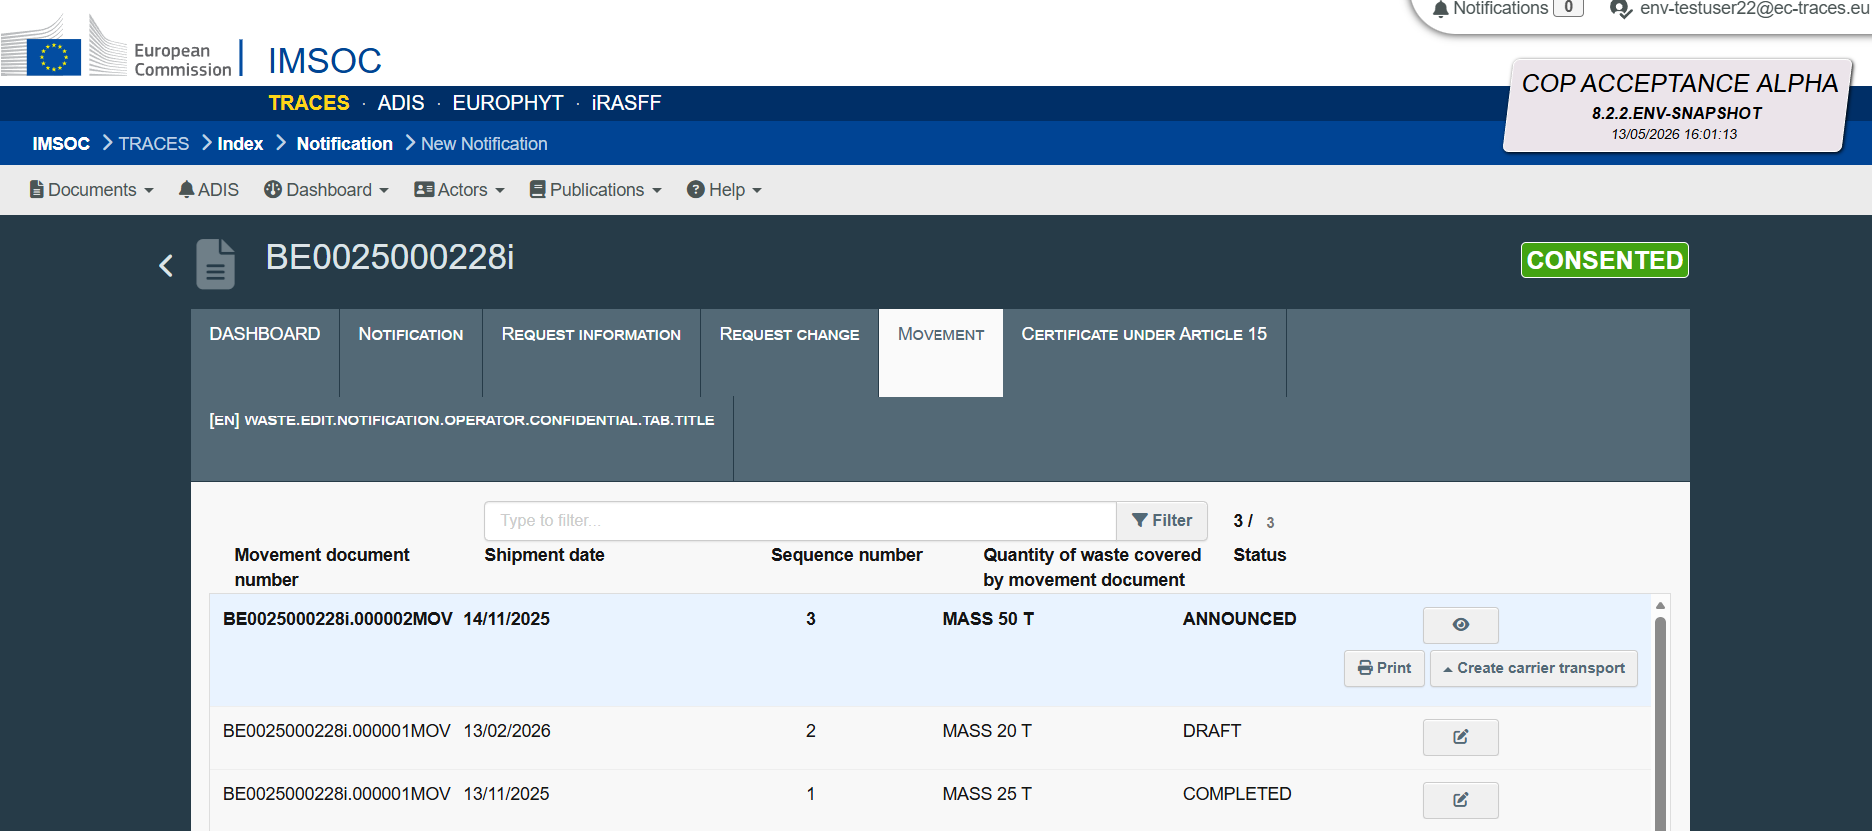

Then, the user will be asked to select a carrier that is submitting a confirmation of transport of waste by selecting the name of the operator from a list.

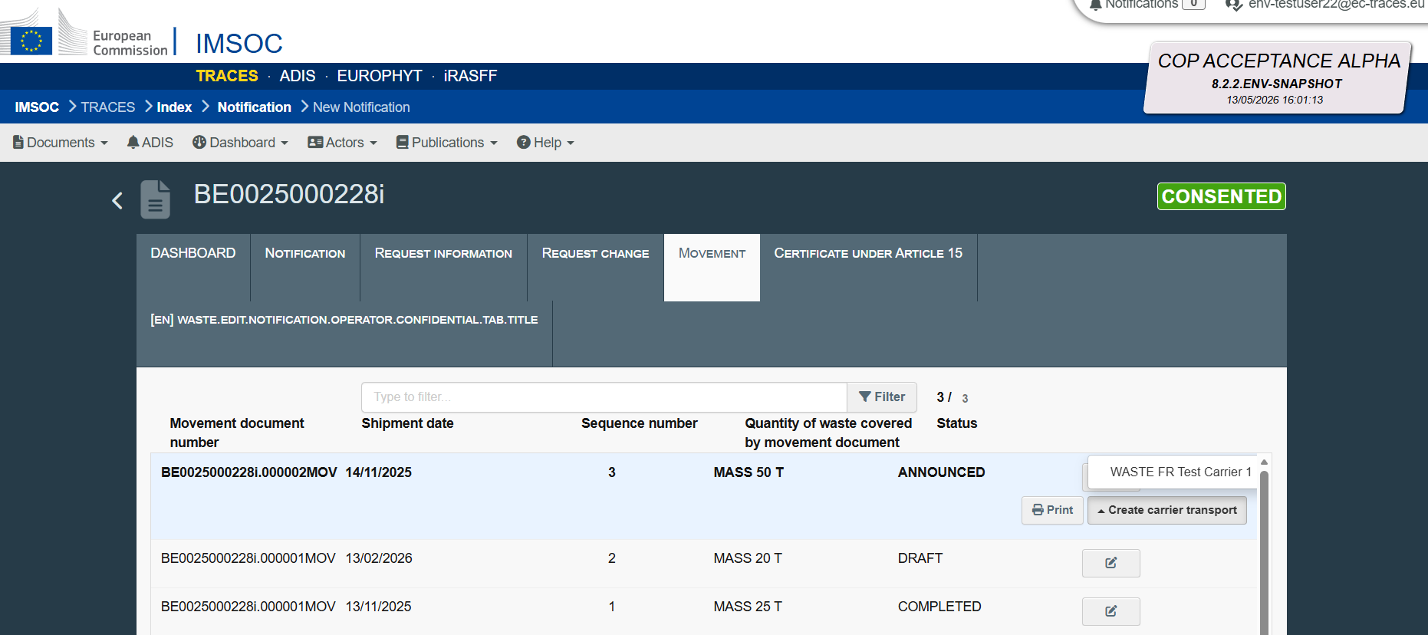

- Next, a pop-out window will open. The user needs provide information on :
  - the date of the transfer of waste – by clicking on the calendar icon and selecting relevant date;
  - means of transport used by the carrier – by selecting it from the drop-down list.
If needed, the user may indicate additional information relevant for the shipment of waste by completing a free text field.

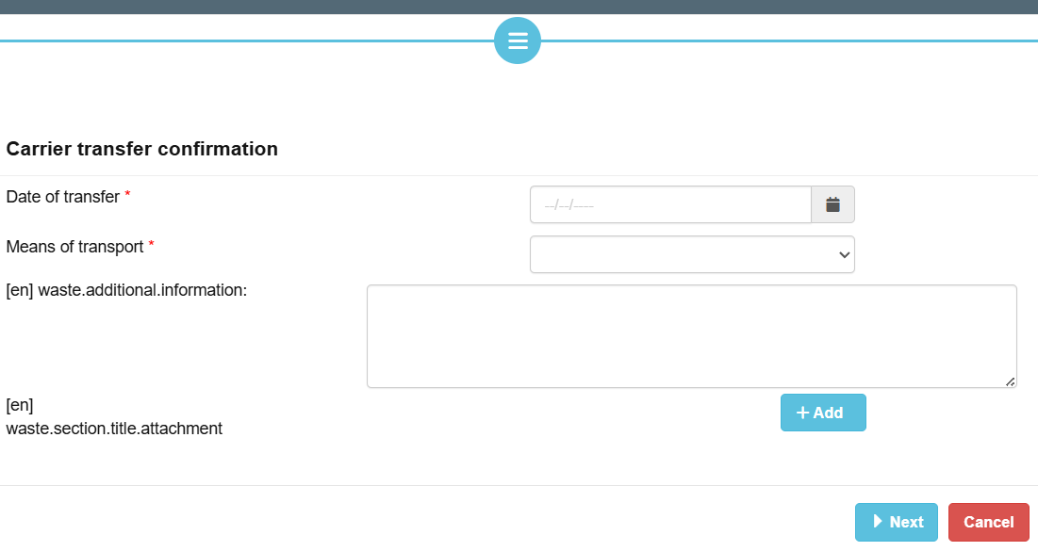

The user may also add an attachment by clicking on “+ Add”. Then, the user will be asked to select a label from the list and add an attachment by clicking on the grey field.

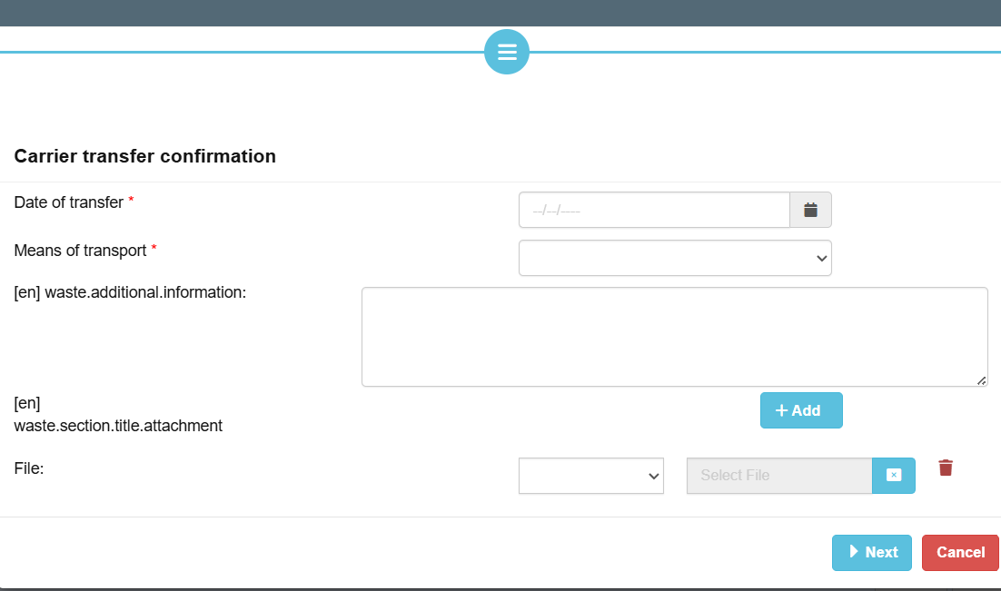
When all information is provided, the user needs to click on “Next”.

- Then, the user will be asked to authenticate the information provided. This authentication process in DIWASS is an equivalent of signing the documents.

In the pop-up window, the user should indicate what is the role they perform in the organisation of the operator (e.g. proxy, member of the board, president etc.). Then, the user should click on “Confirm”.

- Following that step, DIWASS will again display the dashboard summarising details of the notification document.

To verify its contribution to the movement document, the user needs to click once again on tab “Movement”, and then select the relevant document from the list.
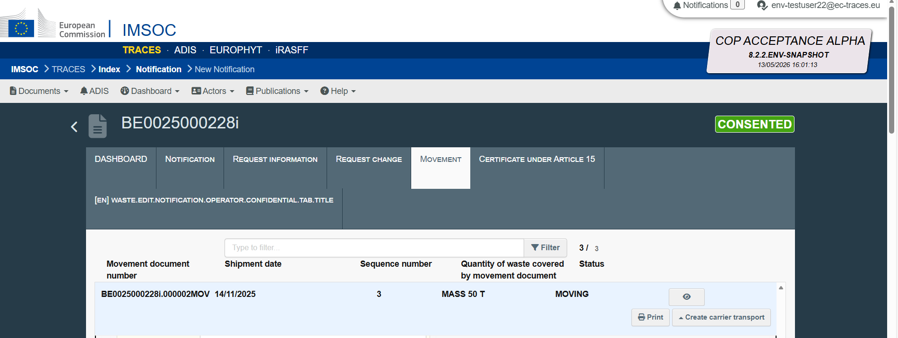
To see the confirmation of transfer of waste, the user needs to scroll down to display box 8 of the movement document. There, below the details of the carrier, DIWASS will display the confirmation submitted by carrier.
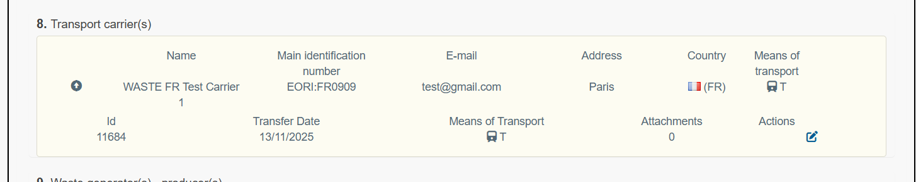

Updating of transfer confirmation
- Following the login and selecting the relevant notification document from the list of all notification documents involving the operator, the user should click on tab “Movement”.
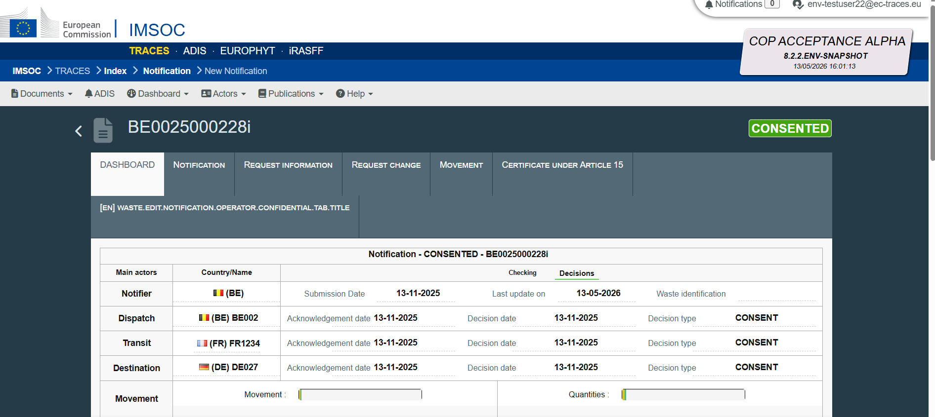
- Then, from list of movement documents, the user should select the movement document it intends to update and click on the icon next to the status of the document.
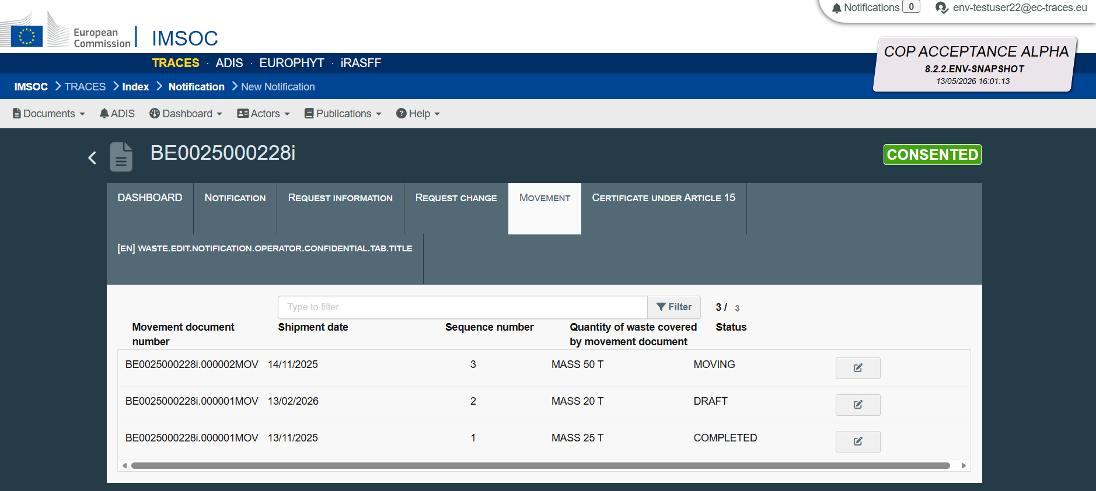
- DIWASS will display the submitted movement document.
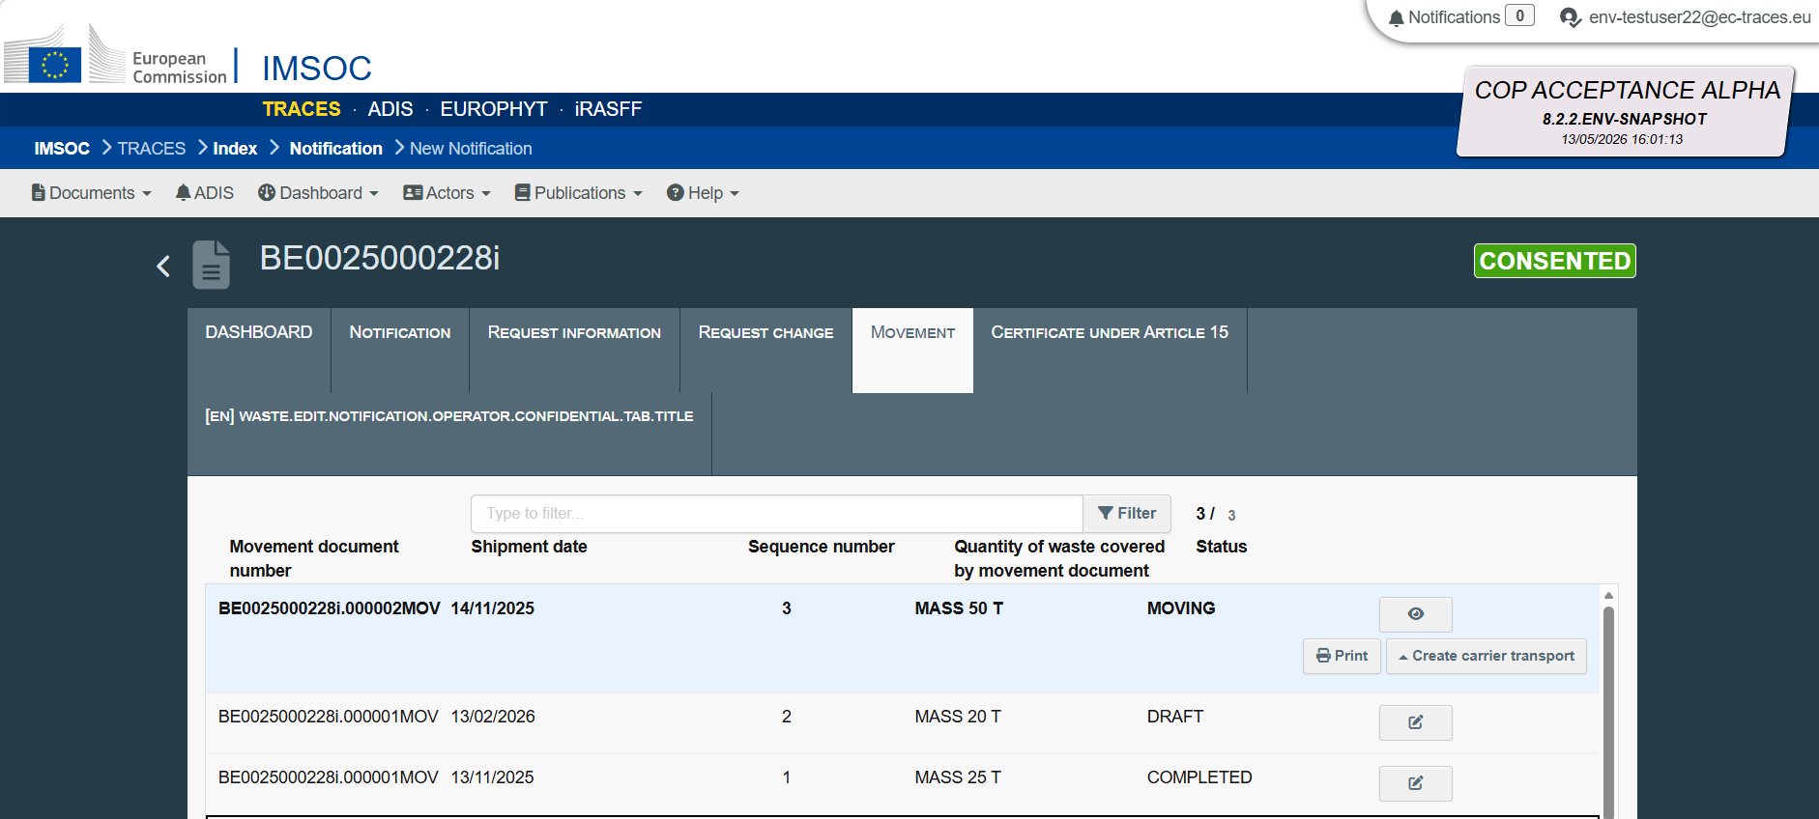

The user intending to update the carrier transfer confirmation needs to scroll down to box 8 of the movement document and select the icon next to the submitted confirmation.
DIWASS will display, in the pop-out window, information as provided initially by the carrier. The user will be able to update it by changing the relevant boxes. To confirm the changes, the user needs to click “Next”.
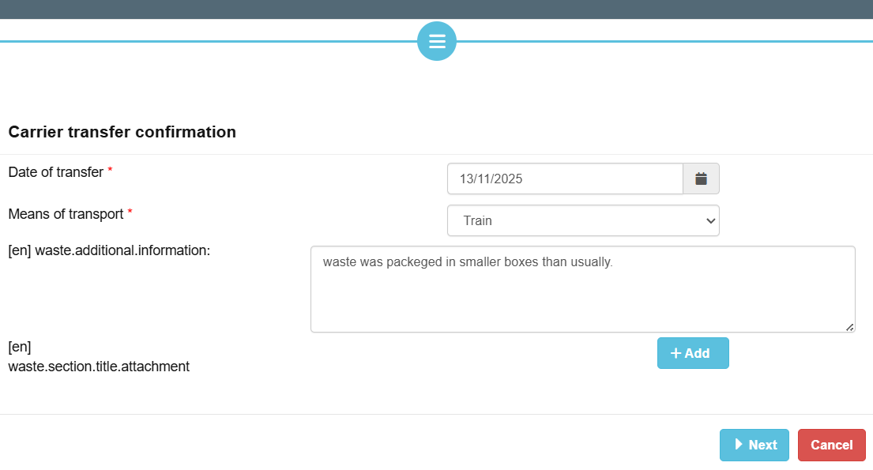
- Then, DIWASS will display the pop-out window concerning the authentication details. The user should update, if necessary, the field concerning the role in organisation of the operator on behalf of which the confirmation is submitted and click on “Confirm”.
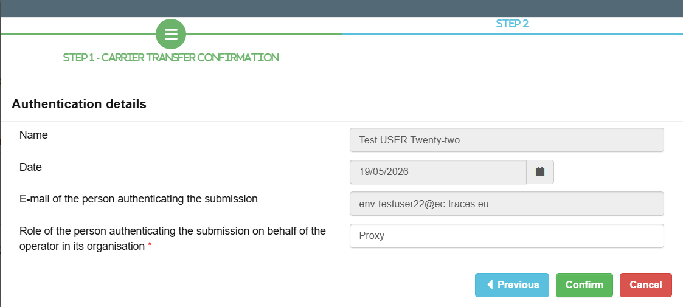
- Following that step, DIWASS will again display the dashboard summarising details of the notification document.
To verify its contribution to the movement document, the user needs to click once again on tab “Movement”, and then select the relevant document from the list in order to review it.

Chapter 10 Contribution of consignee to a movement document

General note
This chapter provides general instructions on how a consignee should submit the movement document. Please note that:
- The consignee will be able to see the movement document only after the notifier submits (announces) it in DIWASS;
- The consignee will be able to contribute to the movement documents when the document will be in statuses: “Announced”, “Moving” and “Received”;
- Movement documents cannot be generated after the consent for the shipment is revoked or expired. The movement documents submitted in the system can be however updated and relevant information can be provided there by carriers, consignee and facility.

Specific instructions

Confirming the receipt of waste
- Following the login and selecting the relevant notification document from the list of all notification documents involving the operator, the user should click on “Movement”.
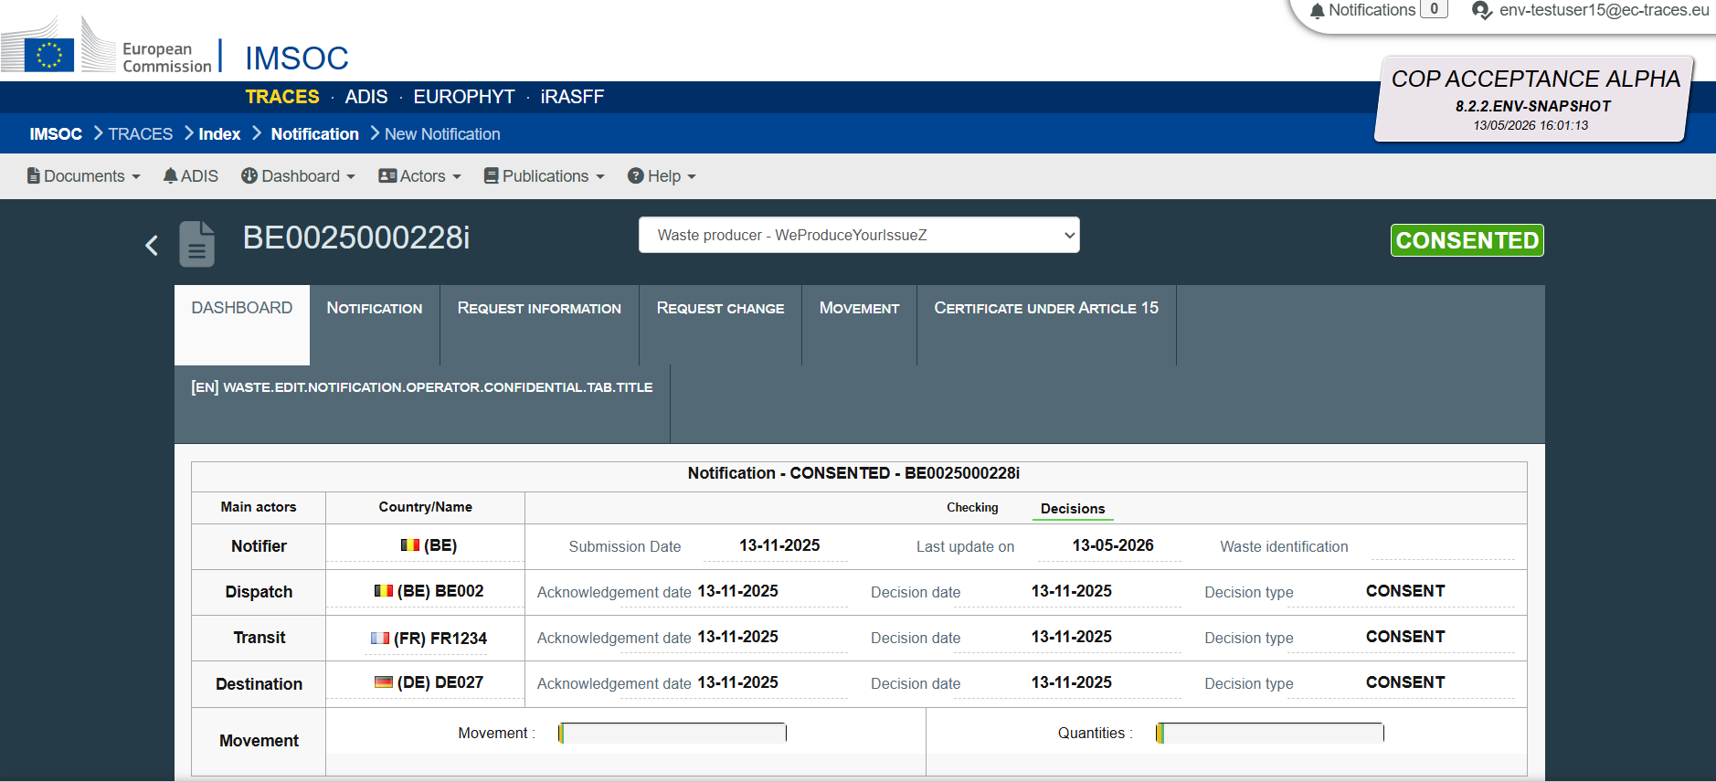
- Next, the user needs to select, from the list of movement documents, the relevant movement document it intends to fill in. The user needs to click in the icon next to the relevant movement document, on the right side of the screen.
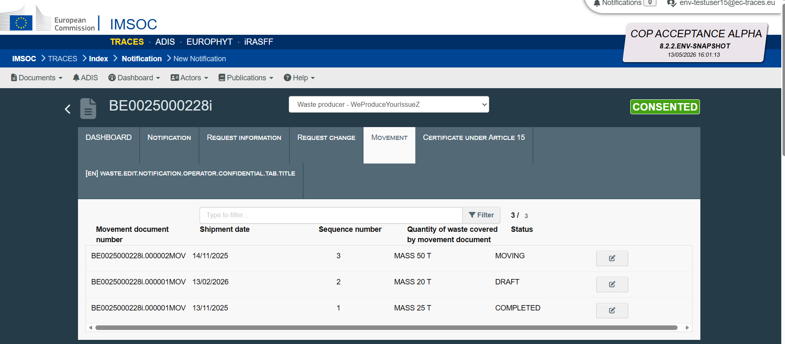

- Then the template of the movement document will open. The consignee needs to click on “Create consignee certificate”.
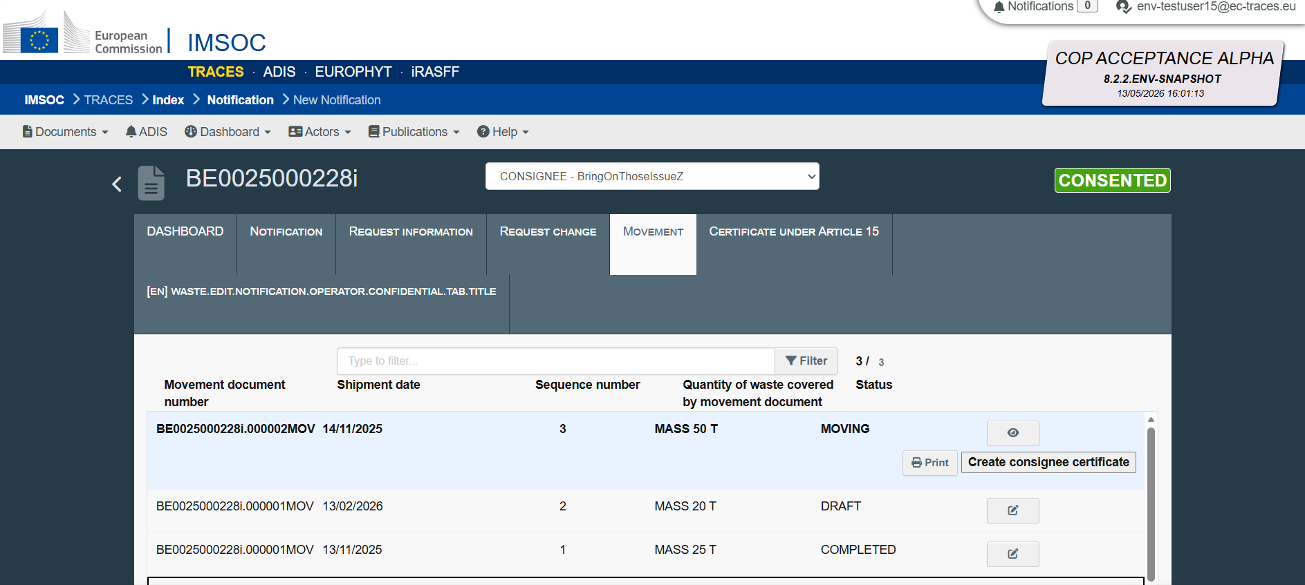
- Next, a pop-out window will open. The user needs provide information on the date of the receipt of waste – by clicking on the calendar icon and selecting relevant date.

If needed, the user may indicate additional information relevant for the shipment of waste by completing a free text field.

[Please note that the Commission works on improving this screen]

The user should also provide contact information concerning the consignee, by filling in the free-text fields.

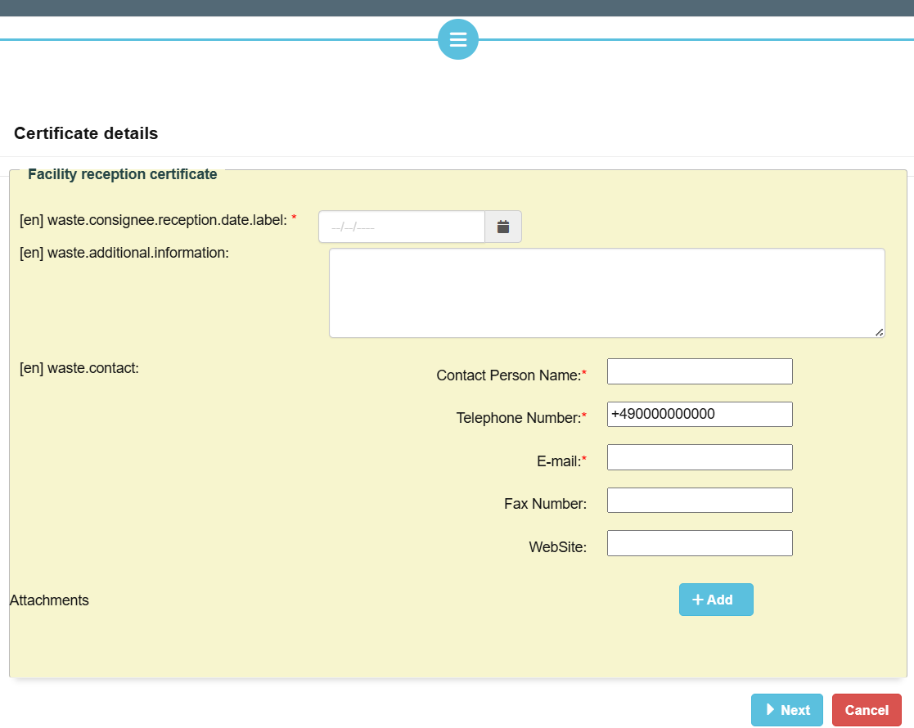
The user may also add an attachment by clicking on “+ Add”. Then, the user will be asked to select a label from the list and add an attachment by clicking on the grey field.

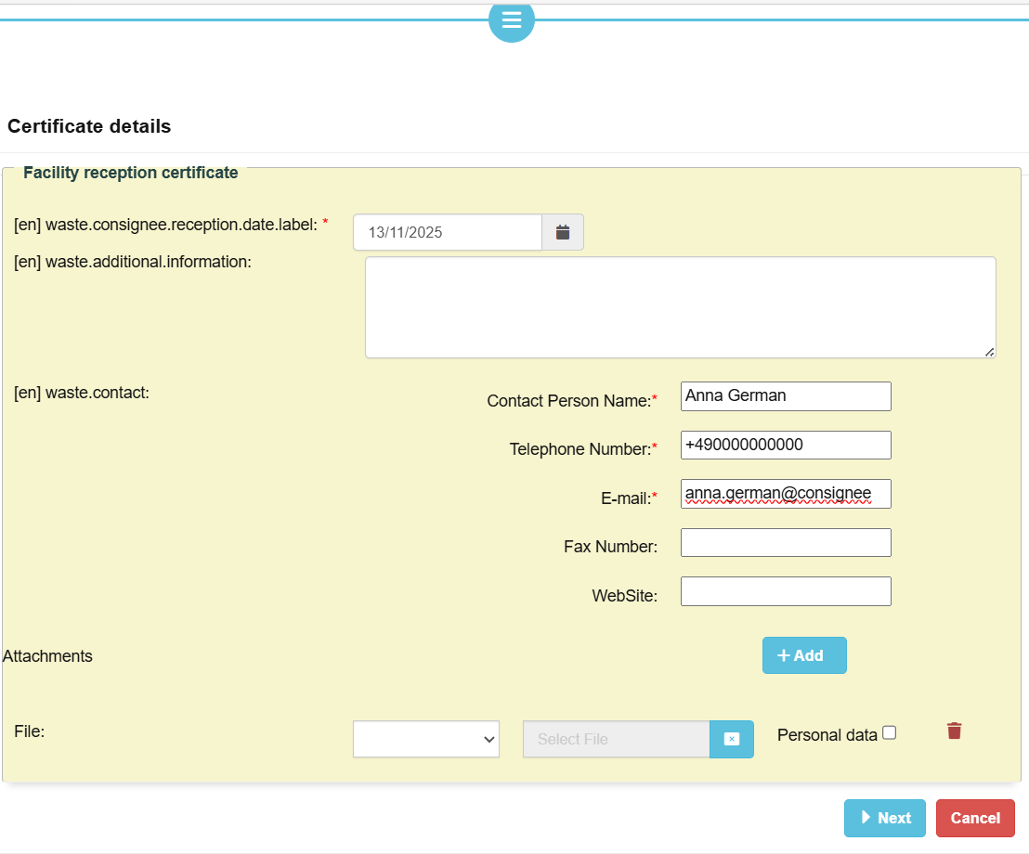

When all information is provided, the user needs to click on “Next”.

- Then, the user will be asked to authenticate the information provided. This authentication process in DIWASS is an equivalent of signing the documents.

In the pop-up window, the user should indicate what is the role they perform in the organisation of the operator (e.g. proxy, member of the board, president etc.). Then, the user should click on “Confirm”.
- Following that step, DIWASS will again display the dashboard summarising details of the notification document.

To verify its contribution to the movement document, the user needs to click once again on tab “Movement”, and then select the relevant document from the list.
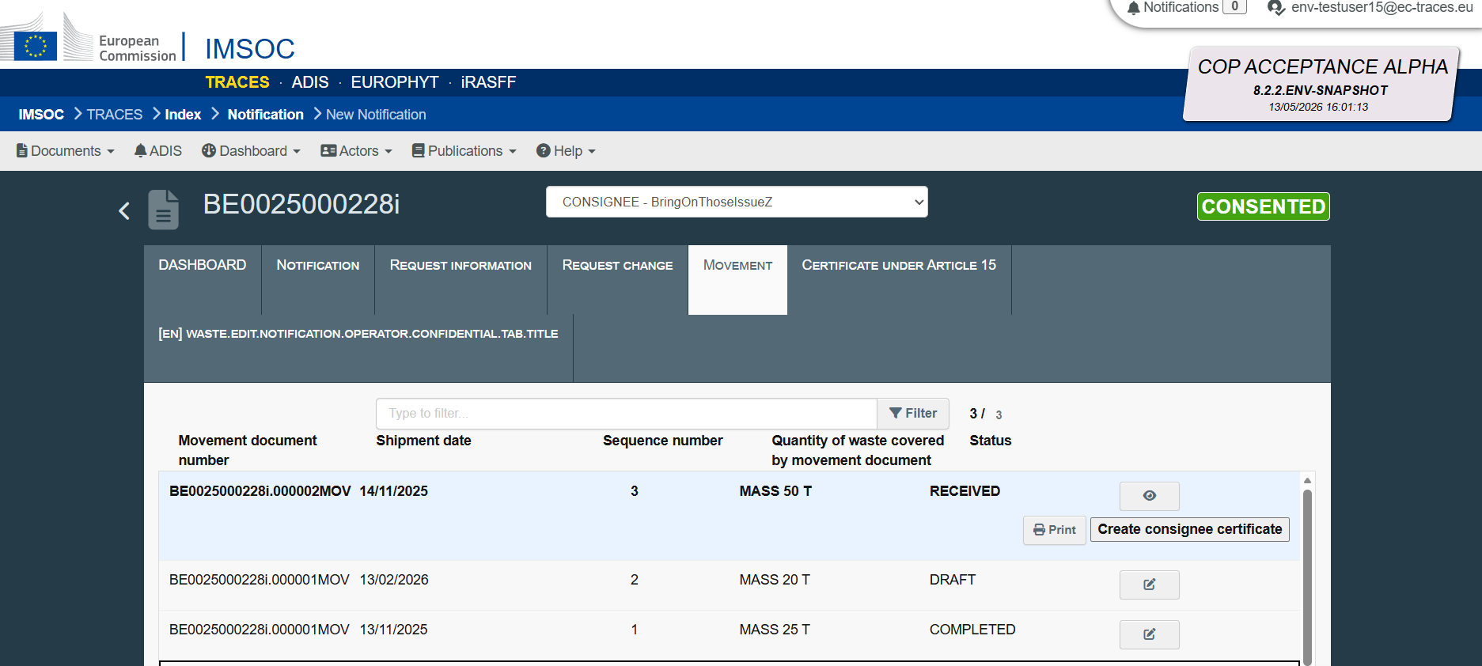

To see the confirmation of receipt of waste, the user needs to scroll down to display box 17 of the movement document. There, below the details of the consignee, DIWASS will display the confirmation submitted by the consignee. The information will be displayed when clicking on the arrow on the left side of the box.
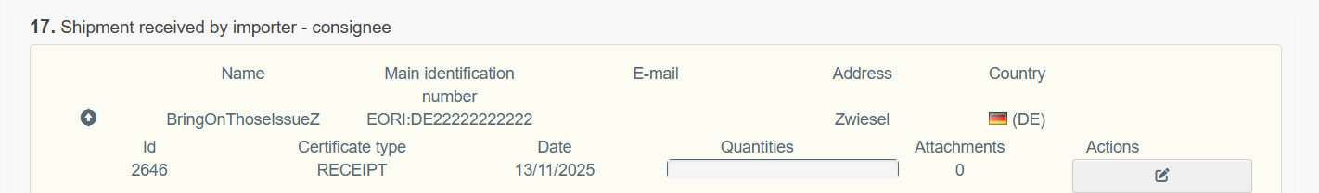

Updating the confirmation of receipt of waste
- Following the login and selecting the relevant notification document from the list of all notification documents involving the operator, the user should click on tab “Movement”.
- Then, from list of movement documents, the user should select the movement document it intends to update and click on the icon next to the status of the document.
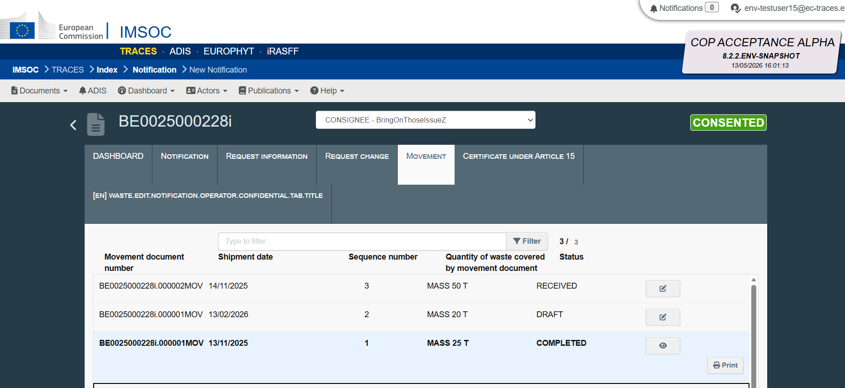
- DIWASS will display the submitted movement document.
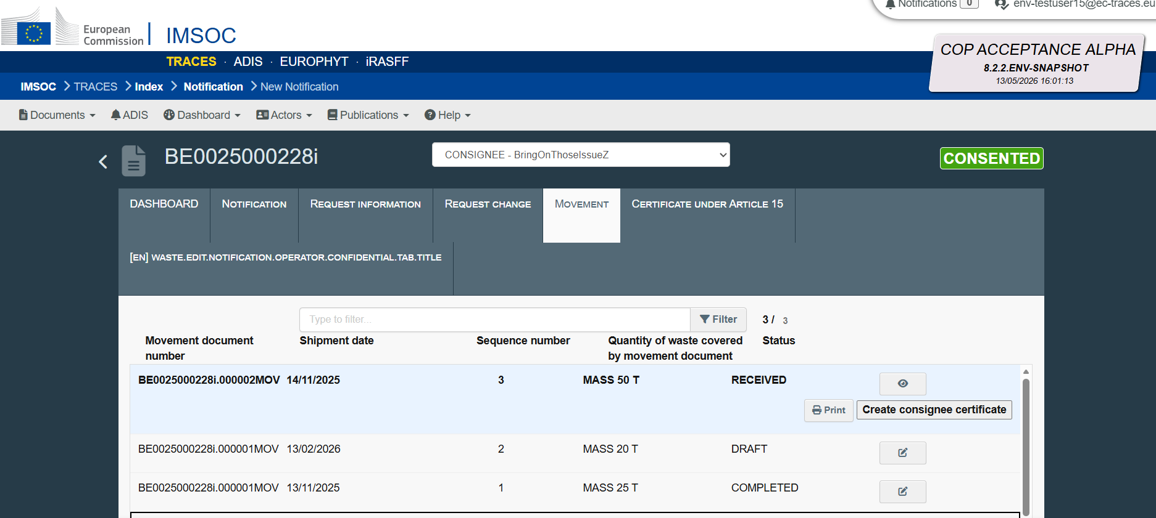

The user intending to update the confirmation of receipt of waste by the consignee needs to scroll down to box 17 of the movement document, click on the arrow on the left side of the box and select the icon next to the submitted confirmation in the column “Actions”.
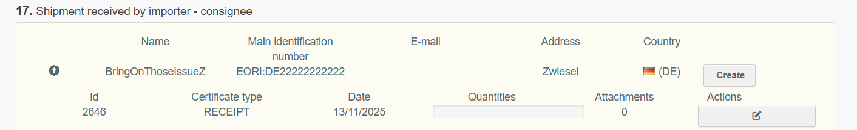
DIWASS will display, in the pop-out window, information as provided initially by the consignee. The user will be able to update it by changing the relevant boxes. To confirm the changes, the user needs to click “Next”.
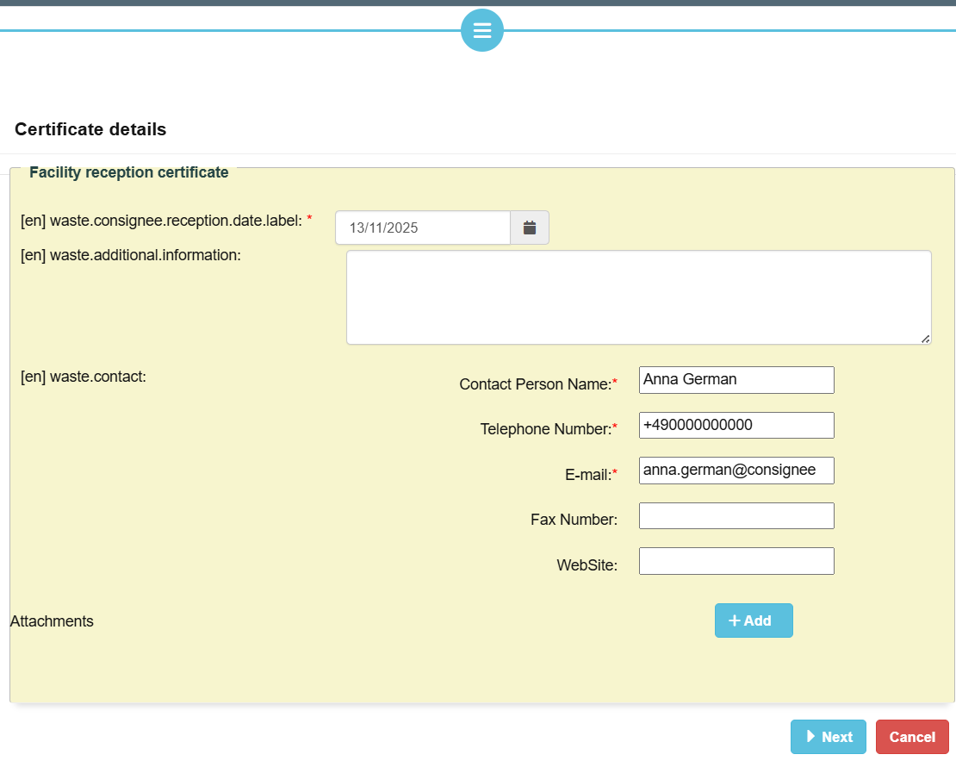
- Then, DIWASS will display the pop-out window concerning the authentication details. The user should update, if necessary, the field concerning the role in organisation of the operator on behalf of which the confirmation is submitted and click on “Confirm”.
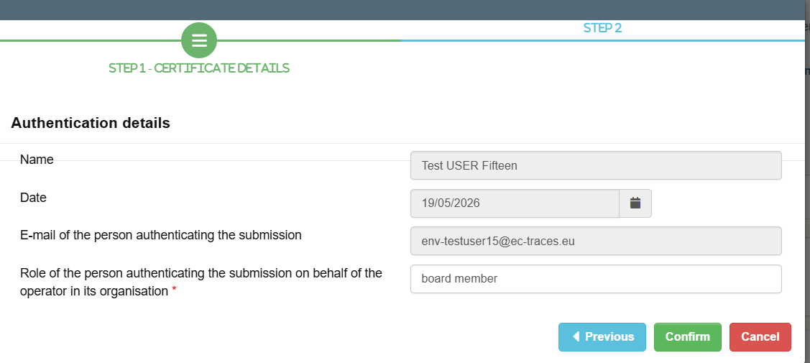
- Following that step, DIWASS will again display the dashboard summarising details of the notification document.
To verify its contribution to the movement document, the user needs to click once again on tab “Movement”, and then select the relevant document from the list in order to review it.

Chapter 11 Contribution of waste receiving facility to a movement document

General note
This chapter provides general instructions on how a waste receiving facility should submit the movement document. Please note that:
- The waste receiving facility will be able to see the movement document only after the notifier submits (announces) it in DIWASS.
- The waste receiving facility will be able to contribute to the movement documents when the document will be in statuses: “Announced”, “Moving” and “Received”.
- Movement documents cannot be generated after the consent for the shipment is revoked or expired. The movement documents submitted in the system can be however updated and relevant information can be provided there by carriers, consignee and facility.

Specific instructions

Confirming the receipt of waste
- Following the login and selecting the relevant notification document from the list of all notification documents involving the operator, the user should click on “Movement”.
- Next, the user needs to select, from the list of movement documents, the relevant movement document it intends to fill in. The user needs to click in the icon next to the relevant movement document, on the right side of the screen.
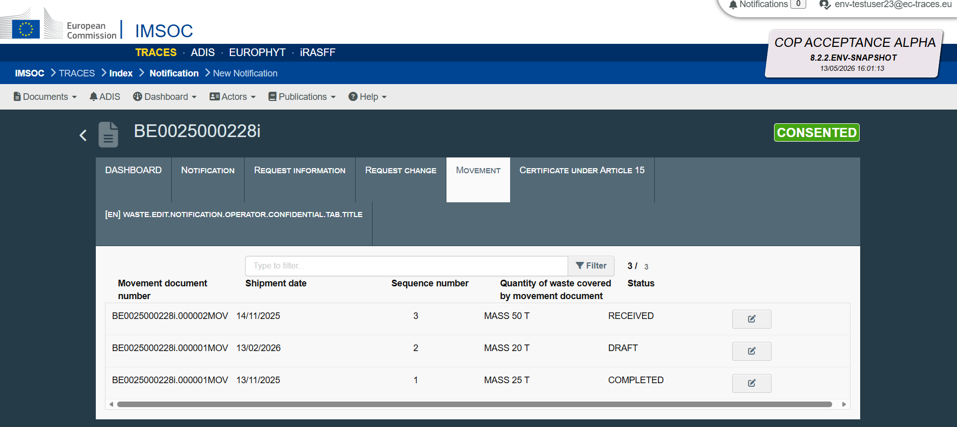

- Then the template of the movement document will open. The waste receiving facility needs to click on “Create certificate”.
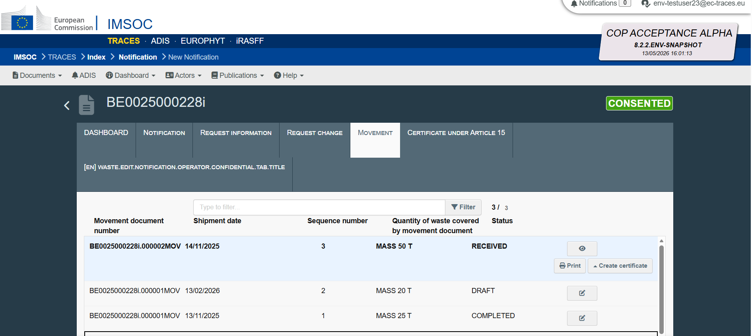
Then, the user will be asked to select a waste receiving facility that is submitting a confirmation of waste receipt by selecting the name of the operator from a list.

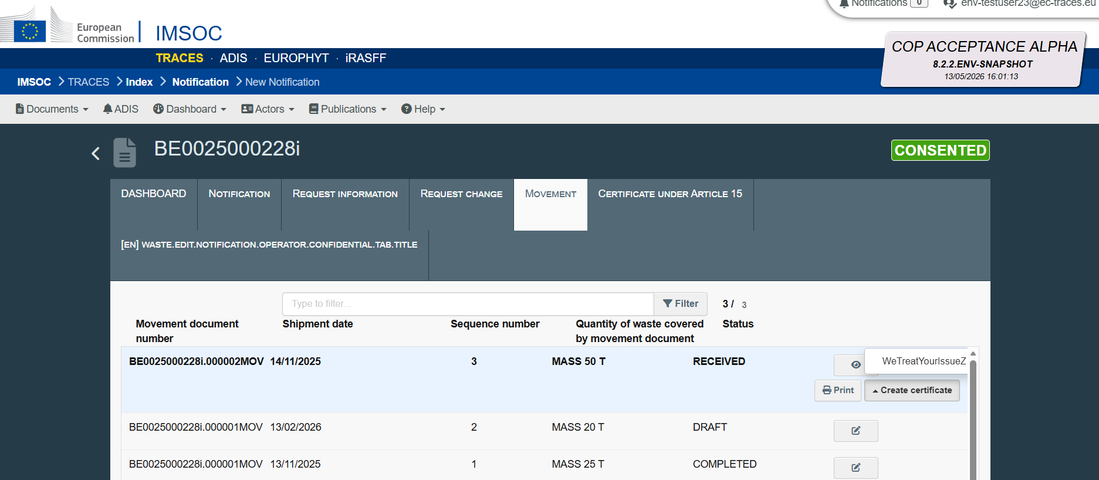

- Next, a pop-out window will open asking a user to specify if it intends to submit a facility reception certificate or facility completion certificate. Following the selection of facility reception certificate, the user needs to click on “Next”.
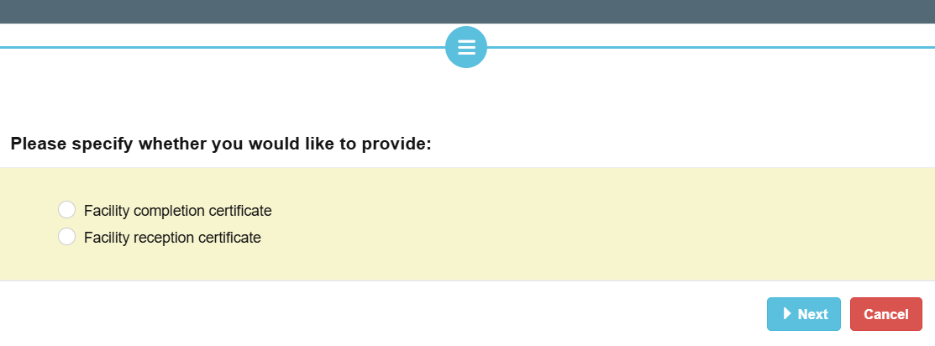
- In the next window, the user needs to provide information on
  - the date of the receipt of waste – by clicking on the calendar icon and selecting relevant date,
  - Accepted quantity of waste – by clicking on icon “+ Add”, selecting the unit of measure and filling in a free text field,
  - Rejected quantity of waste – by clicking on icon “+ Add”, selecting the unit of measure and filling in a free text field,
  - Reasons for rejection – by completing the free text field,
  - Approximate of date of disposal/recovery – by clicking on the calendar icon and selecting relevant date.

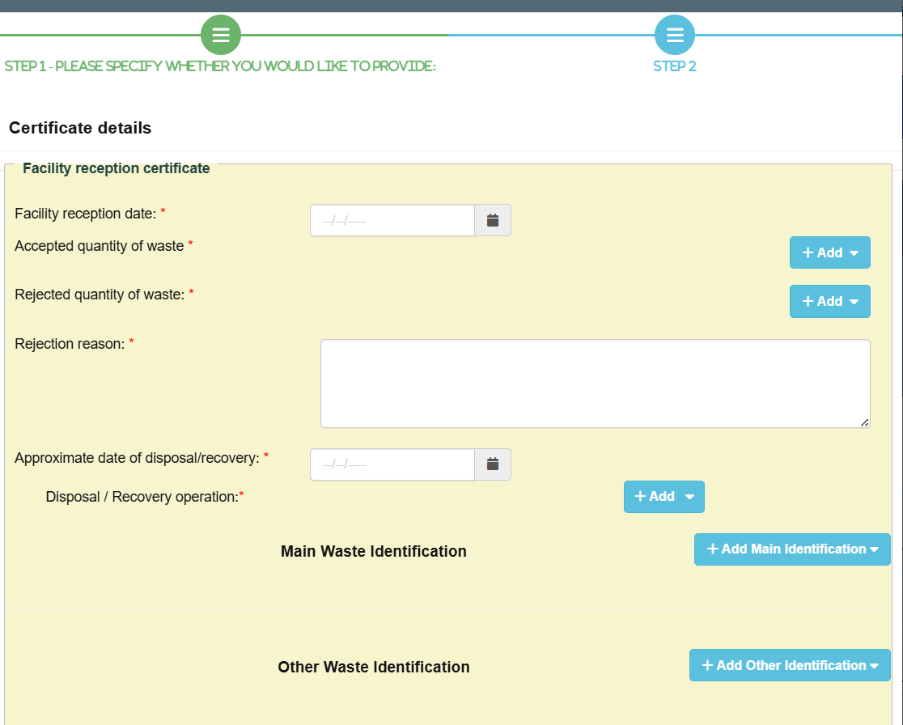

[Please note that the Commission works on improving these screens]

Then, the user should also provide information on:
  - Disposal and recovery operation – by clicking “+ Add” and selecting the relevant operation from the drop-down list,
  - Waste identification codes – according to instructions below.
Please note that data provided in this place should be identical as data provided by the notifier in the consented notification.

To facilitate the selection of relevant waste codes, DIWASS incorporates the list of codes, so that the user can select them from the drop-down menu. DIWASS provides also a separate selection for “Main Waste Identification” and “Other Waste Identification”.

The “Main Waste Identification” incorporates the lists of waste codes as provided for in box 14 of the notification document, notably:
- Basel Annex VIII (or IX if applicable),
- OECD,
- EU list of waste,
- National code in country of export,
- National code in country of import,
- Other,
- Y-code,
- H-code,
- UN class,
- UN Number,
- UN Shipping name.

The user needs to click on “+ Add Main Identification” to select the type of waste identification list. The user should select the respective list by clicking on it. The user may choose one or more waste identification lists. If more than one waste code is present, click “+ Add Main Identification” the needed number of times.
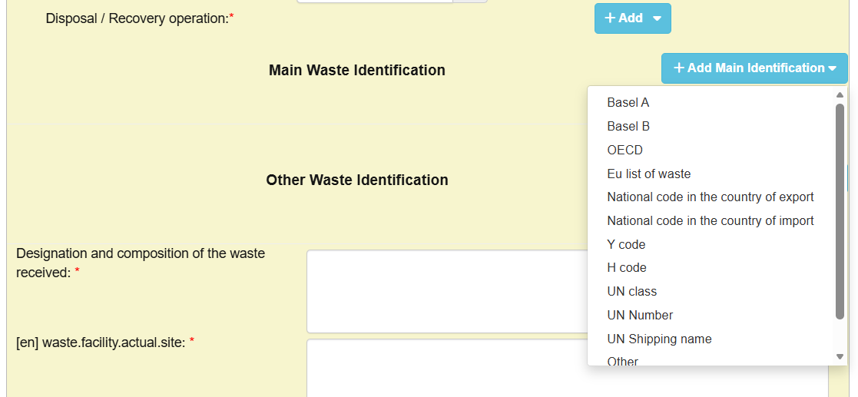
Once the type(s) of waste identification code are selected, the user can select the specific type of waste by clicking “+ Waste code”.
The drop-down list is available for the following waste codes: Basel, OECD, EU list of waste, Y code, H code, and UN class.
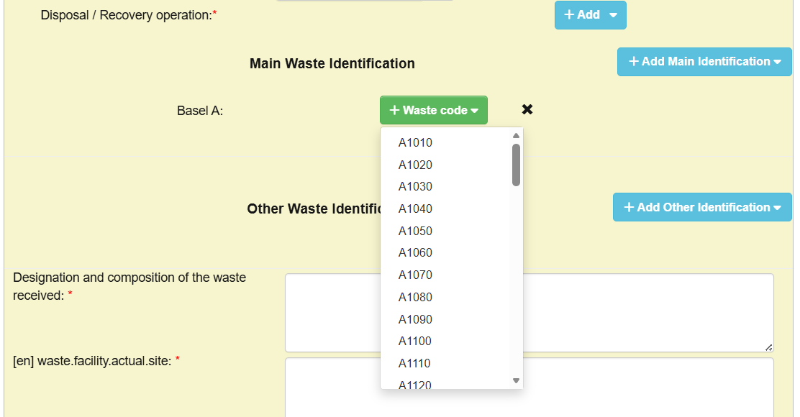
Please note that, for other of the available lists (National code in the country of import, National code in the country of export, UN Number, and UN shipping name, Other and Unlisted waste), the user will be able to insert a code in the free text box.

The “Other Waste Identification” allows the user to provide codes from the drop-down menu from other lists than indicated explicitly in box 14 of notification document.
If the user selects “+ Add Other Identification”, a drop-down menu will appear, showing:
- WSR Annex III,
- WSR Annex IIIA,
- WSR Annex IIIB,
- WSR Annex IV and
- HP codes.
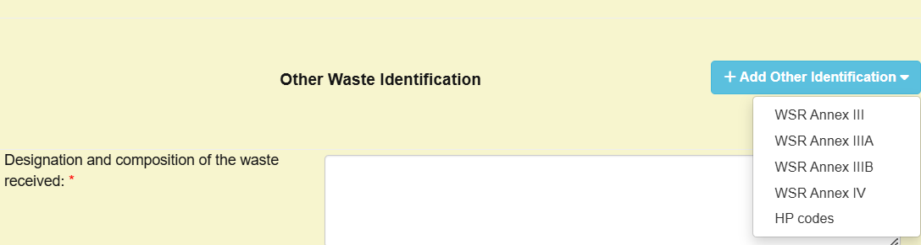

Once the type(s) of waste identification code are selected, the user can select the specific type of waste by clicking “+ Waste code”.

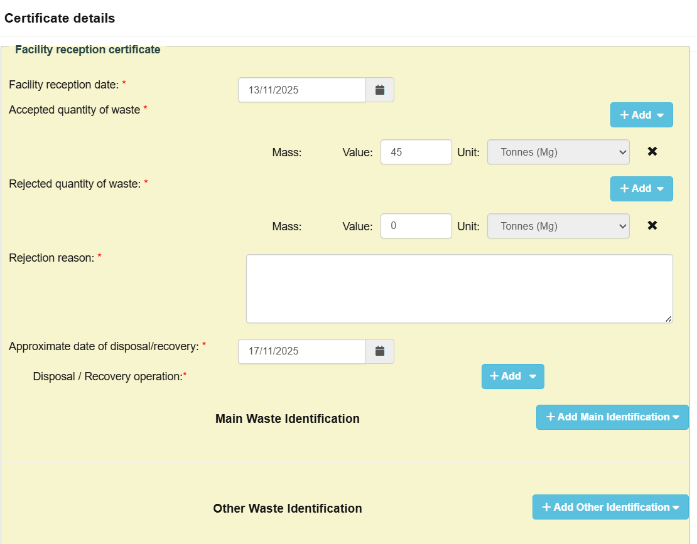

Then, the user needs to provide information by completing the following free-text fields:
  - Designation and composition of waste
  - Actual site of the disposal or treatment
  - Additional information relevant for shipment of waste, if needed.
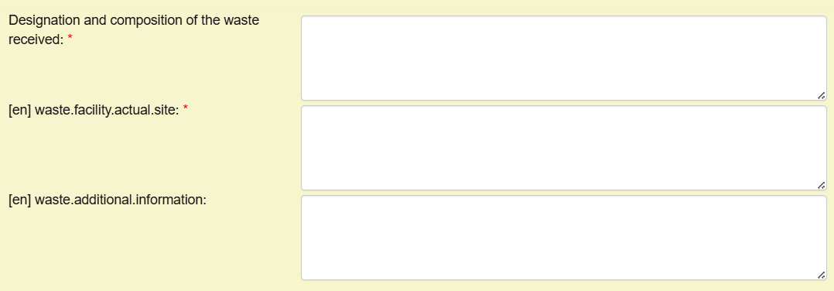

The user should also provide contact information concerning the waste receiving facility, by filling in the free-text fields.

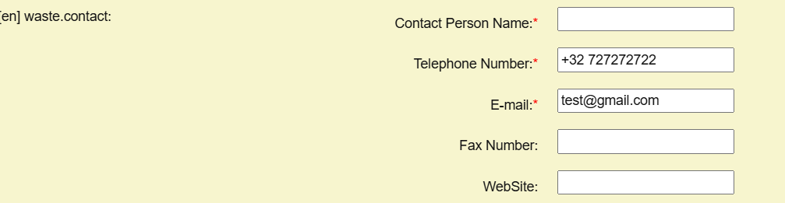

The user may also add an attachment by clicking on “+ Add”. Then, the user will be asked to select a label from the list and add an attachment by clicking on the grey field.

When all information is provided, the user needs to click on “Next”.

- Then, the user will be asked to authenticate the information provided. This authentication process in DIWASS is an equivalent of signing the documents.

In the pop-up window, the user should indicate what is the role they perform in the organisation of the operator (e.g. proxy, member of the board, president etc.). Then, the user should click on “Confirm”.
- Following that step, DIWASS will again display the dashboard summarising details of the notification document.

To verify its contribution to the movement document, the user needs to click once again on tab “Movement”, and then select the relevant document from the list.

To see the confirmation of receipt of waste, the user needs to scroll down to display box 10 of the movement document. There, below the details of the waste receiving facility, DIWASS will display the confirmation submitted by this facility. The information will be displayed when clicking on the arrow on the left side of the box.
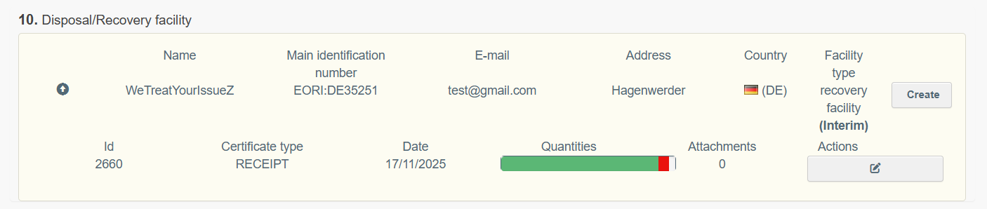

Updating the confirmation of receipt of waste
- Following the login and selecting the relevant notification document from the list of all notification documents involving the operator, the user should click on tab “Movement”.
- Then, from list of movement documents, the user should select the movement document it intends to update and click on the icon next to the status of the document.
- DIWASS will display the submitted movement document.
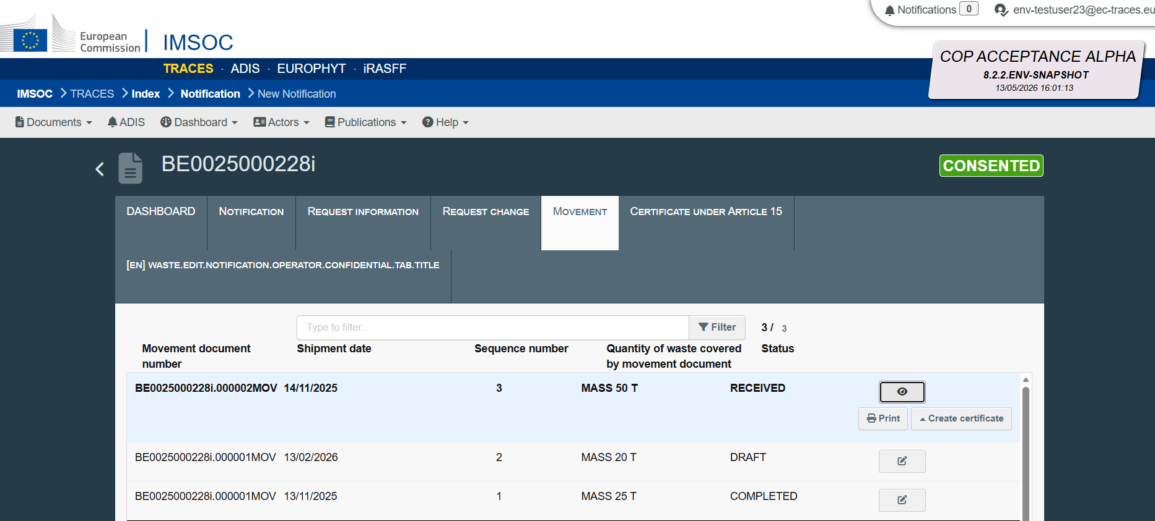

The user intending to update the confirmation of receipt of waste by the waste receiving facility needs to scroll down to box 10 of the movement document, click on the arrow on the left side of the box and select the icon next to the submitted confirmation in the column “Actions”.
DIWASS will display, in the pop-out window, information as provided initially by the waste receiving facility. The user will be able to update it by changing the relevant boxes, as explained in specific instructions for Confirming the receipt of waste above. To confirm the changes, the user needs to click “Next”.
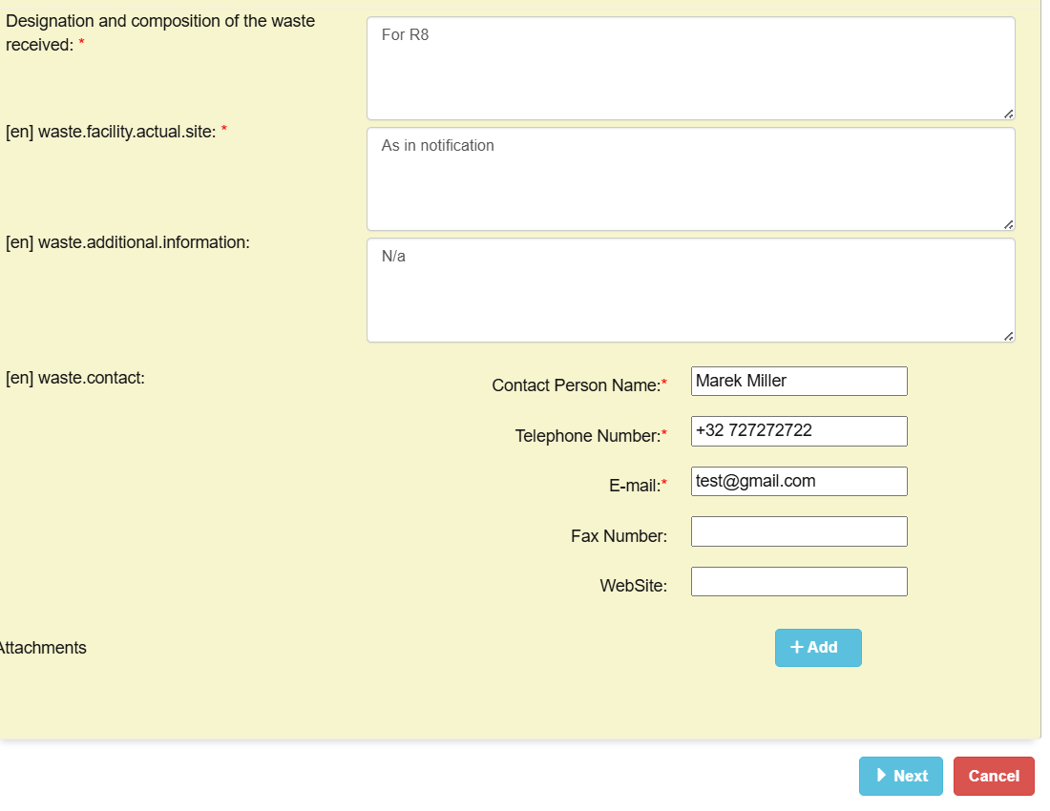
- Then, DIWASS will display the pop-out window concerning the authentication details. The user should update, if necessary, the field concerning the role in organisation of the operator on behalf of which the confirmation is submitted and click on “Confirm”.
- Following that step, DIWASS will again display the dashboard summarising details of the notification document.
To verify its contribution to the movement document, the user needs to click once again on tab “Movement”, and then select the relevant document from the list in order to review it.

Confirming the treatment of waste
- Following the login and selecting the relevant notification document from the list of all notification documents involving the operator, the user should click on “Movement”.
- Next, the user needs to select, from the list of movement documents, the relevant movement document it intends to fill in. The user needs to click in the icon next to the relevant movement document, on the right side of the screen.

- Then the template of the movement document will open. The waste receiving facility needs to click on “Create certificate”.
Then, the user will be asked to select a waste receiving facility that is submitting a confirmation of waste receipt by selecting the name of the operator from a list.

- Next, a pop-out window will open asking a user to specify if it intends to submit a facility reception certificate or facility completion certificate. Following the selection of facility completion certificate, the user needs to click on “Next”.
- In the next window, the user needs to provide information on
  - Waste treatment completion date – by clicking on the calendar icon and selecting relevant date,
  - Identification of waste treated – please follow instructions included in point 5 of specific instructions for Confirming the receipt of waste,
  - Quantities of waste: prepared for re-use or recycled, recovered in other manner or disposed of – by clicking on “+ Add” and providing the information in the free text field. In case the facility did not perform one or two of these operations (e.g. did not dispose of any waste), it should indicate “0” In the respective fields (and not leave them blank).
[Please note that the Commission works on improving these screens]
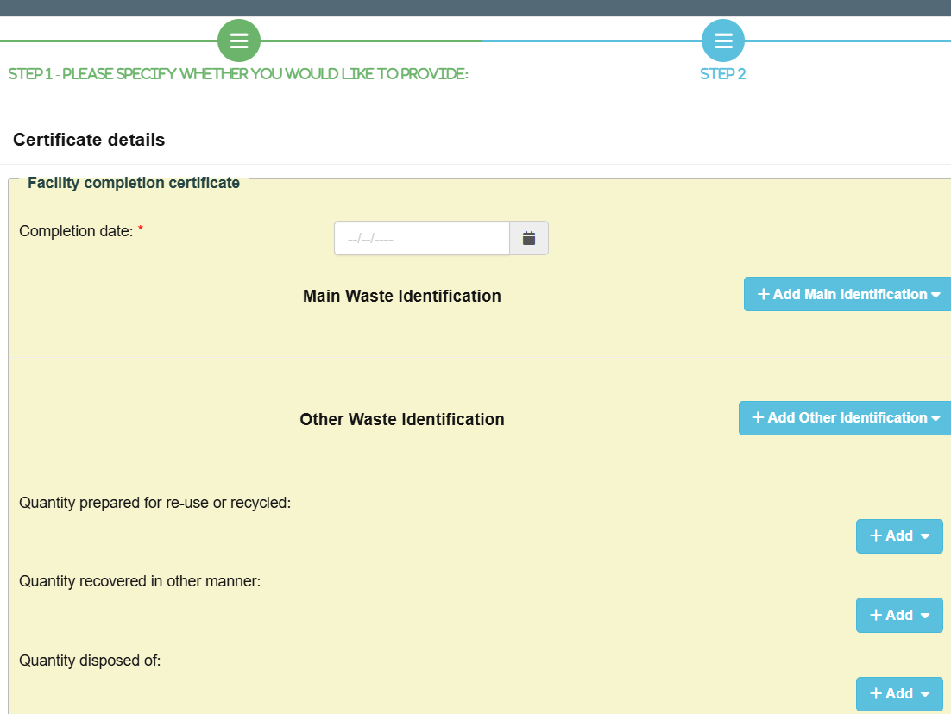

Then, the user needs to provide information by completing the following free-text fields:
  - Actual site of the disposal or treatment,
  - Additional information relevant for shipment of waste, if needed,
  - contact information concerning the waste receiving facility, by filling in the free-text fields.

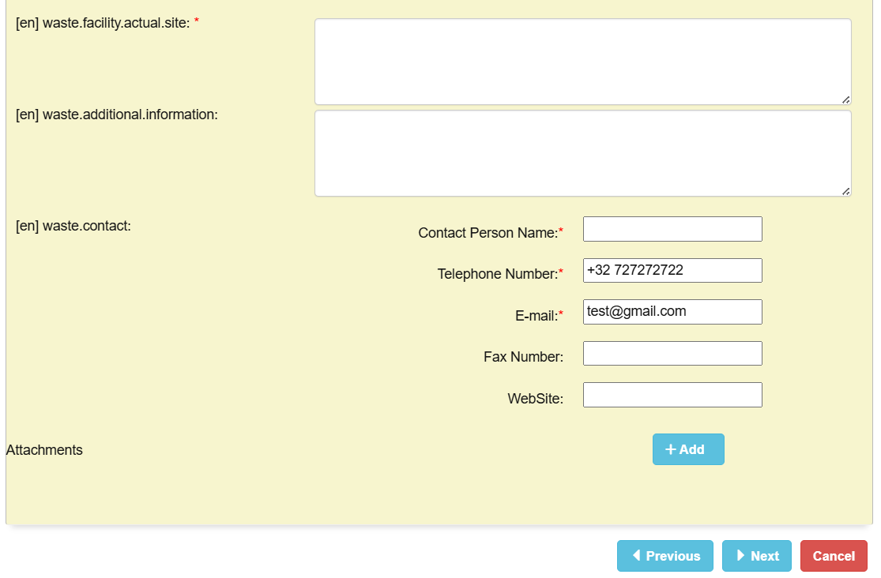

The user may also add an attachment by clicking on “+ Add”. Then, the user will be asked to select a label from the list and add an attachment by clicking on the grey field.

When all information is provided, the user needs to click on “Next”.

- Then, the user will be asked to authenticate the information provided. This authentication process in DIWASS is an equivalent of signing the documents.

In the pop-up window, the user should indicate what is the role they perform in the organisation of the operator (e.g. proxy, member of the board, president etc.). Then, the user should click on “Confirm”.
- Following that step, DIWASS will again display the dashboard summarising details of the notification document.

To verify its contribution to the movement document, the user needs to click once again on tab “Movement”, and then select the relevant document from the list.
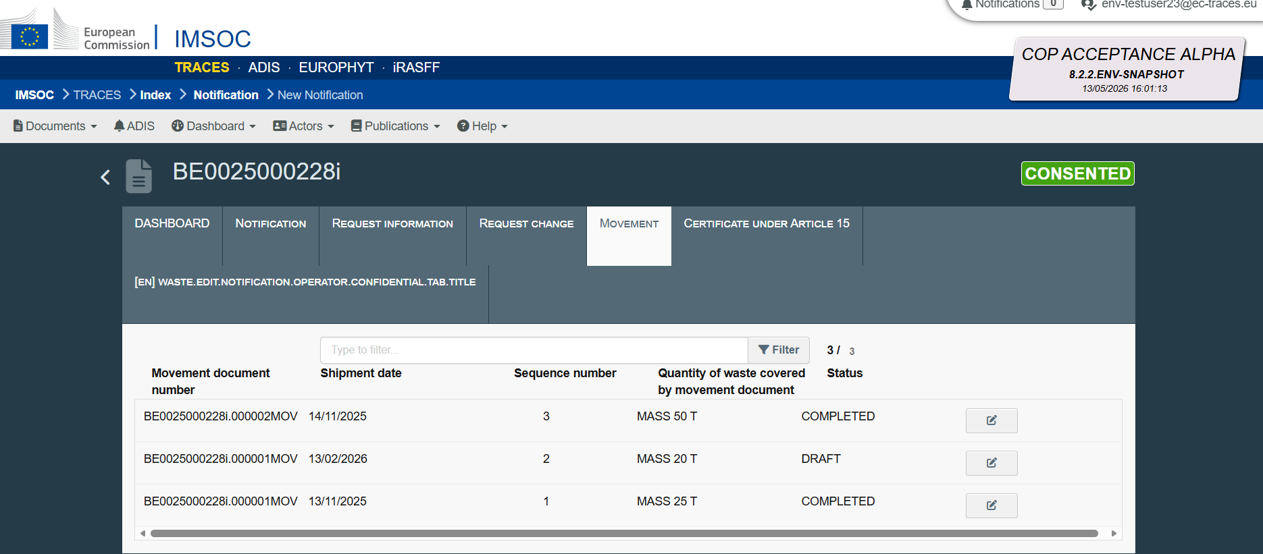

To see the confirmation of treatment of waste, the user needs to scroll down to display box 10 of the movement document. There, below the details of the waste receiving facility, DIWASS will display the confirmation submitted by this facility. The information will be displayed when clicking on the arrow on the left side of the box.
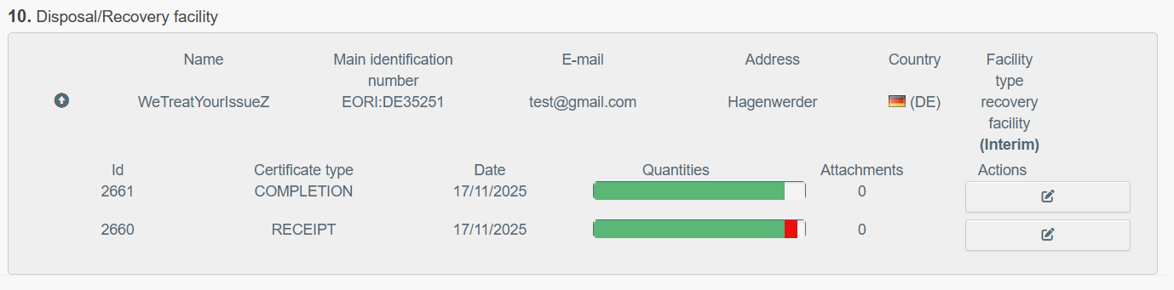

Updating the certificate confirming treatment of waste
- Following the login and selecting the relevant notification document from the list of all notification documents involving the operator, the user should click on tab “Movement”.
- Then, from list of movement documents, the user should select the movement document it intends to update and click on the icon next to the status of the document.
- DIWASS will display the submitted movement document.
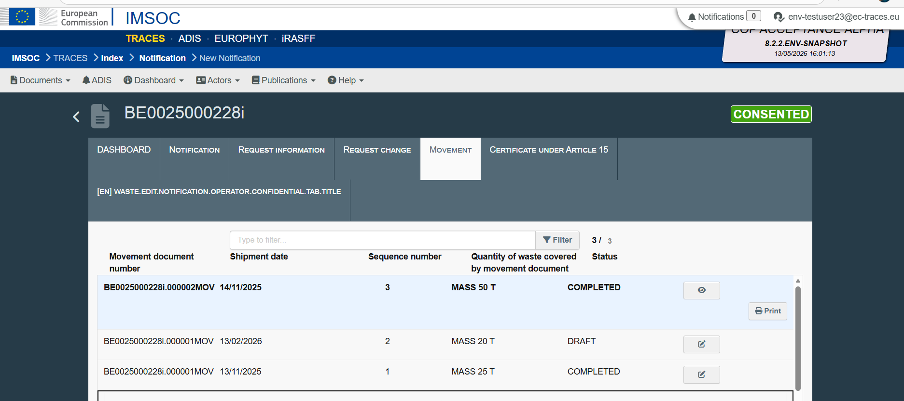

The user intending to update the confirmation of treatment of waste by the waste receiving facility needs to scroll down to box 10 of the movement document, click on the arrow on the left side of the box and select the icon next to the submitted confirmation in the column “Actions”.
DIWASS will display, in the pop-out window, information as provided initially by the waste receiving facility. The user will be able to update it by changing the relevant boxes, as explained in specific instructions for Confirming the treatment of waste above. To confirm the changes, the user needs to click “Next”.
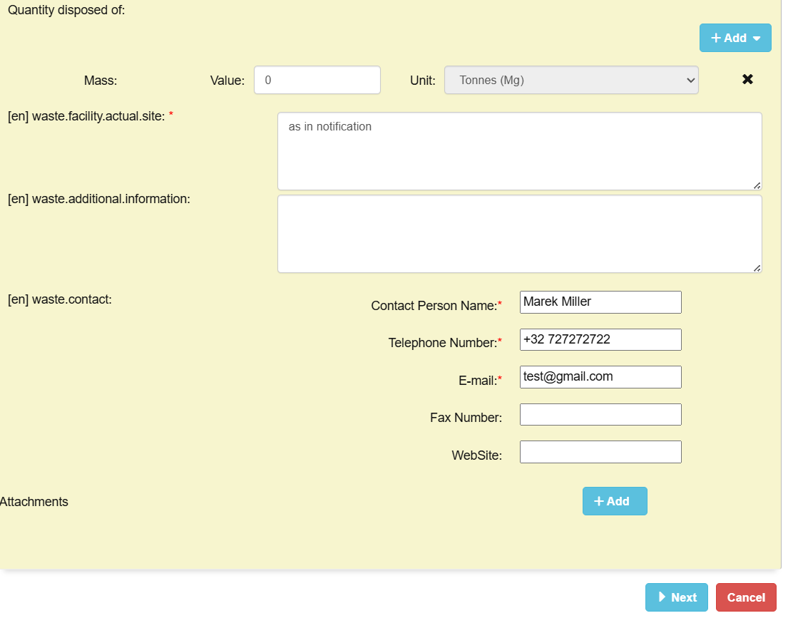
- Then, DIWASS will display the pop-out window concerning the authentication details. The user should update, if necessary, the field concerning the role in organisation of the operator on behalf of which the confirmation is submitted and click on “Confirm”.
- Following that step, DIWASS will again display the dashboard summarising details of the notification document.
To verify its contribution to the movement document, the user needs to click once again on tab “Movement”, and then select the relevant document from the list in order to review it.

For registration of operators, please refer to Chapters 1, 2 and 4 of the instruction manual on Operators [for operators and CAs].
For authorisation of users to represent operators, please refer to Chapters 3 and 5 of the instruction manual on Operators [for operators and CAs].
See also Article 15(4) of DIWASS Implementing act.
Please see also Commission Delegated Regulation (EU) 2024/2571 of 19 July 2024 supplementing Regulation (EU) 2024/1157 of the European Parliament and of the Council by establishing the information to be provided in the certificate confirming the completion of a subsequent interim or non-interim recovery operation or a subsequent interim or non-interim disposal operation, OJ L, 2024/2571, 27.9.2024, ELI: http://data.europa.eu/eli/reg_del/2024/2571/oj
If the update was done after the waste producer authenticated the draft notification, the waste producer will need to authenticate it again in order to allow the notifier to submit it.
All communication between the notifier and the CA that invalidated the notification, that is aimed to ensure that the CA revalidates the notification should happen outside DIWASS.
See also Article 17(14) of DIWASS Implementing act.
Please note that DIWASS will enforce this restriction only when the CA provides a lower number of shipments in a specific field in the decision box concerning the total number of shipments under a notification. If such requirement is provided only as text in free text field or in the attachment added to the decision, DIWASS will not recognise it.
Please note that DIWASS will enforce this restriction only when the CA provides a lower quantity of waste to be shipped in a specific field in the decision box concerning the total quantity of waste to be shipped under a notification. If such requirement is provided only as text in free text field or in the attachment added to the decision, DIWASS will not recognise it.
As indicated in the General note of this Chapter, changing data in the consented notification is explained in Chapter 6 Submitting the request for change of notification after consent (Art. 17 WSR).
As indicated in the General note of this Chapter, changing data in the consented notification, including adding new carriers, is explained in Chapter 6 Submitting the request for change of notification after consent (Art. 17 WSR).

